
Document is developed by HKRP Innovations LLP (HKRP) for Ministry of New and renewable Energy (MNRE) and UTTAR PRADESH Energy Development Agency (PEDA), UTTAR PRADESH under contract number 83368545

This document has been prepared on the basis set out in HKRP’s contract for ‘To develop state Portals and integrate that with National portal for monitoring and progress of Component C Feeder Level Solarisation for PMKUSUM’ with Deutsche Gesellschaft für Internationale Zusammenarbeit (GIZ) GmbH (“the Client”).

USER mANUAL

PM-KUSUM: UTTAR PRADESH State Solar Energy Data Management Platform (Component – C Feeder Level Solarisation)

Table of Contents

1. INTRODUCTION TO PM-KUSUM SCHEME 11
2. SEDM PURPOSE & VISION 12
3. WELCOME PAGE 13
4. SIGN IN ON SEDM PLATFORM 21
5. HOME PAGE 24
6. USER PROFILE PAGE 25
7. CHANGE PASSWORD 28
8. REGISTER NEW STATE IMPLEMENTING AGENCY (SIA) 30
9. SETTING MODULE 30
9.1. REGISTRATION OF DISCOM 31
9.2. REGISTRATION OF STATE IMPLEMENTING AGENCY (SIA) 35
10. USER ROLE MANAGEMENT 38
10.1 REGISTER NEW USER 39
11. MASTER SETTINGS (CONFIGURATIONS) 64
11.1. REGISTRATION OF TENDER 65
11.2. EA RATE CARD 70
11.3. REGISTRATION OF EA STORE SUB LOCATION 76
11.4. REGISTRATION OF MANUFACTURER DETAILS 80
11.5. REGISTRATION OF PRODUCT DETAILS 86
11.6. REGISTRATION OF TENDER CHECKLIST 91
11.7. REGISTRATION OF TENDER CHECKLIST DETAILS 97
11.8. AUDIT TRAIL 102
12. APPLICATION WORKFLOW STAGES 106
13. CONSUMER/FARMER APPLICATION REGISTRATION 107
14. Authentication 130
15. Technical Verification 131
16. FEASIBLE APPLICATION 132
17 LOA Award 134
18 PPA Signing 137
19. Financial Clearance 137
20. INSTALLATION AND COMMISSION (I&C) DONE 138
20.1 INSTALLATION & COMMISSION DONE (I&C) 142
21 LIVE MONITORING 146
22 PERFORMANCE ANALYSIS 156
23 SUMMARY 164
24 SCHEME PROGRESS 171
24.1 SCHEME PROGRESS REPORT 172
25 SIGN OUT 177
26 SUPPORT TEAM CONTACT DETAILS 178
ANNEXURE-I (IMEI NUMBER REGISTRATION) 179

Figures
Figure 1 Welcome Page 13
Figure 2 Frequently Asked Questions (FAQs) 14
Figure 3 Hindi Selected 15
Figure 4 Component – C Feeder Level Solarisation District Wise Details 16
Figure 5 PM-KUSUM Component - C Feeder Level Solarisation District Wise Status Report 17
Figure 6 Installers 18
Figure 7 Track Application 18
Figure 8 Application Entered To Track Application 19
Figure 9 Track Application Report 19
Figure 10 Notice 20
Figure 11 Important Documents 20
Figure 12 Contact Us 21
Figure 13 Sign In Page 22
Figure 14 Sign In screens 23
Figure 15 Home Page 24
Figure 16 User Profile Information box 26
Figure 17 Change Password 28
Figure 18 Modules 30
Figure 19 Setting Module 31
Figure 20 Empanelled Agency Tab 32
Figure 21 Empanelled Agency Tab Dashboard 32
Figure 22 CSV of Empanelled Agency Details 33
Figure 23 New Empanelled Agency Details 34
Figure 24 State Implementing Agency Tab 38
Figure 25 State Implementing Agency Tab Dashboard 38
Figure 26 CSV of State Implementing Agency Details 39
Figure 27 New State Implementing Agency Details 40
Figure 28 User Role Module 43
Figure 29 Add User Button on User Role Dashboard 44
Figure 30 Add User Form 48
Figure 31 User Information 49
Figure 32 Module Roles 55
Figure 33 Consumer Functionality 56
Figure 34 Scheme Progress Functionality 58
Figure 35 Site Survey Functionality 59
Figure 36 Asset Functionality 61
Figure 37 Live Monitoring Functionality 63
Figure 38 Device Registration Functionality 64
Figure 39 Complaint Sub Modules 65
Figure 40 User Role Dashboard 66
Figure 41 Change Password Screen 67
Figure 42 Assign Farmer Rights 68
Figure 43 User Role Module Selection Screen 70
Figure 44 Setting Module 71
Figure 45 Tender Tab 72
Figure 46 Tender Tab Dashboard 73
Figure 47 CSV of Tender Details 74
Figure 48 New Tender Details 75
Figure 49 EA Rate Card Tab 77
Figure 50 EA Rate Card Dashboard 78
Figure 51 CSV of EA Rate Card Details Figure 79
Figure 52 New EA Rate Card Details 80
Figure 53 EA Store Sub Location Tab 83
Figure 54 EA Store Sub Location Dashboard 84
Figure 55 CSV of EA Store Sub Location Details 85
Figure 56 New EA Store Sub Location Details 86
Figure 57 Manufacturer Tab 87
Figure 58 Manufacturer Tab Dashboard 88
Figure 59 CSV of Manufacturer Details 89
Figure 60 New Manufacturer Details 90
Figure 61 Product Tab 93
Figure 62 Product Tab Dashboard 94
Figure 63 CSV of Product Details 95
Figure 64 New Product Details 96
Figure 65 Tender Checklist Tab 98
Figure 66 Tender Checklist Tab Dashboard 99
Figure 67 CSV of Tender Checklist 100
Figure 68 New Checklist Details 101
Figure 69 Tender Checklist Detail Tab 104
Figure 70 Select Tender Checklist Template 105
Figure 71 Tender Checklist Template Dashboard 105
Figure 72 CSV of Tender Checklist Template 106
73 New Tender Checklist Details 107
Figure 74 Audit Tab 109
Figure 75 Audit Tab Filters 110
Figure 76 Audit Dashboard (Applied Filters) 111
Figure 77 Audit Details – CSV File 112
Figure 78 Details 114
Figure 79 Select District 114
Figure 80 District List 115
Figure 81 Add Farmer Button 115
Figure 82 Add farmer Form 116
Figure 83 Application & Consumer Details 117
Figure 84 Communication & Location Details 119
Figure 85 Irrigation Details 121
Figure 86 Pump Details 123
Figure 87 Solar Details 124
Figure 88 Agriculture Details 125
Figure 89 Financial & Commercial Details 126
Figure 90 Other Details 127
Figure 91 Loan Details 129
Figure 92 Bank Details 130
Figure 93 List of Document Attached 131
Figure 94 Detail Dashboard 132
Figure 95 Consumer Detail Data Columns (i) 132
Figure 96 Consumer Detail Data Columns (iI) 133
Figure 97 Consumer/Farmer Detail Dashboard 136
Figure 98 Confirmation Screen to Delete All Updated Consumer/Farmer Application Status 136
Figure 99 Filter 1 Solution & Empanelled Agency 137
Figure 100 Filter 2 Empanelled Agency 137
Figure 101 District Survey Summary Details CSV 138
Figure 102 Download data Filters Screen 138
Figure 103 Details dashboard csv file (i) 139
Figure 104 Details dashboard csv file (ii) 139
Figure 105 Details dashboard Excel file (i) 139
Figure 106 Details dashboard Excel file (ii) 140
Figure 107 Details dashboard Excel file (iii) 140
Figure 108 Details dashboard PDF 141
Figure 109 Show / Hide columns filter 142
Figure 110 Scheme Progress report for Consumer/Farmer 143
Figure 111 Site Survey Detail of Consumer/Farmer 145
Figure 112 Details 146
Figure 113 Details Dashboard 146
Figure 114 Site Survey Details 147
Figure 115 Application Accept button 148
Figure 116 Application Hold-Reject Button 148
Figure 117 Reason for Application Hold/Reject 148
Figure 118 Farmer Application Flow Chart 149
Figure 119 Details 150
Figure 120 Updated Farmer Share Received 151
Figure 121 Details 152
Figure 122 Details Dashboard 152
Figure 123 Assign EA to the Consumer/Farmer. 153
Figure 124 Updated Order Place to EA 153
Figure 125 Test Report 154
Figure 126 Asset Test Report 155
Figure 127 Add Asset Test Report 156
Figure 128 Set Report 159
Figure 129 Individual Report 160
Figure 130 Lot Management Option 161
Figure 131 Lot Creation Button 162
Figure 132 Lot Form 163
Figure 133 Select Input/CSV Dropdown 166
Figure 134 Entering Comma Separated Asset Serial Nos. 166
Figure 135 Serial No. CSV Format Button 167
Figure 136 Serial No CSV File 167
Figure 137 Filters to Fetch Out Consumer/Farmer’s Application Numbers 167
Figure 138 Add Asset box 168
Figure 139 Next Button 168
Figure 140 Pump Checklist 169
Figure 141 Solar Panel Checklist 170
Figure 142 Pump Controller Checklist 171
Figure 143 Structure Checklist 172
Figure 144 Checklist & Document Submit Button 172
Figure 145 Status Updated 173
Figure 146 Asset Mapping By EA Option 175
Figure 147 Asset Mapping in Bulk 175
Figure 148 Asset Mapping Format 176
Figure 149 Save as CSV (Comma Delimited) 176
Figure 150 Asset Mapping by EA Dashboard 177
Figure 151 Consumer Info Tab 178
Figure 152 Individual Asset Mapping 179
Figure 153 IMEI Replacement 179
Figure 154 I & C Photos 180
Figure 155 I&C Status box 181
Figure 156 Insurance Policy 181
Figure 157 Asset Details 182
Figure 158 Real-time Dashboard 184
Figure 159 View History 185
Figure 160 Asset Mapping By SNA Option 186
Figure 161 Asset Mapping by SNA Dashboard 187
Figure 162 Consumer info Tab 188
Figure 163 Site Inspection Checklist 190
Figure 164 Installation Report Upload Screen 191
Figure 165 Project Completion Report 198
Figure 166 Live Monitoring Dashboard Option 199
Figure 167 Live Monitoring Dashboard 200
Figure 168 Consumer Details (i) 201
Figure 169 Consumer Details (ii) 201
Figure 170 Update RMS Latitude - Longitude 202
Figure 171 Invalid Parameters of Green Box of Live Monitoring Dashboard 204
Figure 172 Amritsar District Solar Pump Statistics 205
Figure 173 Broad View of Consumer/Farmer of Selected District 206
Figure 174 Consumer/Farmer Solar Pump Statistics 206
Figure 175 Real Time View of the Consumer/Farmer 207
Figure 176 State level performance analysis 209
Figure 177 District Statistics 212
Figure 178 Broad View of Consumer/Farmer of Selected District 213
Figure 179 Consumer/Farmer Solar Pump Statistics 214
Figure 180 Real Time View of the Consumer/Farmer 215
Figure 181 Consumer/Farmer Management Summary option selected on Consumer/Farmer Dashboard 216
Figure 182 EA selection option in ‘Select EA’ filter 219
Figure 183 Capacity options in ‘Select Capacity’ filter 220
Figure 184 Applied filter: Sri Savitir Solar Pvt Ltd (EA), AC-7.5HP, Submersible Pumps (Waterfilled Motors) 220
Figure 185 Individual application stage 221
Figure 186 District-wise summary of Applications Received for various pump models report 221
Figure 187 Show / Hide columns filter 222
Figure 188 Using the filter “Show / hide columns” to display only selected columns 222
Figure 189 Using “Search” filter to list down all entries for District = Amritsar 223
Figure 190 The view of downloaded CSV/Excel file 223
Figure 191 Consumer/Farmer Management Analysis option selected on Consumer/Farmer Dashboard 224
Figure 192 Consumer/Farmer Analysis Dashboard 224
Figure 193 Filter Applied: Application Received 225
Figure 194 Filter Applied: Feasible Application 226
Figure 195 Filter Applied: Application Received 226
Figure 196 Filter options for Analysis graphs 227
Figure 197 Consumer/Farmer Analysis - Pie Chart 227
Figure 198 Consumer/Farmer Analysis – Funnel chart 227
Figure 199 Filter Applied: Shakti Pumping 228
Figure 200 Consumer/Farmer Analysis - Filter options 228
Figure 201 Map View 229
Figure 202 Filter Applied: Installation & Commission, Tata Power Solar Systems Ltd 230
Figure 203 Consumer/Farmer Analysis statistics for district-wise location 231
Figure 204 MIS Reports 233
Figure 205 Yearly Progress Summary – Tabular view 234
Figure 206 Yearly Progress Summary – Chart view 235
Figure 207 District Progress Summary- tabular view 236
Figure 208 District Progress Summary – Chart view 237
Figure 209 Capacity wise Progress Summary – Tabular view 238
Figure 210 Capacity wise Progress Summary – chart view 239
Figure 211 Empanelled Agency Progress Summary – Tabular view 240
Figure 212 Empanelled Agency Progress Summary – Chart view 241
Figure 213 Gender Wise Report – Tabular View 242
Figure 214 Bulk Progress Mapping Dashboard 243
Figure 215 Site Survey Done CSV File Upload 245
Figure 216 Site Survey Bulk Upload Format 246
Figure 217 Order to EA CSV File Upload 246
Figure 218 Order Placed to EA Bulk Upload Format 247
Figure 219 Farmer Share Received CSV File Upload 247
Figure 220 Site Survey Bulk Upload Format 248
Figure 221 Bulk Progress Update Form 249
Figure 222 PDF output 249
Figure 223 Excel/CSV output 250
Figure 224 Consumer List 250
Figure 225 Site Location Dashboard 252
Figure 226 Asset History 253
Figure 227 location history 253
Figure 228 Field Service Engineer Dashboard 253
Figure 229 EA Service Store Inspection 254
Figure 230 EA Store 254
Figure 231 Status Update pop-up box 255
Figure 232 Transfer pop-up box 255
Figure 233 Create pop-up box 256
Figure 234 SIA Lab 256
Figure 235 SIA Store 257
Figure 236 Asset dashboard filter – asset type 257
Figure 237 ASSET DASHBOARD FILTER – sub location 257
Figure 238 ASSET DASHBOARD FILTER – ASSET status 258
Figure 239 Asset Mapping By EA Option 259
Figure 240 Asset Mapping by EA Dashboard 260
Figure 241 IMEI Replacement Button 260
Figure 242 IMEI No. Replacement By Generating New IMEI No. 261
Figure 243 IMEI No. Replacement from Registered IMEI Nos. 261
Figure 244 Logout 262
Figure 245 Home Selected 262
Figure 246 Sign out 263
Figure 247 Welcome Page of Site Survey Mobile Application 265
Figure 248 Sign In Box 266
Figure 249 Select Component and Application No 267
Figure 250 Consumer Site Survey Details 269
Figure 251 Key Points of Site Survey Details 271
Figure 252 Get Current Location Button 272
Figure 253 Latitude-Longitude 272
Figure 254 Logout Button 273
Figure 255 Device Registration 274
Figure 256 IMEI Bulk Upload 274
Figure 257 IMEI No. CSV Format 275
Figure 258 Upload IMEI No. CSV 275
Figure 259 Add New Device Registration Button 276
Figure 260 Add Device Registration 276

Table 1 Glossary
Abbreviation | Full Form
CSV file | Comma-separated values file
DO | District Officer
DISCOM | Distribution Company
EA | Empanelled Agency
I&C | Installation and Commission
IMEI | International Mobile Equipment Identity
MNRE | Ministry of New and Renewable Energy
PCR | Project Completion Report
PDF | Printable Document Format
PDI | Pre-Dispatch Inspection
PM-KUSUM | Pradhan Mantri Kisan Urja Suraksha evam Utthaan Mahabhiyan
RMS | Remote Monitoring System
SEDM | Solar Energy Data Management
SIA | State Implementing Agency
SNA | State Nodal Agency (SIA)
SI | System Integrator
HO | Head Office

Table 2 URL links
Module | URL link
PMKUSUM Web Application | https://pmkusum.up.gov.in
PMKUSUM Web API | https://pmkapi.up.gov.in

Table 3 MINIMUM EQUIMENT REQUIRED TO ACCESS STATE SEDM PLATFORM:
Description | Recommended Specifications
Processor | Intel Dual Core or Higher
Processor Speed | 3.2 GHz
RAM | 4 GB or Higher
Operating System | Windows
Browser | Google chrome / Mozilla Firefox
Internet Speed | 4 Mbps or Higher

Release History

Version | Date (dd-Mon-yyyy) | Released by
1.0 | 27-March-2023 | Ekta Soni

- INTRODUCTION TO PM-KUSUM SCHEME
Pradhan Mantri Kisan Urja Suraksha evam Utthaan Mahabhiyan (PM-KUSUM) scheme was initiated by Government of India and launched by the Ministry of New and Renewable Energy (MNRE) to provide farmers with renewable as well as feasible energy sources for electricity and irrigation. PM-KUSUM Yojana got its administrative approval in March 2019 and guidelines were framed in July 2019. The scheme aims towards the installation of solar pumps and grid-connected solar panels in nationwide farmlands, in order to de-dieselize and solarise the agricultural sector.
PM-KUSUM scheme plans to add solar renewable capacity of 30.8 GW by 2022 with the total central financial support of INR 34,035 Crore including installation and service charges to the implementing agencies.
The Scheme consists of three components:
- Component A: 10,000 MW of Decentralized Ground Mounted Grid Connected Renewable Power Plants of individual plant size up to 2 MW.
- Component B: Installation of 20 lakh standalone Solar Powered Agriculture Pumps of individual pump capacity up to 7.5 HP.
- Component C: Solarisation of 15 Lakh Grid-connected Agriculture Pumps of individual pump capacity up to 7.5 HP.
In State, the scheme will be run under the supervision of the Central Government's subordinate Ministry of New and Renewable Energy.
This scheme is especially for the farmers, which is also being added as an important effort towards increasing the income of the farmers.

The Central Government's PM-KUSUM Yojana has been launched in State, which will bring prosperity in the lives of farmers. This scheme has been implemented with the objective of saving electricity during agricultural operations, reducing the electricity expenditure of farmers and promoting solar energy.

- SEDM PURPOSE & VISION
The Solar Energy Data Management (SEDM) Platform has been developed to serve the vision of One Nation – One Solar for PM-KUSUM scheme.
The primary features of SEDM:
- A single platform to monitor various Solar PV based plants and pumps installed under PM-KUSUM scheme in State.
- Stand-alone Solar Pumps, Grid Connected Solar Pumps, Distributed Solar Plants.
- A single platform for multiple stakeholders
- Farmers, Empanelled Agencies (EA), State Implementing Agency (SIA) SIA, DISCOM, MNRE,
- A single platform to undertake multiple processes under PM KUSUM scheme like
- Consumer/Farmer Registration, DBT Integration, Project Process Management, Asset Management, Complaints Management.

- A single platform to remotely monitor plants and pumps by connecting to multiple devices such as
- Pump controllers, Drivers, Energy meters, Inverters, Combiner boxes etc.

- WELCOME PAGE
Upon opening the State SEDM portal, all users (registered/unregistered) land on the welcome page of the portal.
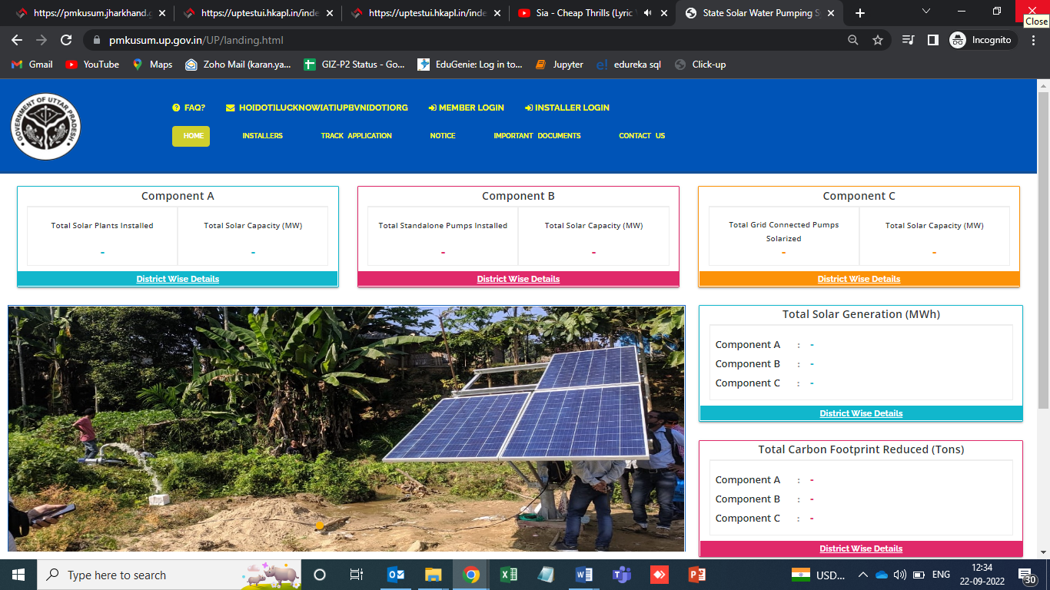
Figure 1 Welcome Page

- On the welcome page’s heading, there is a provision of “Frequently Asked Questions (FAQs)” provided (as highlighted in red in above Figure 1). Below are the frequently asked questions, as shown in Figure 2.

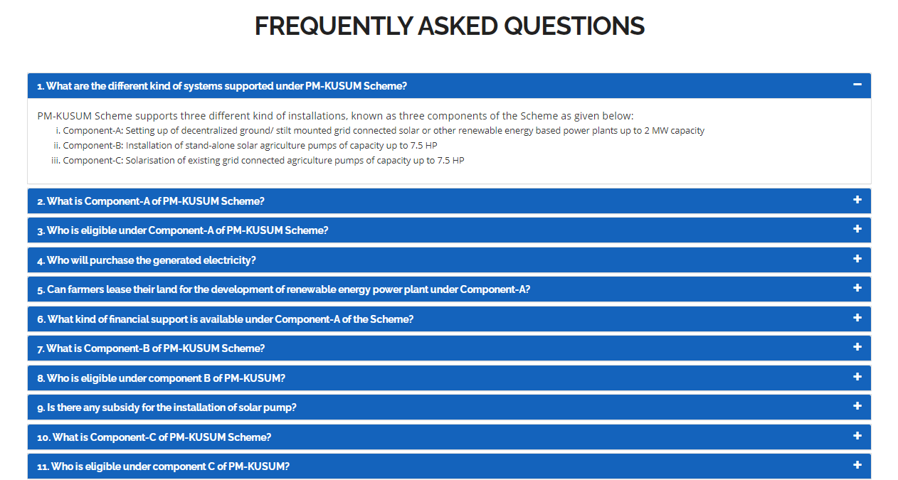
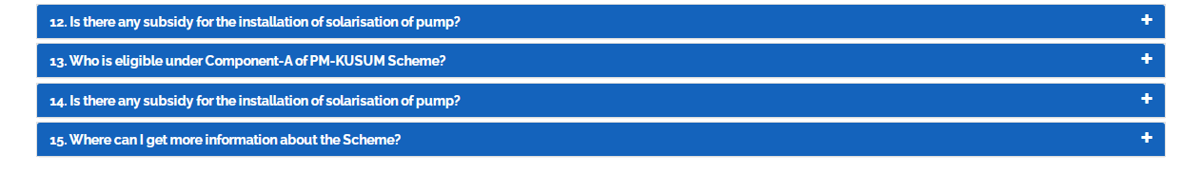

Figure 2 Frequently Asked Questions (FAQs)

- The provision of language is selection is also there on the “Welcome Page” in which default selection will be of “English” language (highlighted in yellow in Figure 1). After selection of different language, corresponding output are shown below in Figure 3.

- Selected – Hindi


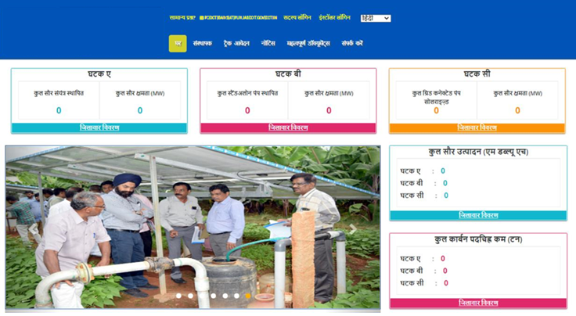
Figure 3 Hindi Selected

- On the welcome page, there are 5 indicators among which 3 depicting the components of PM-KUSUM scheme along with the cumulative figures of total solar plants and pumps installed and their capacity and other two depicts Total Solar Generation (MWh) and Total Carbon Footprint Reduced (Tons) (as shown in Figure 1).
- To get a detailed view of the capacity installed under each component, click on the ‘District Wise Details’ tab under each component (as shown in below Figure 4 C Feeder Level Solarisation District Wise Details the blue box), which will generate a detailed report in tabular form.(refer Figure 5)

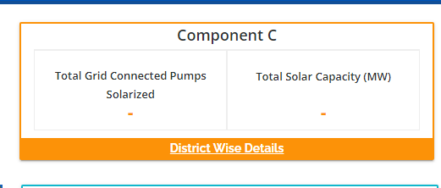
Figure 4 C Feeder Level Solarisation (C FLS) District Wise Details

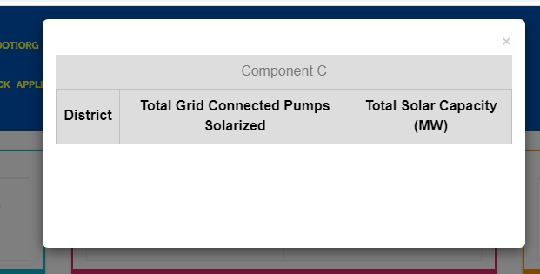

Figure 5 PM-KUSUM C Feeder Level Solarisation (C FLS) District Wise Status Report

- District Wise Details provide the view of total installed Standalone Pumps and its capacity against Districts of State.
- Such report can be also seen without login into the SEDM Portal.

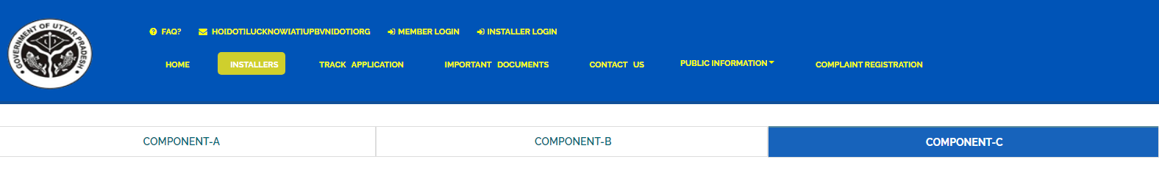
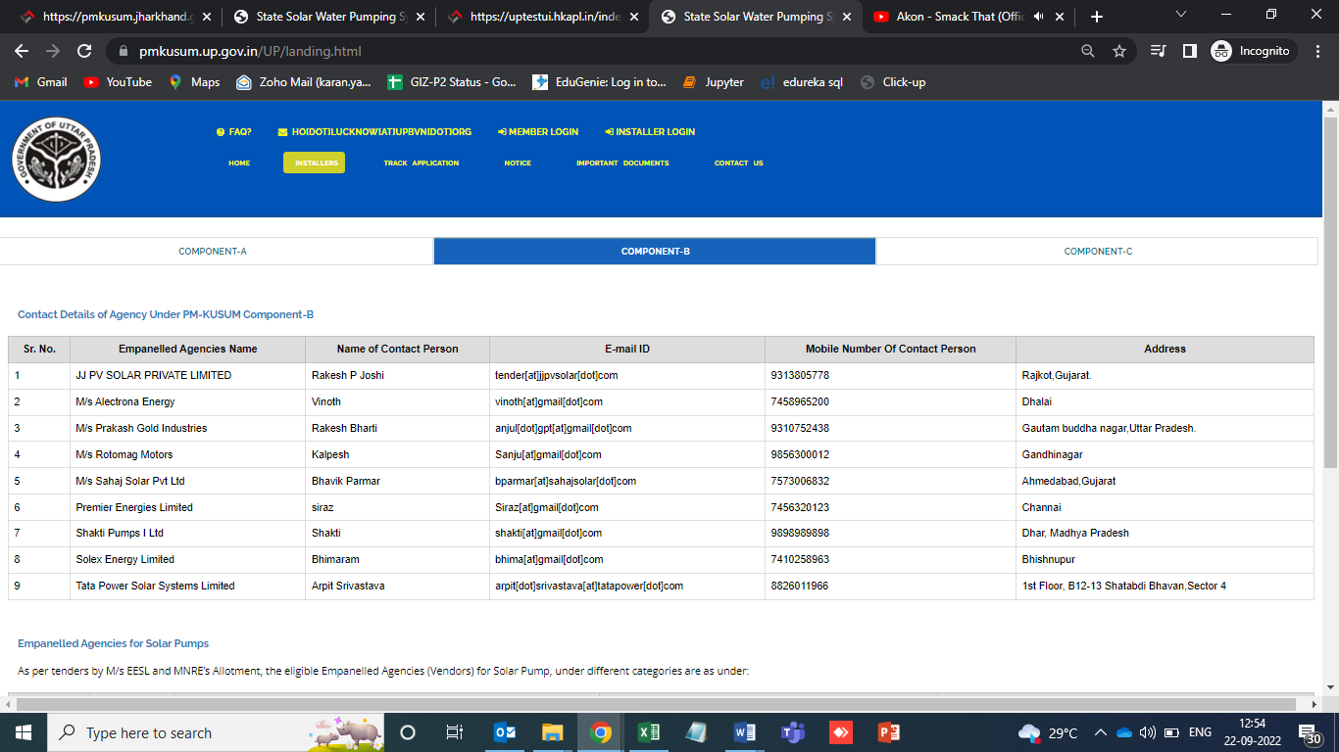

Figure 6 Installers

- “TRACK APPLICATION” tab provides the facility of tracking the Farmer Application by entering Application number or Consumer/Farmer Mobile No (as shown in Figure 7 in red box)

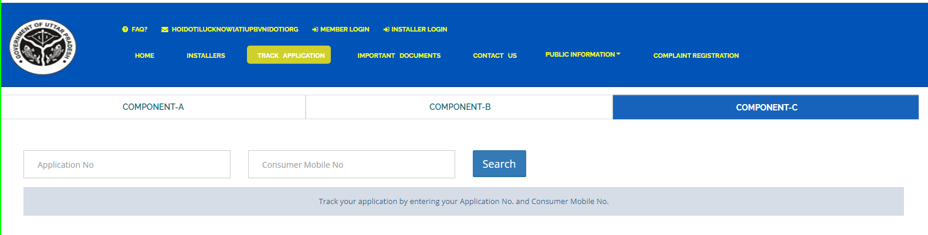
Figure 7 Track Application

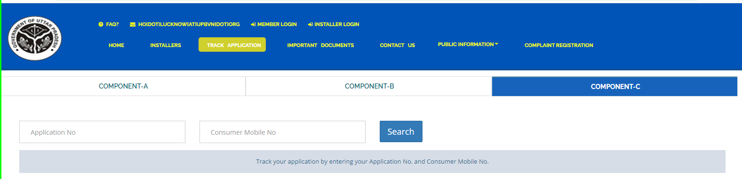

Figure 8 Application Entered To Track Application

- When user enter Application no. or Consumer/Farmer Mobile no. and click on “Search” button, below report (Figure 9) will be shown.
- The completed status will have date on which status was completed.
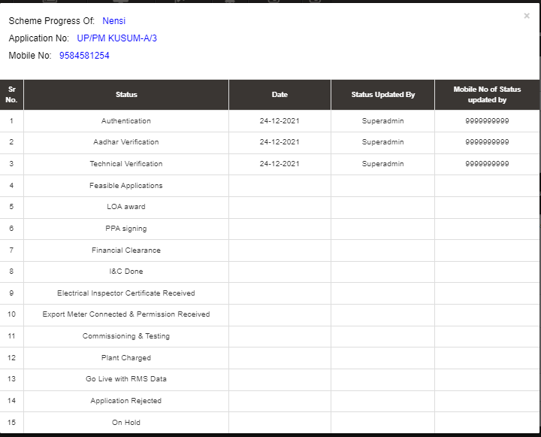

Figure 9 Track Application Report
- The “NOTICE” tab displays list of notices related to PM KUSUM scheme. (as shown in Figure 10)
- Uploaded Notices can be taken out manually.

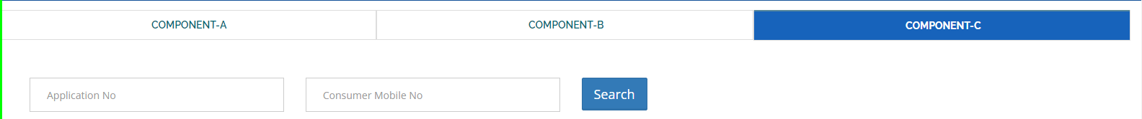
Figure 10 Notice

- “IMPORTANT DOCUMENTS” tab displays list of documents that are vital for the PM KUSUM scheme. (as shown in Figure 11)
- Uploaded Documents can be taken out manually.

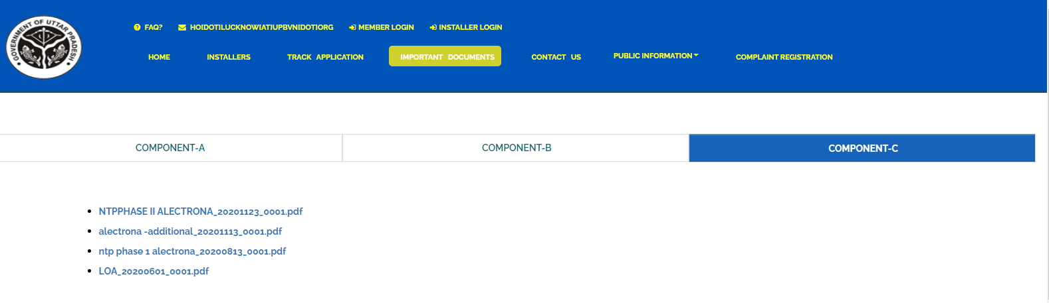
Figure 11 Important Documents

- “CONTACT US” tab displays list of all Nodal officers of Districts for PM KUSUM C Feeder Level Solarisation (C FLS). (as shown in Figure 12)

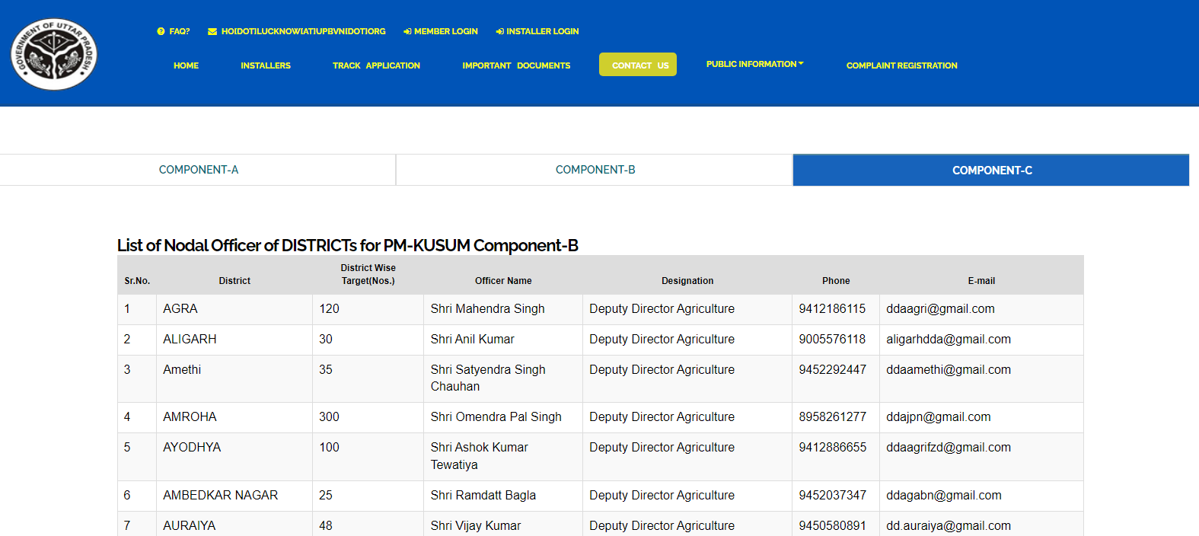

Figure 12 Contact Us

- SIGN IN ON SEDM PLATFORM
- To log in onto the SEDM portal, users can click on the “MEMBER LOGIN OR INSTALLER LOGIN” option on the Welcome Page.(highlighted in red in Figure 13)

Role | Login Option
Head Officer | MEMBER LOGIN
District Officer
Empanelled Agency/Developer | INSTALLER LOGIN

- Such login options will be visible to all users including HO, DISCOM, SDN and EA.

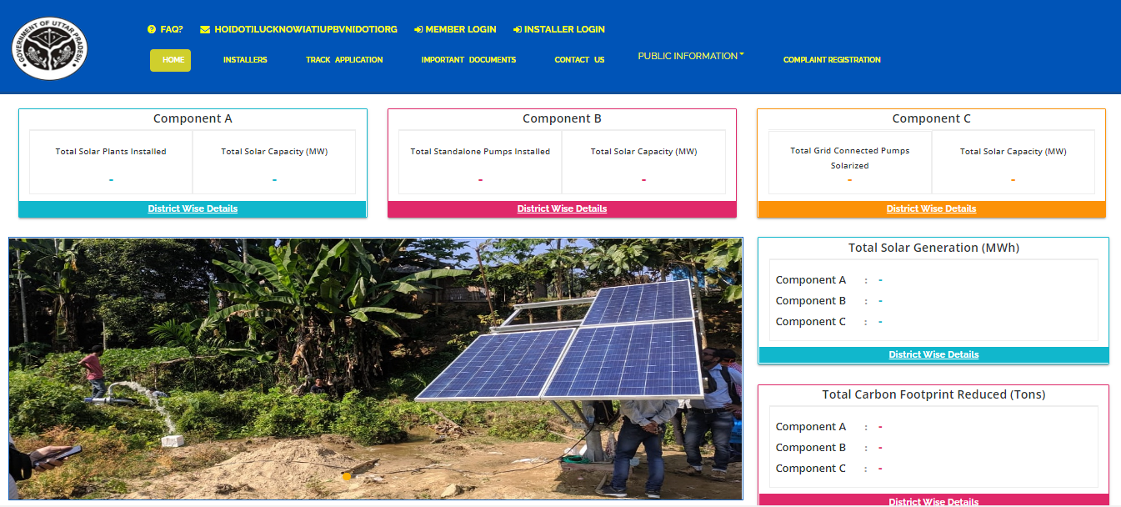
Figure 13 Sign In Page
- By clicking on the login options, it will show a pop-up box where the user must enter his username, password and the captcha code to sign in into their account.
- The user will be provided the credentials via email if the email gateway is configured.
- NOTE: If email gateway is not configured then Organization admin can share credentials manually. (click User Role for more details)

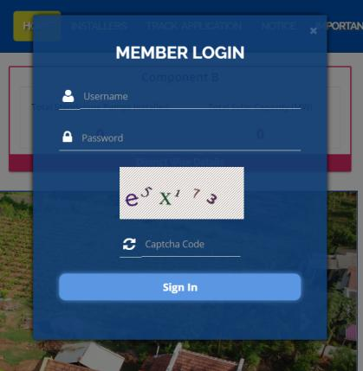  Member Login pop-up for State Implementing Agency | 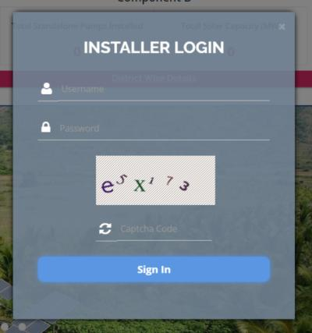  Installer Login pop-up for Empanelled Agency
Figure 14 Sign In screens

- HOME PAGE

- After the user successfully logs in to the SEDM portal it lands on the Home Page screen.
On the Home Page, users can select any of the 1 components to view the required Consumer/Farmer details, asset management, application tracking, performance analysis, etc.
- Component A: Distributed Solar PV
- Component B: Off Grid Solar Pump
- Component C: Grid Connected Solar Pump

- Navigation Steps: -
1. Sign in on the State SEDM Portal
2. Click on ‘Off Grid Solar Pump’ icon on the Home Page as shown in the Figure 15 to access the Component-B of PM-KUSUM Scheme.

- Users having rights to access of related components (A, B, C) only will be allowed to navigate through.
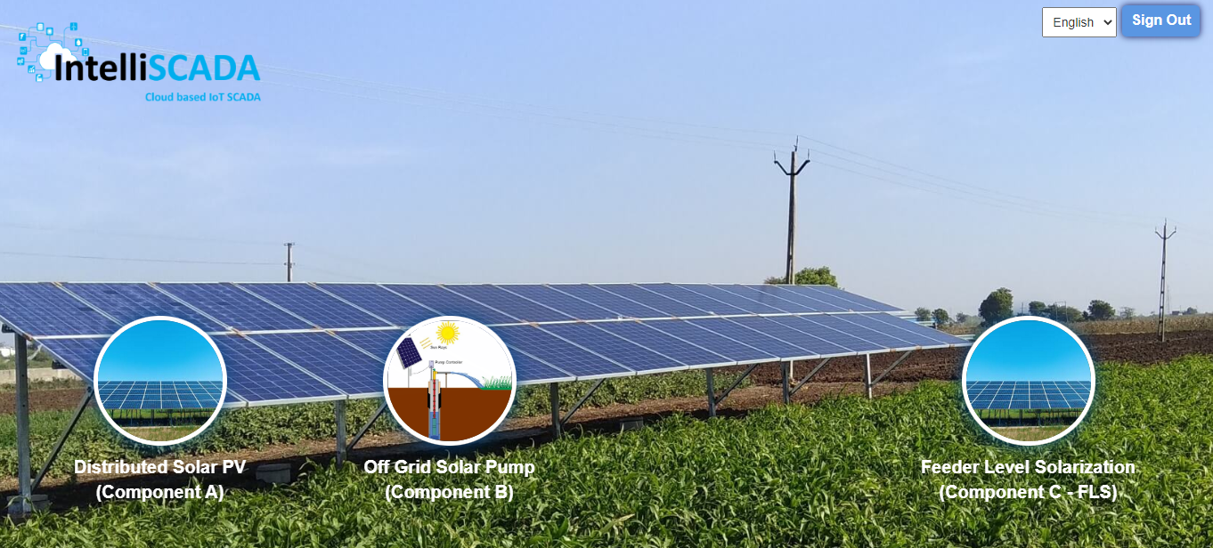
Figure 15 Home Page

- USER PROFILE PAGE

- The users can view their profile information by clicking on the ‘user’ icon image in the top right corner (highlighted in red in below Figure 16) on this manual is for Component B le bar and then selecting the ‘My Profile’ option.
- Navigation Steps: -
1. Sign in on the State SEDM Portal
2. Click on the ‘User’ icon on the Title Bar of the SEDM Portal Dashboard

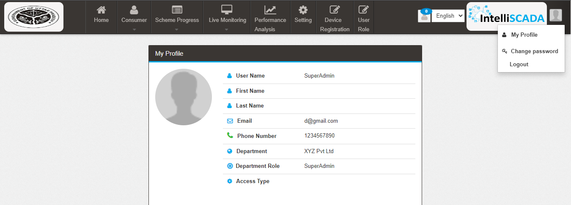
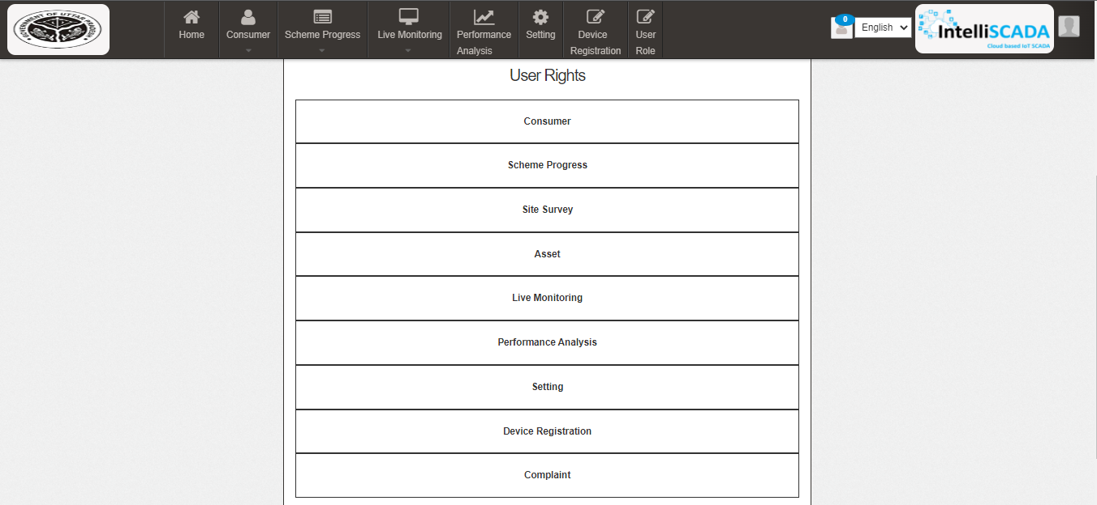

Figure 16 User Profile Information box

- The following details are listed under ‘My Profile’ template card:
- Username
- First Name
- Last Name
- Email
- Phone Number
- Department
- Department Role
- Access Type
- User Rights

- If the user wishes to change any details or sees a discrepancy in his details, he can contact the SEDM support team for required modifications.

- Ctrl + Click here “Support Team” for Support Team Contact details.

CHANGE PASSWORD

- The users can change their account password by clicking on the ‘user’ icon image in the top right corner on the title bar and then selecting the ‘Change Password’ option.
- Navigation Steps: -
1. Sign in on the State SEDM Portal
2. Click on the ‘User’ icon on the Title Bar of the SEDM Portal Dashboard
3. Click on the ‘Change Password’ option from the drop-down menu

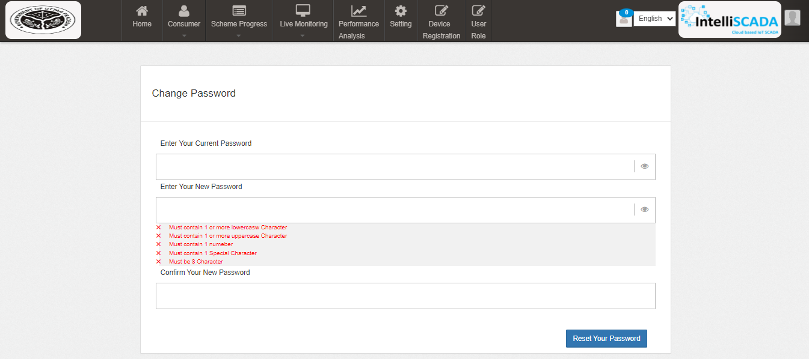
Figure 17 Change Password

- The users can change their password by entering the current password, a new password and re-entering the new password to confirm it in the mentioned text fields. Then click on the ‘Change Password’ button to complete the process.

- Your New Password box and Confirm Your New Password box must have same password inputs otherwise an error will occur i.e. Please enter the same password as entered New Password

Note: Users should make sure their passwords are strong and secure as per below mentioned validations to avoid any untoward activities or misuse of their credentials by any other party.
- Length must be of minimum 8 characters
- 1 or more lowercase character
- 1 or more uppercase character
- 1 special character
- 1 or more numbers

- REGISTER NEW STATE IMPLEMENTING AGENCY (SIA)

- SIA will be shared Super Admin credential that can have access to all the three Components i.e. Distributed Solar PV (Component A), Off Grid Solar Pump (Component B) and Grid Connected Solar Pump (Component C) and also can have access to all the below mentioned 9 modules of portal:
- Consumer
- Scheme Progress
- Asset
- Live Monitoring
- Performance Analysis
- Setting
- Device Registration
- User Role
- Complaint

Figure 18 Modules

- Super Admin can register new State Implementing Agency (SIA) and Empanelled Agency (EA) in “Setting” module.

- SETTING MODULE

- New Empanelled Agency & State Implementing Agency can be registered in “Setting” module.

- Navigation Step :-
- Sign in on the State SEDM Portal
- Click on the Setting Module

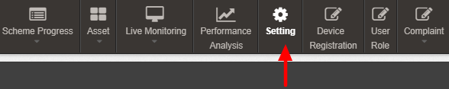

Figure 19 Setting Module

9.1. REGISTRATION OF DISCOM

- Super Admin can register DISCOM by clicking on “DISCOM” tab as pointed in below Figure 20.

- Navigation Step :-
- Sign in on the State SEDM Portal
- Click on the Setting Module
- Click on DISCOM

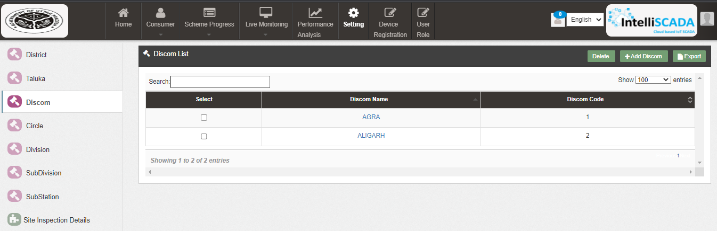
Figure 20 Empanelled Agency Tab
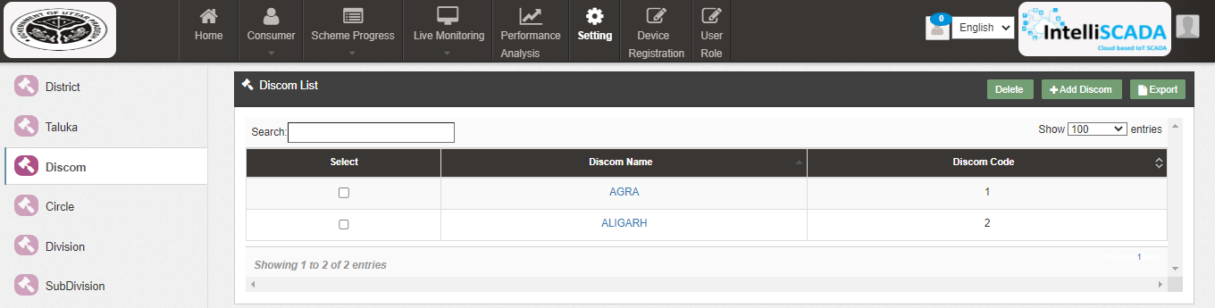

Figure 21 Empanelled Agency Tab Dashboard

Table 4 EMPANELLED AGENCY DASHBOARD DESCRIPTION
Action | Functionality | Highlighted Colour | Type | Description
Search | DISCOM | Blue | Text Box | Enter input to explore DISCOM details
Delete | Delete DISCOM | Yellow | Button | Select check box (highlighted in pink) and click on delete button to Delete DISCOM. This will be a soft delete wherein, all the data related to DISCOM will still be stored in Database
Add DISCOM | Register DISCOM | Red | Button | Register new Empanelled Agency by clicking on Add DISCOM button
Export | CSV file for Empanelled Agency details | Green | Button | Download CSV file of DISCOM details

- User can register new Empanelled Agency by clicking on “DISCOM” button. (highlighted in red in Figure 21)
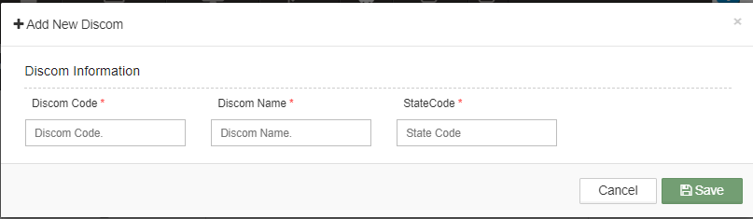
Figure 23 New DISCOM Details

Table 5. DISCOM REGISTRATION FIELDS DESCRIPTION
Field | Input | Mandatory Field | Sample Values | Description | Validations
Discom Code | Text box |  | 01562 | Enter Discom code (if available) | -
Discom Name | AGRA  -ALIGARH  -AMBEDAKAR NAGAR  -AMETHI  -AMAROHA  -AURAIYA  -AYODHYA  - AZAMGARH  - BAGHPAT  - BAHRAICH  - BALLIA  - BALARAMPUR  - BANDA  - BARABANKI  - BAREILLI  - BASTI  - BHADOHI  -BIJNOR |  | BAGHPAT | Enter name of the DISCOM | -
State Code | Text box |  | 25 | Enter state code as per the LG Directory | -

- After filling all the details, user has to click on the “Save” button (highlighted in red in Figure 23) to register discom.

9.2. REGISTRATION OF STATE IMPLEMENTING AGENCY (SIA)

- Registering Taluka

- Super Admin can register New State Implementing Agency by clicking on “State Implementing Agency” tab as pointed in below Figure 24.

- Navigation Step :-
- Sign in on the State SEDM Portal
- Click on the Setting Module
- Click on Taluka
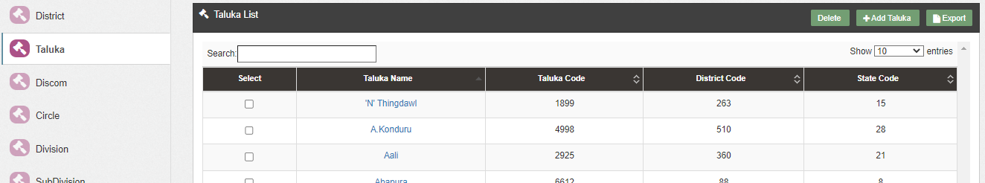
Figure 24 State Implementing Agency Tab

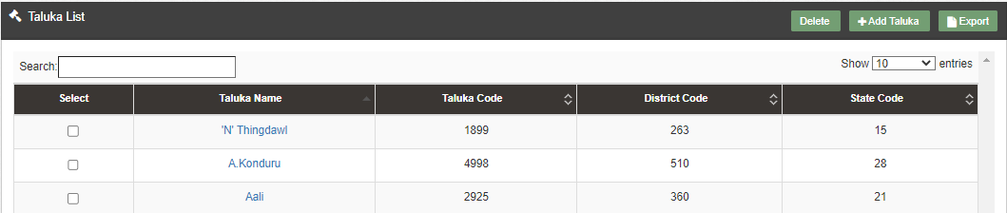
Figure 25 State Implementing Agency Tab Dashboard

Table 6 STATE IMPLEMENTING AGENCY DASHBOARD DESCRIPTION
Action | Functionality | Highlighted Colour | Type | Description
Search | Search Taluka | Blue | Text Box | Enter input to explore State Implementing Agency details
Delete | Delete Taluka | Yellow | Button | Select check box (highlighted in pink) and click on delete button to Delete Taluka . This will be a soft delete wherein, all the data related to Taluka will still be stored in Database
Add Taluka | Register new Taluka | Red | Button | Register new Taluka by clicking on Add Taluka button
Export | CSV file for Taluka | Green | Button | Download CSV file of State Implementing Agency details,

- User can register new Taluka by clicking on “Add Taluka” button. (highlighted in red in Figure 25)

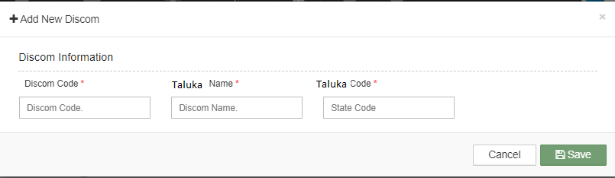
Figure 27 New Taluka Details

Table 7 STATE IMPLEMENTING AGENCY REGISTRATION FIELDS DESCRIPTION
Field | Input | Drop Down Options | Mandatory Field | Sample Values | Description | Validations
Discom Code | Drop Down | - 015234 |  | 015234 | Select Discom code as per the requirement. | -
Taluka name | Text | - |  | xyz | Enter name of a taluka | -
Taluka code | Text | - |  | 014754 | Give unique code to taluka | -

- After filling all the details, user has to click on the “Save” button (highlighted in red in Figure 27) to register New taluka
- After registering taluka and taluka, Super Admin can now create users and assign roles to the users.

- USER ROLE MANAGEMENT
- User Role Management

- User Role Management module facilitates the creation of users of SIA with assignment of roles.
- Furthermore, it also provides the functionality to the Organization Admin of registering the new users of the corresponding Organization with access rights.
- After registering the Discom/SIA and Taluka, Super Admin can now register new users and assign roles through User Role module.

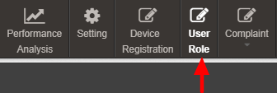

Figure 28 User Role Module

10.1 REGISTER NEW USER

- Register New User

- To register new user, Super Admin has to click on the “Add User” button (pointed in below Figure 29).
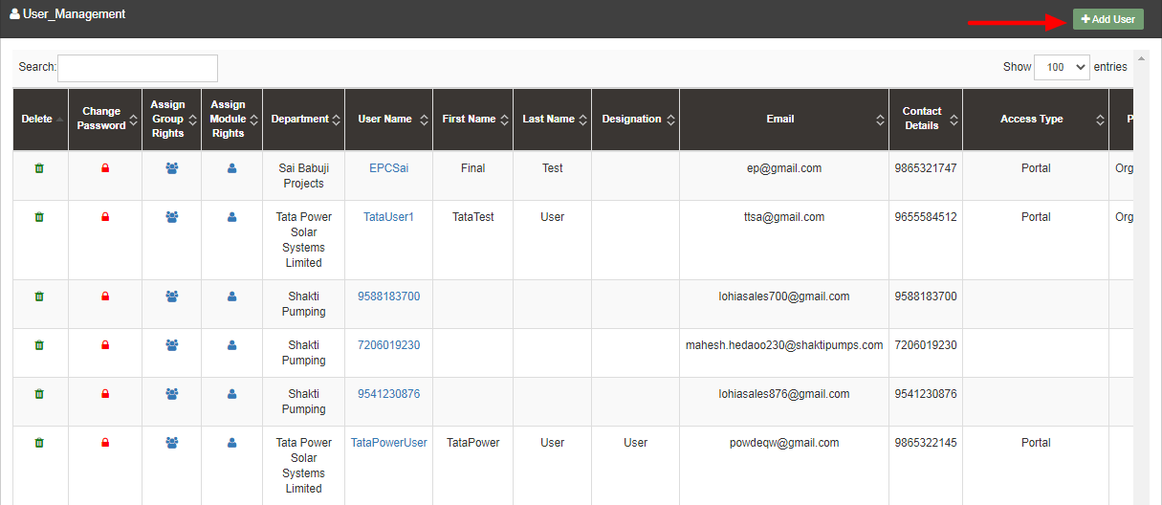

Figure 29 Add User Button on User Role Dashboard

- To register new user, user has to enter two types of following details :
- User Information
- Module Roles

- Add User
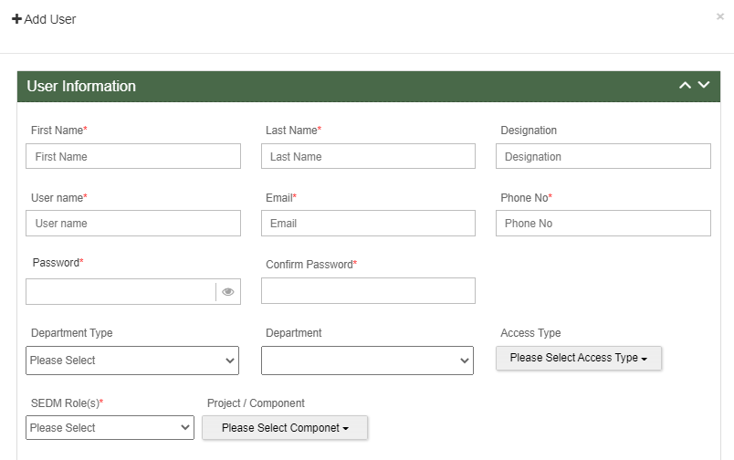
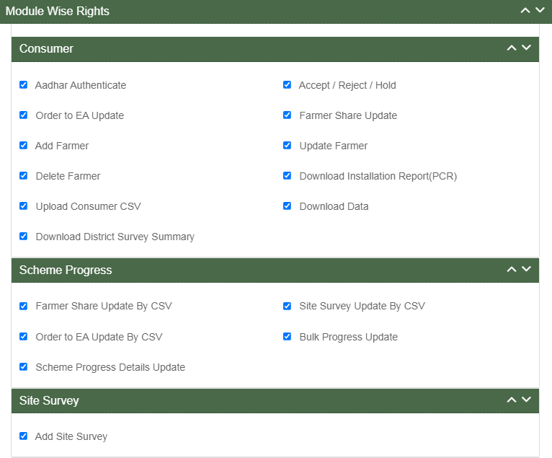

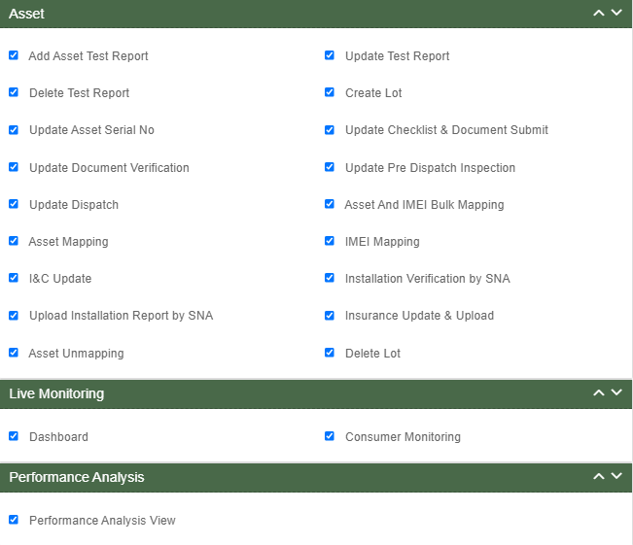
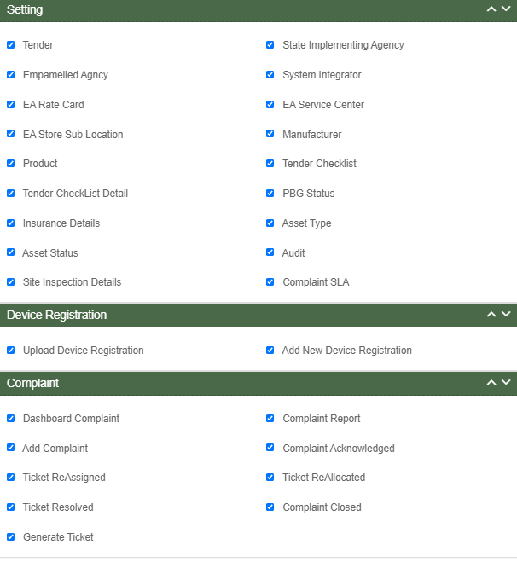

Figure 30 Add User Form

- User Information

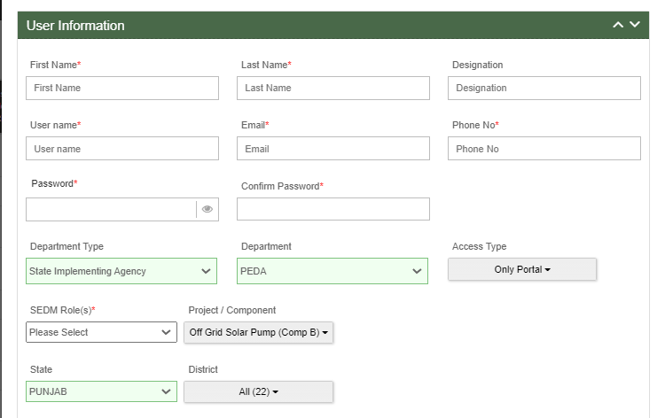
Figure 31 User Information

Table 8 NEW USER REGISTRATION FIELDS DESCRIPTION

Field | Input | Drop Down & Check Box Options | Mandatory Field | Sample Values | Description | Validations
First Name | Text | - |  | Ram | Input first name of the user | -
Last Name | Text | - |  | Sharma | - | -
Designation | Text | - | - | EPC | - | -
Username | Text | - |  | ramsharma | - | -
Email | Email | - |  | ram@gmail.com | - | It must contain :  - Alphabets (a-z) in lower case only  - Digits (0-9) (non mandatory)  - Printable characters ( ! # $ % & ’ * + - / = ? ^ _ ` { } | ~ )  - Symbol “@”  - Domain name (gmail , gov , yahoo)  - A period (.)  - Sub domain name (co.in , com , org)
Phone No | Numerical | - |  | 7458748588 | - | - Must be of 10 digits only
Password | Password | - |  | Ram@123 | - | - Length must be of minimum 8 characters  - 1 or more lowercase character  - 1 or more uppercase character  - 1 special character  - 1 or more numbers
Confirm Password | Password | - |  | Ram@123 | - | - Length must be of minimum 8 characters  - 1 or more lowercase character  - 1 or more uppercase character  - 1 special character  - 1 or more numbers
Department Type | Drop Down | - State Implementing Agency  - Empanelled Agency  - System Integrator |  | Empanelled Agency | Selection of relevant Department as per the requirement. System Integrator is a separate Empanelled agency who installs RMS system separately as required in GJ
Department | Drop Down | - Sai Babuji Project Pvt. Ltd.  - Gautam Solar Pvt. Ltd.  - CRI Pumps Pvt. Ltd.  - Shakti Pumps Ltd.  - Solex Energy Ltd.  - Junna Solar System Pvt. Ltd. |  | Gautam Solar Pvt. Ltd. | Selection of relevant department according to the selected department type. | -
Access Type | Drop Down | - Only Configuration  - Only Portal  - Only Mobile Application |  | Only Portal | Selection of relevant access type as per the requirement. (refer  Table 9 ACCESS TYPE DROP DOWN) | -
User Role(s) | Drop Down | - Super Admin  - Organization Admin  - User |  | Super Admin | Selection of relevant user role as per the requirement. Only Super Admin can create new Super Admin user. | -
State | Drop Down | - STATE  - GUJARAT  - UTTAR PRADESH  - TRIPURA  - UTTAR PRADESH |  | UTTAR PRADESH | Selection of relevant state.  This shall be loaded on the basis of Layer. | -
District | Drop Down | - AGRA  - ALIGARH  - AMBEDAKAR NAGAR  - AMETHI  - AMAROHA  - AURAIYA  - AYODHYA  - AZAMGARH  - BAGHPAT  - BAHRAICH  - BALLIA  - BALARAMPUR  - BANDA  - BARABANKI  - BAREILLI  - BASTI  - BHADOHI  - BIJNOR |  | - BASTI | Select district according to the selected State.  This shall be loaded on the basis of Layer. | -
Project / Component | Drop Down | - Distributed Solar PV – A  - Off Grid Solar Pump – B  - Grid Connected Solar Pump –C |  | Grid Connected Solar Pump –C | Selection of PM-KUSUM Scheme Component | -

Department Type Drop Down | Department Type | Description | Department Drop Down | Description
- State Implementing Agency  - Empanelled Agency  - System Integrator | State Implementing Agency | Selecting this option indicates that the new user will belong from the State Implementing Agency department type. | - STATE IMPLEMENTING AGENCY  - JREDA  - GUVNL  - PEDA | By selecting SIA will provide SIA list to process further as shown in Department Drop Down.
 | Empanelled Agency | Selecting this option indicates that the new user will belong from the Empanelled Agency department type. | - Sai Babuji Project Pvt. Ltd.  - Gautam Solar Pvt. Ltd.  - CRI Pumps Pvt. Ltd.  - Shakti Pumps Ltd.  - Solex Energy Ltd.  - Junna Solar System Pvt. Ltd. | By selecting EA will provide EA list to process further as shown in Department Drop Down.
 | System Integrator | Selecting this option indicates that new user will belong from the System Integrator department type. | - HKRP  - ABCD | By selecting System Integrator will provide System Organization list to process further as shown in Department Drop Down.

Table 9 ACCESS TYPE DROP DOWN

Access Type Drop Down | Option Name | Description
- Only Configuration  - Only Portal  - Only Mobile Application | Only Configuration | This option gives writes to user to access configuration.
 | Only Portal | This option gives writes to user to access Portal.
 | Only Mobile Application | This option gives writes to user to access Mobile Application

Table 10 USER ROLE DROPDOWN

User Role Drop Down | Role | Access | User Creation | Specifications
- Super Admin  - Organization Admin  - User | Super Admin | This user has access of every module of State SEDM Platform. | This user can create “Organization Admin” & “User” and also can provide access to any of all modules. | This user can only register Tender, State Implementing Agency (SIA) and Empanelled Agency (EA).
 |  |  |  | This user can create other Super Admin of SIA only and not of EA.
 | Organization Admin | This user has access to the modules that Super Admin provided. | This user can create other “Organization Admin” and “User” and can provide access to those modules only that he have access of. | This user can create one or more “User” for its own Organization only.
 | User | This user has access to the modules that Super Admin or Organization Admin provided. | This user can neither create any user nor can provide any access. | This user cannot register State Implementing Agency (SIA) & Empanelled Agency (EA) and cannot create any “User”.

- Module Roles

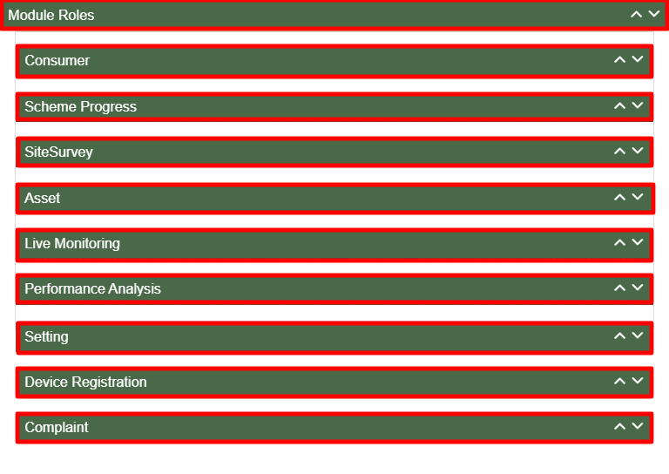

Figure 32 Module Roles

- User has to click anywhere in the red highlighted boxes (as shown in the above Figure 32) to open up the module to provide the access of Functionality to the existing user.
- After opening the module, user has to select the Check Box (highlighted in red in below Figure 33) to choose the access of Functionality for the new user.
- Following are the Functionality, whose access can be decided by the Super Admin / Organization Admin for the new users or existing users :

- Consumer Functionality

Figure 33 Consumer Functionality

Table 11 Consumer Functionality
Consumer Functionality Name | Description
Aadhaar Authenticate | Selecting this Functionality will provide the access to update the developer/beneficiary application status “Aadhaar Authentication”.
Technical Verification | Selecting this Functionality will provide the access to update the developer/beneficiary’s technical details of the site.
Feasible Applications | Selecting this Functionality will provide the access to accept or reject or hold the developer/ beneficiary’s application.
LOA award | Selecting this Functionality will provide the access to update issue of LOA to the beneficiary/developer.
PPA signing | Selecting this Functionality will provide the access to update the PPA agreement between the developer and the DISCOM/SIA
Financial Clearance | Selecting this Functionality will provide the access to update the Financial Clearance between beneficiary/developer and DISCOM/SIA
Update Application | Selecting this Functionality will provide the access to amend the beneficiary/developer application details.
Delete Farmer | Selecting this Functionality will provide the access to delete the beneficiary/developer application.

- Scheme Progress

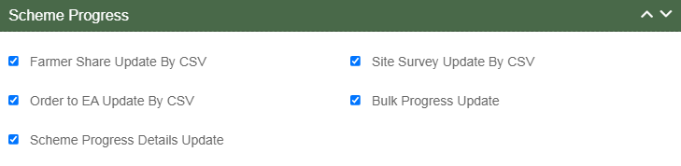

Figure 34 Scheme Progress Functionality

- Site Survey Functionality

Figure 35 Site Survey Functionality

Table 13 Site Survey Functionality

Site Survey Functionality Name | Description
Add Site Survey | Selecting this Functionality will provide the access to Site Survey Mobile Application update the consumer/farmer application status “Site Survey” via Site Survey.

- Asset Functionality

Figure 36 Asset Functionality

- Live Monitoring Functionality

Figure 37 Live Monitoring Functionality

Table 15 Live Monitoring Functionality
Live Monitoring Functionality Name | Description
Dashboard | Selecting this Functionality will provide the access Live Monitoring Dashboard
Consumer Monitoring | Selecting this Functionality will provide the access of consumer monitoring in which user can monitor RMS data, map individual Asset Serial no. and IMEI nos., update I&C Done status and I&C Verification and Insurance

- Device registration Functionality

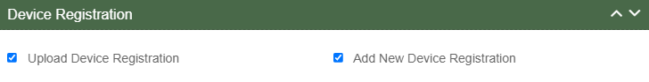

Figure 38 Device Registration Functionality

Table 16 Device Registration Functionality

Device Registration Functionality Name | Description
Upload Device Registration | Selecting this Functionality will provide the access to register Device IMEI numbers in bulk by uploading a CSV file.
Add New Device Registration | Selecting this Functionality will provide the access to register a Device IMEI number.

- Complaint Sub Modules

Figure 39 Complaint Sub Modules

Table 17 Complaint Functionality

Complaint Sub Module Name | Description
Dashboard Complaint | Selecting this sub module will provide the access to the Complaint Dashboard
Add Complaint | Selecting this sub module will provide the access to register a new complaint
Ticket Reassigned | Selecting this sub module will provide the access to reassign the ticket to user within the organization
Ticket Resolved | Selecting this sub module will provide the access to update the Complaint Status “Resolved”
Generate Ticket | Selecting this sub module will provide the access to generate the ticket for a complaint
Complaint Report | Selecting this sub module will provide the access to the Complaint Reports
Complaint Acknowledge | Selecting this sub module will provide the access to update the Complaint Status “Acknowledge”
Ticket Reallocated | Selecting this sub module will provide the access to reallocate the ticket to organization (SIA / EA)
Complaint Closed | Selecting this sub module will provide the access to close the complaint

- User has to select the check box corresponding to the Functionality as shown in above figures.
- After selection of the Functionality, Super Admin can create new user role and can also provide access to modules and Functionality to the new user. (Refer “User Role” drop down in New User Registration form - Figure 31)

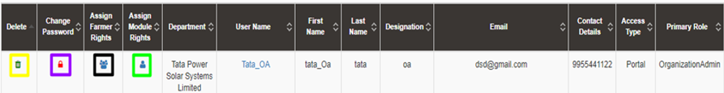
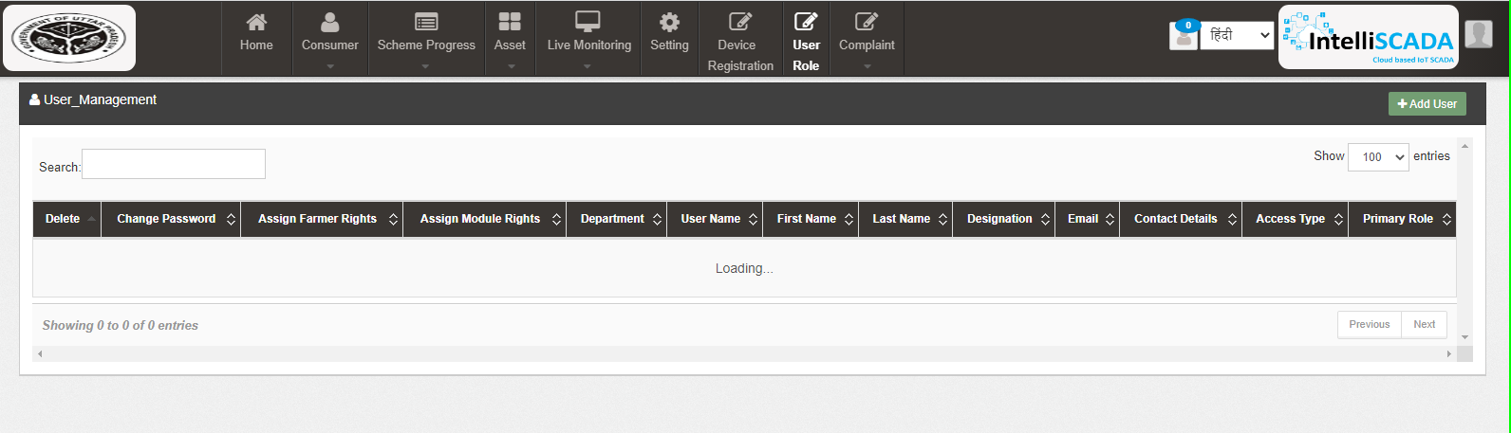

Figure 40 User Role Dashboard

Table 18 USER ROLE DASHBOARD DESCRIPTION
Action | Functionality | Highlighted Colour | Type | Description
Search | Search User | Blue | Text Box | Enter input to explore User details
Add User | Create New User | Red | Button | Create New User by clicking on Add User button
Delete Icon | Delete User | Yellow | Icon Button | Click on delete green icon button to Delete User details
Change Password Icon | Change Password | Purple | Icon Button | Click Change password red icon to change password
Assign Farmer Rights | Farmer wise Access | Black | Icon Button | This functionality will provide access to the user to view the data of RMS system of allowed/mapped farmers
Assign Module Rights | Edit Module Rights | Green | Icon Button | Using this option organization admin can modify User Rights.

- Change Password

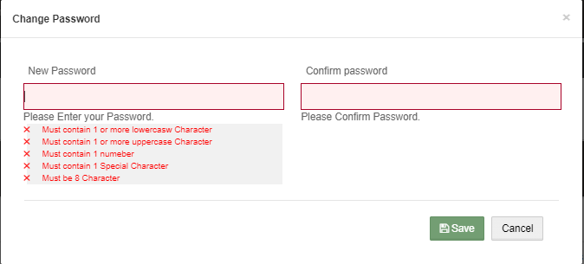

Figure 41 Change Password Screen

- User has to enter “New password” and “Confirm password” as shown in above Figure 41.
- Assign Farmer Rights

- By clicking on the icon of “Assign Farmer Rights” (highlighted in black in Figure 40), Super Admin / Organization admin can provide access to the user to view the data of RMS System mapped with the selected farmers. (window screen for the same shown below in Figure 42)

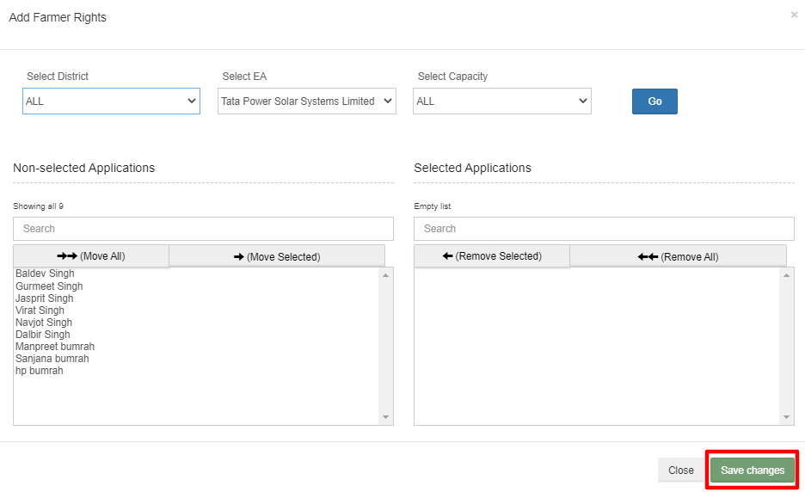

Figure 42 Assign Farmer Rights

- By moving beneficiary from Non-Selected Applications to Selected Applications, that particular user will get the access to view the RMS data of the selected Applications.
- User can update the module and Functionality access of any particular existing user by clicking on the user icon. (highlighted in green in Figure 40)
- After clicking on user icon, a Screen will occur for the editing the access of the Functionality. (as shown in below Figure 43)
Figure 43 User Role Module Selection Screen

- MASTER SETTINGS (CONFIGURATIONS)

- SIA with Super Admin credentials can add or update several following settings :
- DISCOM
- District
- Taluka
- Circle
- Divisiom
- Sub Division
- Sub Station
- Site Inspection Details

- These updates can be performed in the “Setting” module.

- Navigation Step :-
- Sign in on the State SEDM Portal
- Click on the Setting Module

Figure 44 Setting Module

11.1. REGISTRATION OF TENDER

- Registering New Tender
- Super Admin can register New Discom by clicking on “Discom” tab as pointed in below Figure 45.
- New Tender will belong from either of three components i.e. Distributed Solar PV - A, Off Grid Solar Pump - B and Grid Connected Solar Pump - C.

- Navigation Step :-
- Sign in on the State SEDM Portal
- Click on the Setting Module
- Click on Tender Tab

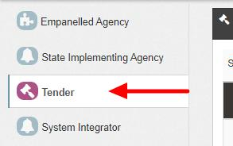

Figure 45 Tender Tab

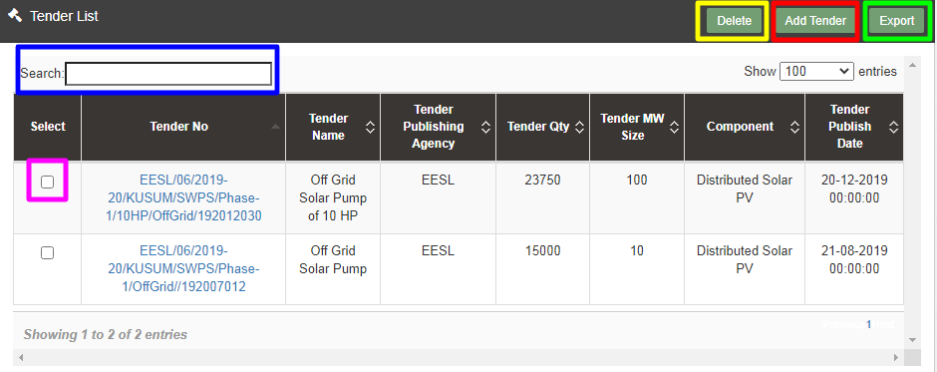

Figure 46 Tender Tab Dashboard

Table 19 TENDER DASHBOARD EXPLANATION
Action | Functionality | Highlighted Colour | Type | Description
Search | Search Tender | Blue | Text Box | Enter input to explore Tender details
Delete | Delete Tender | Yellow | Button | Select check box (highlighted in pink) and click on delete button to Delete Tender details
Add Tender | Register new Tender | Red | Button | Register new Tender by clicking on Add Tender button
Export | CSV file for Tender details | Green | Button | Download CSV file of Tender details

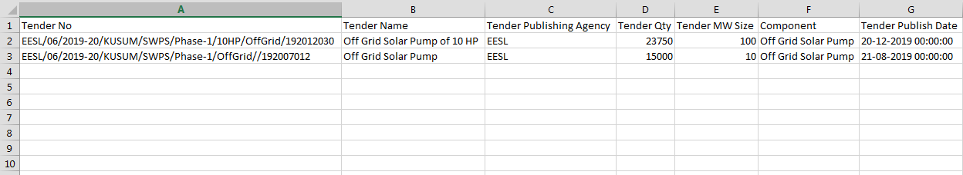

Figure 47 CSV of Tender Details

- User can register new Tender by clicking on “Add Tender” button. (highlighted in red in Figure 46)

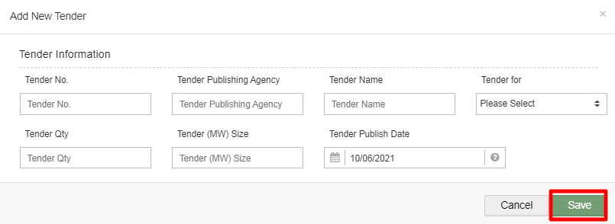

Figure 48 New Tender Details

Table 20 TENDER REGISTRATION FIELDS DESCRIPTION
Field | Input | Drop Down & Check Box Options | Mandatory Field | Sample Values | Description
Tender No. | Numerical | - |  | EESL/06/2019-20/KUSUM/SWPS/Phase-1/10HP/OffGrid/192012030 | -
Tender Publishing Agency | Text | - |  | EESL | -
Tender Name | Text | - |  | Off Grid Solar Pump of 10 HP | -
Tender for | Drop Down | - Distributed Solar PV  - Off Grid Solar Pump  - Grid Connected Solar Pump |  | Grid Connected Solar Pump | Selection of relevant Tender as per the requirement.
Tender Qty | Numerical | - |  | 23750 | -
Tender (MW) Size | Numerical | - |  | 100 | -
Tender Publish Date | Date | - |  | 22/12/2019 | -

- After filling all the details, user has to click on the “Save” button (highlighted in red in above Figure 48) to register New Tender.

11.2. EA RATE CARD

- EA Rate Card includes Central/State/Farmer Contribution as the subsidy to the Farmer’s total cost of the Solar Pump.
- It gives information of the total cost of the Solar Pump in “Rs.” and in “%” divided between Central Government, State Government and the Consumer/Farmer.
- Super Admin can update these information in the “Setting” module.

- Navigation Step :-
- Sign in on the State SEDM Portal
- Click on the Setting Module
- Click on EA Rate Card Tab

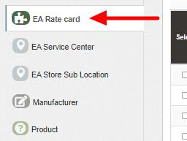

Figure 49 EA Rate Card Tab
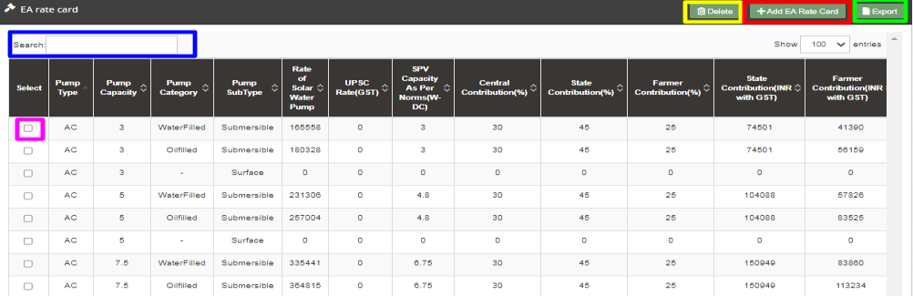

Figure 50 EA Rate Card Dashboard

Table 21 EA RATE CARD DASHBOARD EXPLANATION
Action | Functionality | Highlighted Colour | Type | Description
Search | Search EA Rate Card | Blue | Text Box | Enter input to explore EA Rate Card details
Delete | Delete EA Rate Card | Yellow | Button | Select check box (highlighted in pink) and click on delete button to Delete EA Rate Card details
Add EA Rate Card | Add new EA Rate Card | Red | Button | Register new EA Rate Card by clicking on Add EA Rate Card Sub Location button
Export | CSV file for EA Rate Card details | Green | Button | Download CSV file of EA Rate Card details

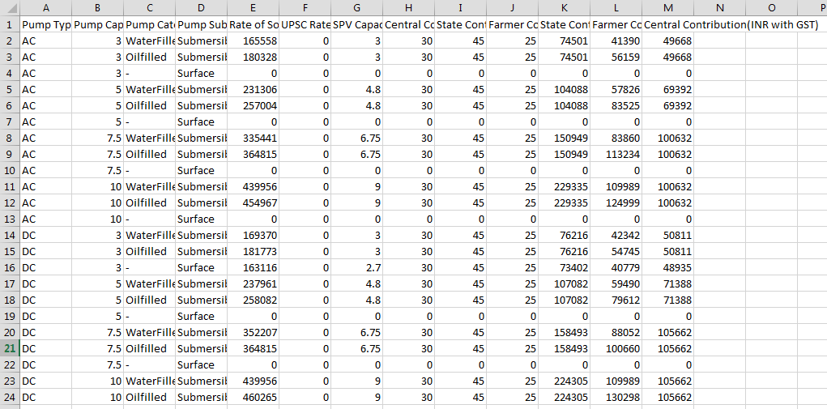
Figure 51 CSV of EA Rate Card Details Figure

- User can add new EA Rate Card by clicking on “Add EA Rate Card” button. (highlighted in red in Figure 50)
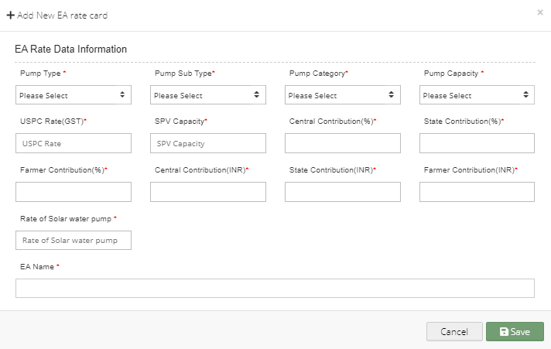
Figure 52 New EA Rate Card Details

Table 22 EA RATE CARD REGISTRATION FIELDS DESCRIPTION
Field | Input | Drop Down & Check Box Options | Mandatory Field | Sample Values | Description
Pump Type | Text | - AC  - DC |  | AC | Selection of the Pump Type
Pump Sub Type | Drop Down | - Submersible  - Surface |  | Submersible | Selection of the Pump Sub Type
Pump Category | Drop Down | - Oil Filled  - Water Filled |  | Water Filled | Selection of the Pump Category
Pump Capacity | Drop Down | - 1 HP  - 2 HP  - 3 HP  - 5 HP  - 7.5 HP  - 10 HP |  | 5 HP | Selection of the Pump Capacity
USPC Rate (GST) | Numerical | - |  | 0 | -
SPV Capacity | Numerical | - |  | 3 | -
Central Contribution (%) | Numerical | - |  | 30 | -
State Contribution (%) | Numerical | - |  | 45 | -
Farmer Contribution (%) | Numerical | - |  | 25 | -
Central Contribution (INR) | Numerical | - |  | 49668 | -
State Contribution (INR) | Numerical | - |  | 74501 | -
Farmer Contribution (INR) | Numerical | - |  | 41930 | -
Rate of Solar Water Pump | Numerical | - |  | 16558 | -
EA Name | Drop Down | - Sai Babuji Project Pvt. Ltd.  - Gautam Solar Pvt. Ltd.  - CRI Pumps Pvt. Ltd.  - Shakti Pumps Ltd.  - Solex Energy Ltd.  - Junna Solar System Pvt. Ltd. |  | Sai Babuji Project Pvt. Ltd | Selection of the relevant Empanelled Agency

- After filling all the details, user has to click on the “Save” button (highlighted in red in above Figure 52) to register New EA Rate Card.

11.3. REGISTRATION OF EA STORE SUB LOCATION

- EA Store Sub Location is the location of the Empanelled Agency where the assets are inspected and stored.
- Super Admin can register EA Store Sub Location Details by clicking on “EA Store Sub Location” tab as pointed in below Figure 53.
- SIA with Super Admin credentials needs to be collect the store location details from Empanelled agencies and then register the store sub-location details here.

- Navigation Step :-
- Sign in on the State SEDM Portal
- Click on the Setting Module
- Click on EA Store Sub Location Tab

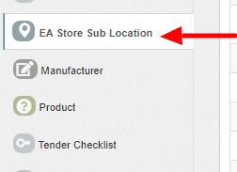

Figure 53 EA Store Sub Location Tab

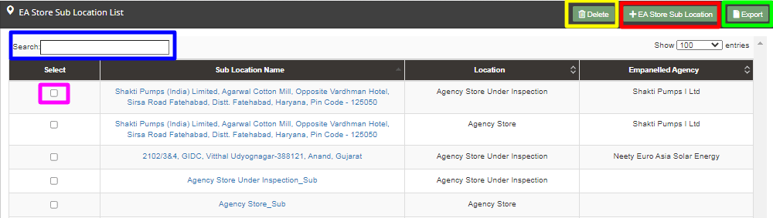

Figure 54 EA Store Sub Location Dashboard

Table 23 EA STORE SUB LOCATION DASHBOARD EXPLANATION
Action | Functionality | Highlighted Colour | Type | Description
Search | Search EA Store Sub Location | Blue | Text Box | Enter input to explore EA Store Sub Location details
Delete | Delete EA Store Sub Location | Yellow | Button | Select check box (highlighted in pink) and click on delete button to Delete EA Store Sub Location details
Add EA Store Sub Location | Register new EA Store Sub Location | Red | Button | Register new EA Store Sub Location by clicking on Add EA Store Sub Location button
Export | CSV file for EA Store Sub Location details | Green | Button | Download CSV file of EA Store Sub Location details

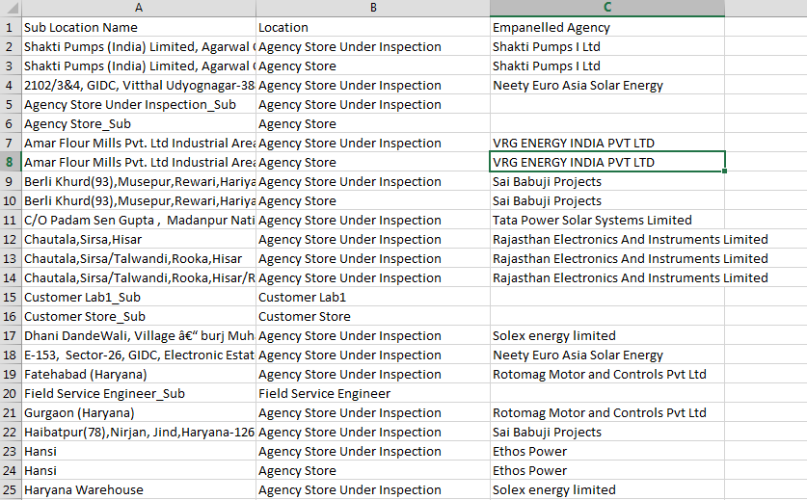

Figure 55 CSV of EA Store Sub Location Details

- User can register new EA Store Sub Location by clicking on “Add EA Store Sub Location” button. (highlighted in red in Figure 54)

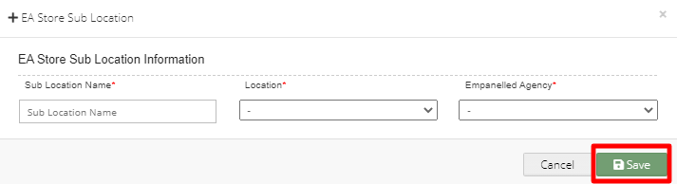
Figure 56 New EA Store Sub Location Details

Table 24 EA STORE SUB LOCATION REGISTRATION FIELDS DESCRIPTION
Field | Input | Drop Down & Check Box Options | Mandatory Field | Sample Values | Description
Sub Location Name | Text | - |  | Agency Store Sub | -
Location | Drop Down | - Field Service Engineer  - Agency Store Under Inspection  - Agency Store  - Manufacturer Store  - Manufacturer Service |  | Agency Store Under Inspection | Selection of relevant Location
Empanelled Agency | Drop Down | - Sai Babuji Project Pvt. Ltd.  - Gautam Solar Pvt. Ltd.  - CRI Pumps Pvt. Ltd.  - Shakti Pumps Ltd.  - Solex Energy Ltd.  - Junna Solar System Pvt. Ltd. |  | Gautam Solar Pvt. Ltd. | Selection of relevant Empanelled Agency

- After filling all the details, user has to click on the “Save” button (highlighted in red in above Figure 56) to register New EA Store Sub Location.

11.4. REGISTRATION OF MANUFACTURER DETAILS

- Super Admin can register Manufacturer Details by clicking on “Manufacturer” tab as pointed in below Figure 57.
- Manufacturer registration serves the purpose as the manufacturer of the assets i.e. Solar Pump, Solar Panel, Pump Controller, Structure, RMS, etc.
- Manufacturer need to be added while creation of Asset Test Report along with the product details which will be further used in Lot creation. (click here to know more)

- Navigation Step :-
- Sign in on the State SEDM Portal
- Click on the Setting Module
- Click on Manufacturer Tab

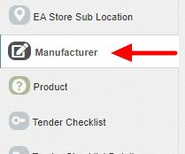

Figure 57 Manufacturer Tab

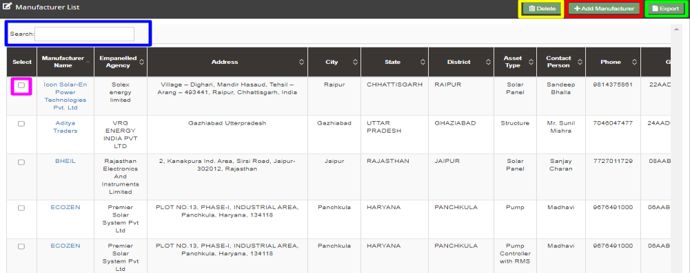

Figure 58 Manufacturer Tab Dashboard

Table 25 MANUFACTURER DASHBOARD EXPLANATION
Action | Functionality | Highlighted Colour | Type | Description
Search | Search Manufacturer | Blue | Text Box | Enter input to explore Manufacturer details
Delete | Delete Manufacturer | Yellow | Button | Select check box (highlighted in pink) and click on delete button to Delete Manufacturer details
Add Manufacturer | Register new Manufacturer | Red | Button | Register new Manufacturer by clicking on Add Manufacturer button
Export | CSV file for Manufacturer details | Green | Button | Download CSV file of Manufacturer details

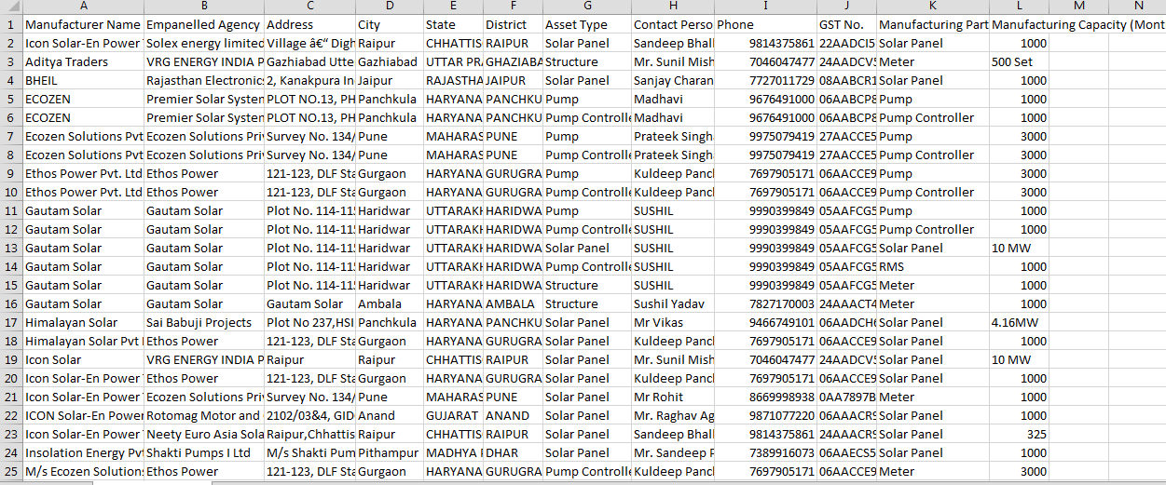
Figure 59 CSV of Manufacturer Details
- User can register new Manufacturer by clicking on “Add Manufacturer” button. (highlighted in red in Figure 58)

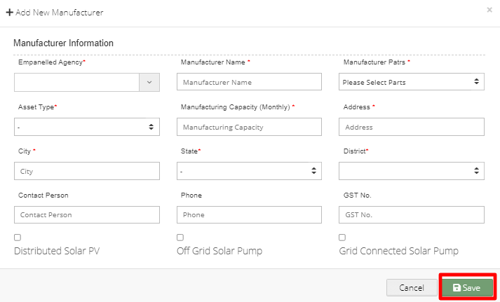

Figure 60 New Manufacturer Details

Table 26 MANUFACTURER REGISTRATION FIELDS DESCRIPTION
Field | Input | Drop Down & Check Box Options | Mandatory Field | Sample Values | Description | Validations
Empanelled Agency | Drop Down | - Sai Babuji Project Pvt. Ltd.  - Sri Savitri Solar Pvt. Ltd.  - Gautam Solar Pvt. Ltd.  - CRI Pumps Pvt. Ltd.  - Shakti Pumps Ltd.  - Solex Energy Ltd.  - Junna Solar System Pvt. Ltd. |  | Sri Savitri Solar Pvt. Ltd. | Selection of relevant Empanelled Agency | -
Manufacturer name | Text | - |  | M/s. Sri Savitr Solar Pvt. Ltd. | - | -
Manufacturer Parts | Drop Down | - Solar Panel  - Inverter  - Pump Controller  - Pump  - RMS  - Meter |  | Solar Panel | Selection of the manufacturer parts of the assets | -
Asset Type | Drop Down | - Pump  - Solar Panel  - Pump Controller with RMS  - Structure |  | Solar Panel | Selection of relevant asset type that the manufacturer is manufacturing. | -
Manufacturer Capacity (Monthly) | Numerical | - |  | 320 | - | -
Address | Text | - |  | Plot No. 34/1, Survey No. 374, CIE Phase II, Gandhinagar | - | -
City | Text | - |  | Hyderabad | - | -
State | Drop Down | - STATE  - GUJARAT  - UTTAR PRADESH  - TRIPURA |  |  | Selection of the relevant State from where the manufacture belong from | -
District | Drop Down | AGRA  - ALIGARH  - AMBEDAKAR NAGAR  - AMETHI  - AMAROHA  - AURAIYA  - AYODHYA  - AZAMGARH  - BAGHPAT  - BAHRAICH  - BALLIA  - BALARAMPUR  - BANDA  - BARABANKI  - BAREILLI  - BASTI  - BHADOHI  - BIJNOR |  | ALIGARH | Selection of the relevant district from where the manufacture belong from | -
Contact Person | Text | - |  | Mr.Sudhir Kant Gir | - | -
Phone | Numerical | - |  | 9949033677 | - | - Must be of 10 digits only
GST No. | Text | - |  | 36AAQCS0838P4Z7 | - | - It must be of 15 digits only  - First two digits should be the state code  - Next ten digits should be the PAN number of the person or business entity  - The thirteenth is alpha-numeric digit (1-9 or A-Z)  - The fourteenth digit will be the alphabet “Z” by default  - The last digit should be any number (1-9)
Component | Radio Button | - Distributed Solar PV (A)  - Off Grid Solar Pump (B)  - Grid Connected Solar Pump (C) |  | Grid Connected Solar Pump (C) | - | -

- After filling all the details, user has to click on the “Save” button (highlighted in red in above Figure 60) to register New Manufacturer.

11.5. REGISTRATION OF PRODUCT DETAILS

- Product details corresponding to Manufacturer and Empanelled Agency need to be added while creation of Asset Test Report which will be further added in Lot creation. (click here to know more)
- Super Admin can register new Product Details by clicking on “Product” tab as pointed in below Figure 61.

- Navigation Step :-
- Sign in on the State SEDM Portal
- Click on the Setting Module
- Click on Product Tab

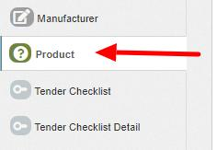
Figure 61 Product Tab

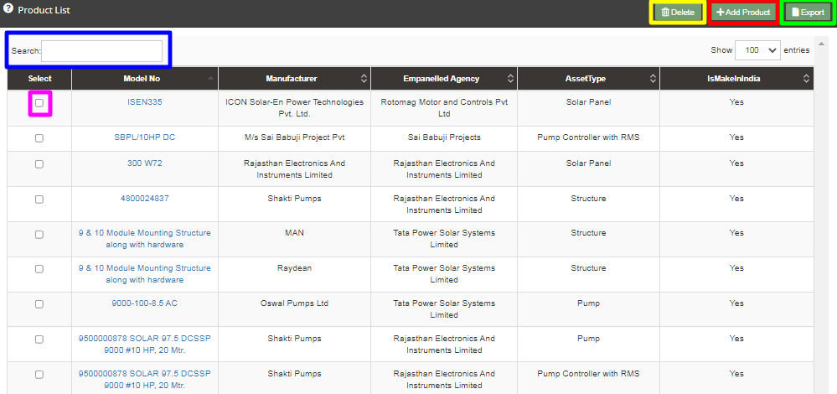

Figure 62 Product Tab Dashboard

Table 27 PRODUCT DASHBOARD EXPLANATION
Action | Functionality | Highlighted Colour | Type | Description
Search | Search Product | Blue | Text Box | Enter input to explore Product details
Delete | Delete Product | Yellow | Button | Select check box (highlighted in pink) and click on delete button to Delete Product details
Add Product | Register new Product | Red | Button | Register new Product by clicking on Add Product button
Export | CSV file for Product details | Green | Button | Download CSV file of Product details

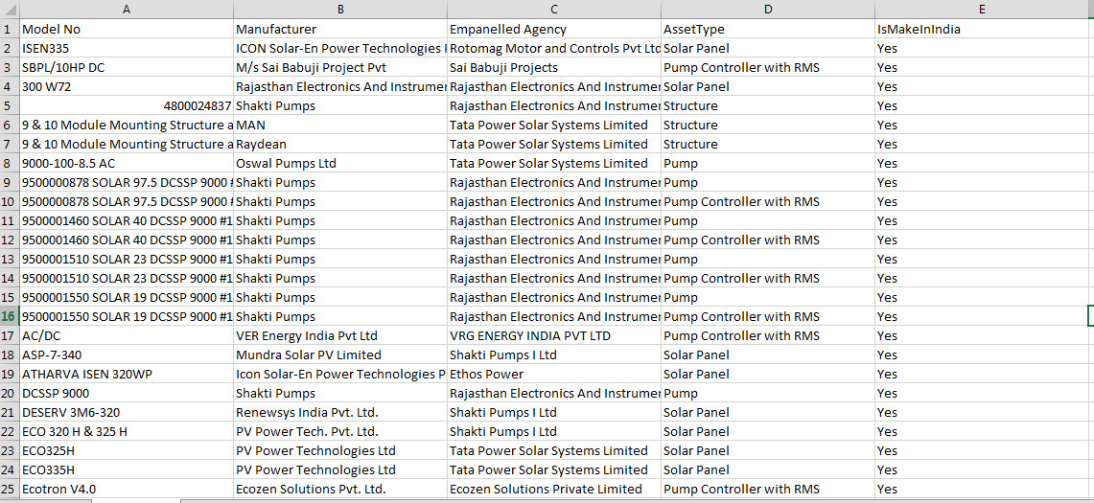
Figure 63 CSV of Product Details

- User can register new Product by clicking on “Add Product” button. (highlighted in red in Figure 62)

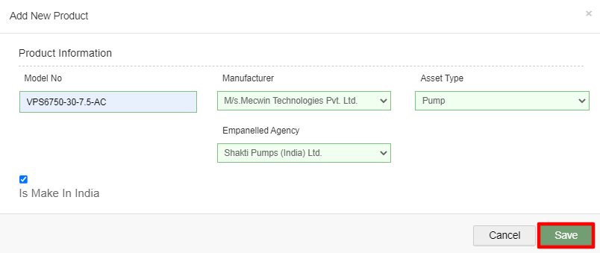

Figure 64 New Product Details

Table 28 PRODUCT REGISTRATION FIELDS DESCRIPTION
Field | Input | Drop Down & Check Box Options | Mandatory Field | Sample Values | Description
Model No. | Text | - |  | VPS6750-30-7.5-AC | -
Empanelled Agency | Drop Down | - Sai Babuji Project Pvt. Ltd.  - Sri Savitri Solar Pvt. Ltd  - Gautam Solar Pvt. Ltd.  - CRI Pumps Pvt. Ltd.  - Shakti Pumps Ltd.  - Solex Energy Ltd.  - Junna Solar System Pvt. Ltd. |  | Shakti Pumps (Idnia) Ltd. | Selection of relevant Empanelled Agency
Manufacturer | Drop Down | - Alectrona  - BHEIL  - Ethos Power Pvt. Ltd  - M/s. Sri Savitri Solar Pvt. Ltd |  | M/s Mecwin Technologies Pvt Ltd | Selection of the relevant manufacturer of the product
Asset | Drop Down | - Pump  - Solar Panel  - Pump Controller with RMS  - Structure |  | Pump | Selection of the asset type
Is Make In India | Check Box | - |  | - | Selecting this Check Box conveys that product is made in India

- After filling all the details, user has to click on the “Save” button (highlighted in red in above Figure 64) to register New Product.

11.6. REGISTRATION OF TENDER CHECKLIST

- Tender Checklist is a template consisting of tender checklist items which acts similar to “guaranteed technical particulars (GTP)” and filled by empanelled agencies as self-declaration of compliance to tender specifications during lot creation and verified by the State Implementing Agency after the lot creation. (click here to know more)
- SIA with Super Admin credentials can register new Tender Checklist by clicking on “Tender Checklist” tab as pointed in below Figure 65.
- Navigation Step :-
- Sign in on the State SEDM Portal
- Click on the Setting Module
- Click on Tender Checklist Tab

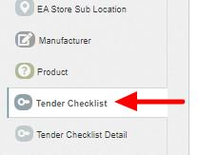

Figure 65 Tender Checklist Tab

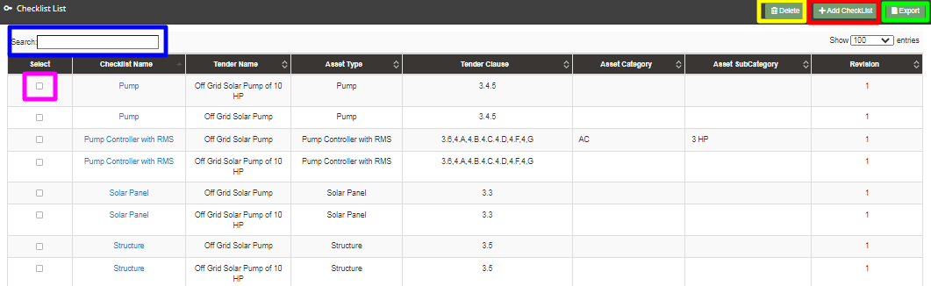

Figure 66 Tender Checklist Tab Dashboard

Table 29 TENDER CHECKLIST DASHBOARD EXPLANATION
Action | Functionality | Highlighted Colour | Type | Description
Search | Search Tender Checklist | Blue | Text Box | Enter input to explore Tender Checklist
Delete | Delete Tender Checklist | Yellow | Button | Select check box (highlighted in pink) and click on delete button to Delete Tender Checklist
Add Checklist | Register new Tender Checklist | Red | Button | Register new Tender Checklist by clicking on Add Checklist button.
Export | CSV file for Tender Checklist | Green | Button | Download CSV file of Tender Checklist

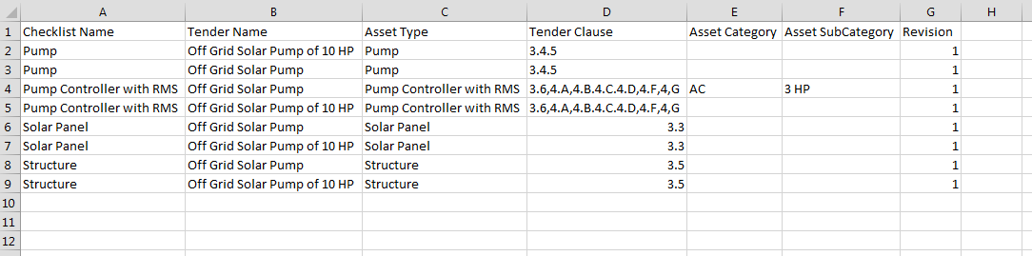
Figure 67 CSV of Tender Checklist

- User can register new Tender Checklist by clicking on “Add Checklist” button. (highlighted in red in Figure 66)

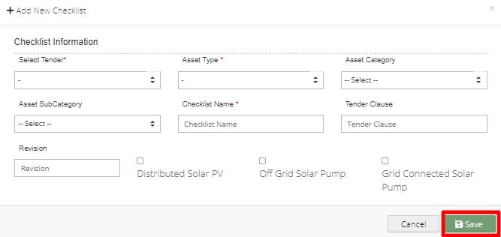

Figure 68 New Checklist Details

Table 30 TENDER CHECKLIST REGISTRATION FIELDS DESCRIPTION
Field | Input | Drop Down & Check Box Options | Mandatory Field | Sample Values | Description
Select Tender | Drop Down | - Off Grid Solar Pump  - Off Grid Solar Pump of 10 HP |  | Off Grid Solar Pump  . | Selection of relevant Tender
Asset Type | Drop Down | - Pump  - Solar Panel  - Pump Controller with RMS  - Structure  - USPC |  | Pump | Selection of the relevant asset type
Asset Category | Drop Down | - AC  - DC |  | AC | Selection of the relevant asset category
Asset Sub Category | Drop Down | - 1 HP  - 2 HP  - 3 HP  - 5 HP  - 7.5 HP  - 10 HP |  | 3 HP | Selection of the relevant asset sub category
Checklist Name | Text | - |  | Pump | Name for identification of checklist
Tender Clause | Text | - |  | - | Reference tender clause of corresponding tender
Revision | Text | - | - | - | Change in tender specifications can be tracked using revision
Component | Radio Button | - Distributed Solar PV (A)  - Off Grid Solar Pump (B)  - Grid Connected Solar Pump (C) |  | Grid Connected Solar Pump (C) | Select PM-KUSUM Component

- After filling all the details, user has to click on the “Save” button (highlighted in red in above Figure 68) to register New Checklist.

11.7. REGISTRATION OF TENDER CHECKLIST DETAILS

- Tender Checklist Details is an individual checklist item which corresponds to tender specification/requirement. Empanelled agencies declare their compliance/deviation against ideal response. (click here to know more)
- Super Admin can register new Tender Checklist Template by clicking on “Tender Checklist Detail” tab as pointed in below Figure 69.

- Navigation Step :-
- Sign in on the State SEDM Portal
- Click on the Setting Module
- Click on Tender Checklist Detail Tab

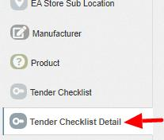

Figure 69 Tender Checklist Detail Tab

- By clicking on the Tender Checklist Detail tab, a drop down will occur on the screen as shown in below figure, to select the Tender Checklist Name which was added in the “Tender Checklist” tab.

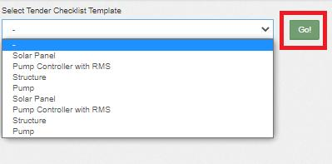
Figure 70 Select Tender Checklist Template
- After selecting the tender checklist template, user can see the Tender Checklist Template dashboard as shown below.

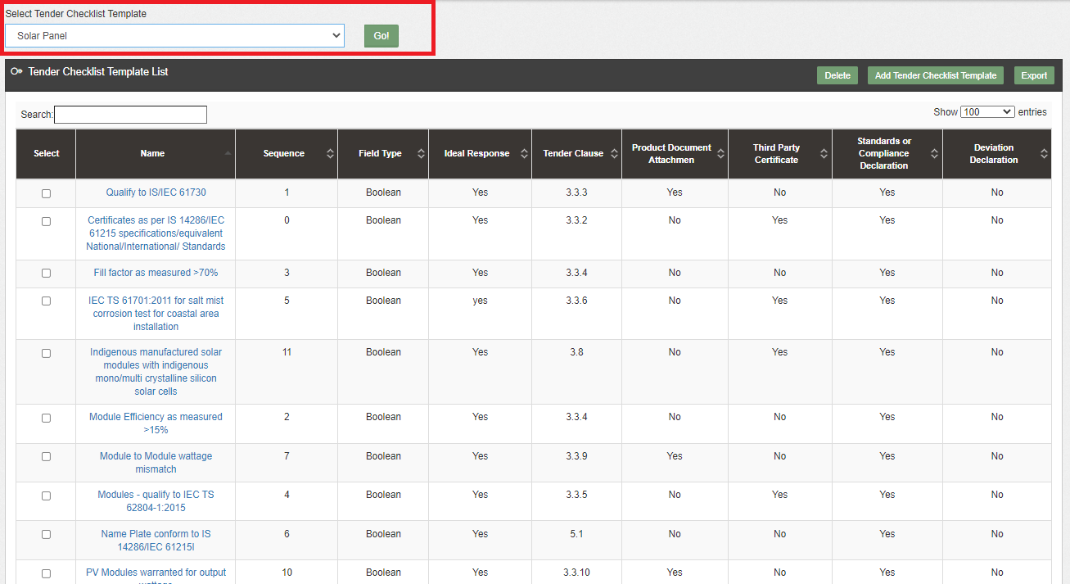
Figure 71 Tender Checklist Template Dashboard

Table 31 TENDER CHECKLIST Template DASHBOARD EXPLANATION
Action | Functionality | Highlighted Colour | Type | Description
Search | Search Tender Checklist Template | Blue | Text Box | Enter input to explore Tender Checklist Template
Delete | Delete Tender Checklist Template | Yellow | Button | Select check box (highlighted in pink) and click on delete button to Delete Tender Checklist Template
Add Tender Checklist Template | Register new Tender Checklist Template | Red | Button | Register new Tender Checklist Template by clicking on Add Tender Checklist Template button
Export | CSV file for Tender Checklist Template | Green | Button | Download CSV file of Tender Checklist Template

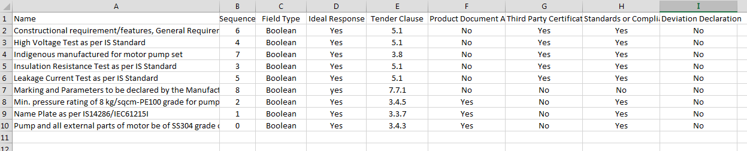

Figure 72 CSV of Tender Checklist Template

- User can register new Tender Checklist Template by clicking on “Add Tender Checklist Template” button. (highlighted in red in Figure 71)
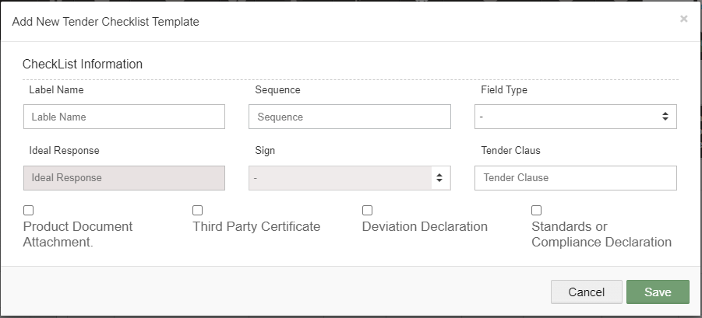
73 New Tender Checklist Details

Table 32 TENDER CHECKLIST TEMPLATE REGISTRATION FIELDS DESCRIPTION
Field | Input | Drop Down & Check Box Options | Mandatory Field | Sample Values | Description
Label Name | Text | - | - | Constructional requirement/features, General Requirements, Design features. | Identifier name to be given against checklist item
Sequence | Numerical | - |  | 6 | Input the sequence number where this checklist item is to be displayed. Display of the checklist item shall be ordered by sequence
Field Type | Drop Down | - Boolean  - String  - Drop Down  - Number | - | Boolean | Selection of the relevant field type of the tender checklist template
Ideal Response | Text | - | - | Yes | Input the ideal response value expected against this checklist item
Sign | Drop Down | - | - | - | Select the sign as per expectation of ideal response
Tender Clause | Numerical | - |  | 5.1 | Reference tender clause of corresponding tender
Additional required Input details against checklist item | Check Box | - Product Document Attachment  - Third Party Certificate  - Deviation Declaration  - Standard or Compliance Declaration | - | - Third Certificate  - Standard or Compliance Declaration | User need to submit corresponding documents/declaration as per selection

- After filling all the details, user has to click on the “Save” button (highlighted in red in above) to register New Tender Checklist Template.

11.8. AUDIT TRAIL

- Audit Trail serves the purpose to store the details of the person that make last update on State SEDM Platform.
- SIA with Super Admin credentials can view the audit trail in “Setting” Menu.

- Navigation Step :-
- Sign in on the State SEDM Portal
- Click on the Setting Module
- Click on Audit Tab

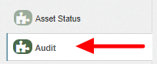
Figure 74 Audit Tab

- By clicking on the Audit tab, the screen along with three filters i.e. Select District, Select Space (modules) and date range will appear as shown in below Figure 75.

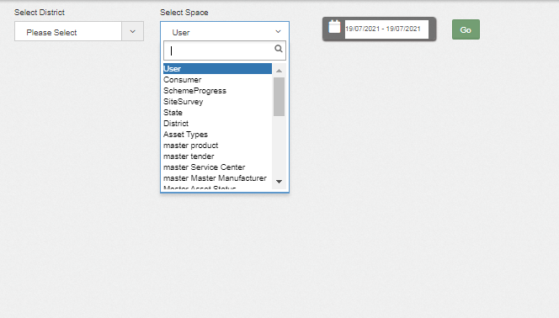

Figure 75 Audit Tab Filters

- By selecting any particular district and Space (modules) against the selected district and date range, Super Admin can get the details about last updates made in particular selected Space (module) as shown in below Figure 76.

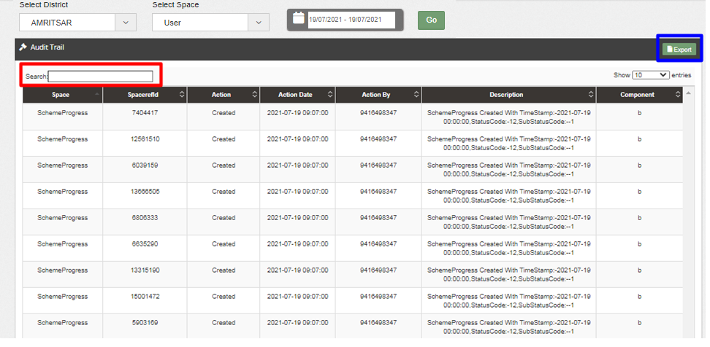

Figure 76 Audit Dashboard (Applied Filters)

- As shown in above Figure 76, filtered dashboard by selecting District : Amritsar, Space : Scheme Progress and date range, one can find details like the person’s registered username (shown as phone numbers in above Figure 76) who had made updates in scheme progress, the date on which updates was made, the action he made while updating Scheme Progress, etc.
- User can search for specific detail by entering input in “Search” box. (highlighted in red in Figure 76)
- User can download a csv file (refer Figure 77) of filtered Audit details by clicking on export button. (highlighted in blue in Figure 76)

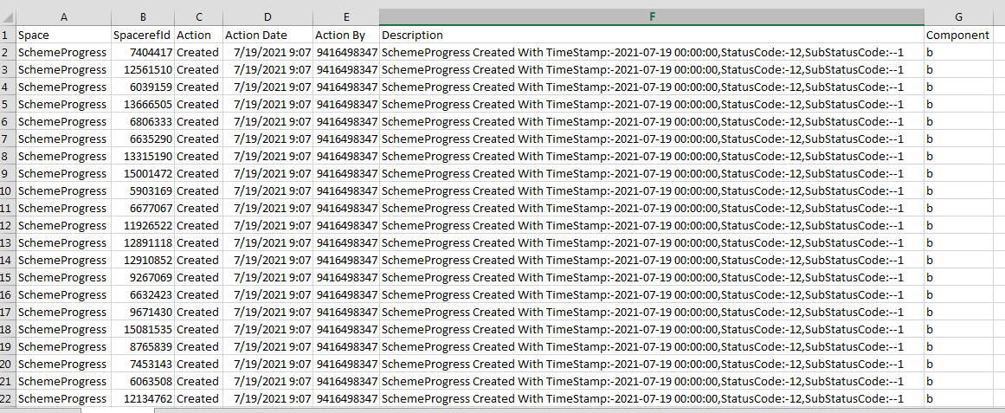

Figure 77 Audit Details – CSV File

APPLICATION WORKFLOW STAGES

- List of Responsible Users Of TN SEDM Portal who will be responsible for the below mentioned Workflow Stages :
  - Sub Division Officer (SDN)
  - Head Officer (HO)
  - Empanelled Agency (EA)

Table 33 FARMER APPLICATION WORKFLOW STAGES

Workflow Stages  (Clickable Links) | Description | Responsibility
Application Received | When a plant application is registered, Application Registration stage will be affected. | SIA/SNA/DISCOM
Authentication | When document of a plant or developer is verified, Authentication stage will be affected. | SIA/SNA/DISCOM
Aadhar Verification | When Aadhaar is verified by the SIA/SNA/DISCOM | SIA/SNA/DISCOM
Technical Verification | When the technical details of the site are captured and updated on the portal. | SIA/SNA/DISCOM
Feasible Application | When the authorized person approve the developer’s application, Feasible Application stage will be affected. | SIA/SNA/DISCOM
LOA award | Selecting this Functionality will provide the access to update issue of LOA to the beneficiary/developer. | SIA/SNA/DISCOM
PPA signing | Selecting this Functionality will provide the access to update the PPA agreement between the developer and the DISCOM/SIA | SIA/SNA/DISCOM
Financial Clearance | Selecting this Functionality will provide the access to update the Financial Clearance between beneficiary/developer and DISCOM/SIA | SIA/SNA/DISCOM
I&C Done | When the site is functional, SIA/SNA/DISCOM will update the I&C stage from the portal. | SIA/SNA/DISCOM
Electrical Inspector Certificate Received | This stage will be updated after clearance from Electrical inspector is received. | SIA/SNA/DISCOM
Export Meter Connected & Permission Received | This stage will be affected when Export Meter is Connected & Permission Received from the concerned department. | SIA/SNA/DISCOM
Commissioning & Testing | This stage will be affected when plant is fully commissioned and tested with proper solar generation and other parameters. | SIA/SNA/DISCOM
Plant Charged | This stage will be updated after ensuring plant is properly charged and energy generation is proper. | SIA/SNA/DISCOM
Go Live with RMS Data | This stage will be updated when real time data is syncing from plant to portal through RMS device. | SIA/SNA/DISCOM
Application Rejected | When application of a registered plant is rejected by the authority. | SIA/SNA/DISCOM
On Hold | When any application is kept on hold due to incomplete data or any relevant reason. | SIA/SNA/DISCOM

CONSUMER/FARMER APPLICATION REGISTRATION

- The Consumer/Farmer Management module of SEDM is focused towards Consumer/Farmer registration, setting up of Consumer/Farmer profile and to provide the application updates, all at one place
- Below are the authorized users for Application registration :
- State Implementing Agency (SIA)
  - Sub Division Officer (SDN)
  - Head Officer (HO)
  - DISCOM
  - SIA/SNA

- Navigation Steps for Consumer/Farmer application Registration :-
            - Sign in on the State SEDM Portal
            - Click on the “Details” on Consumer Module as shown in below Figure 78 Click on the “Add Farmer” button

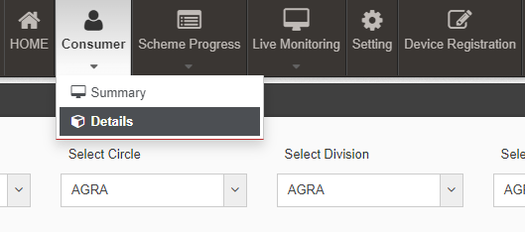
Figure 78 Details

- Select the discom from where the new farmer belongs from and click on the “GO” button as shown in the below Figure 79 and Figure 80
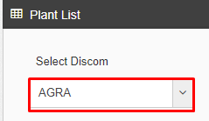

Figure 79 Select DISCOM
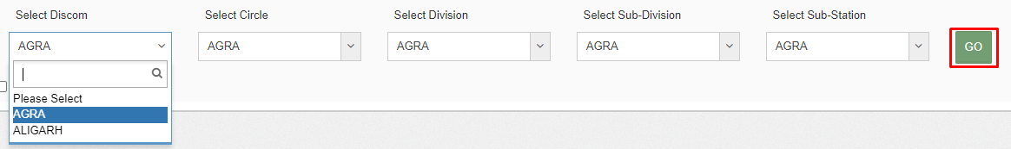
Figure 80 District List

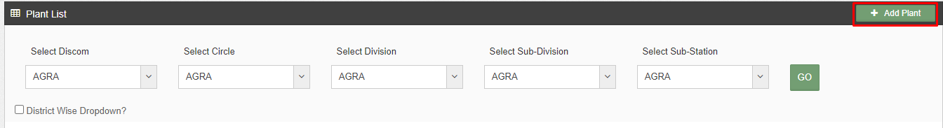
Figure 81 Add Farmer Button

- Click on the “Add Plant” button as highlighted in red in the above Figure 81.

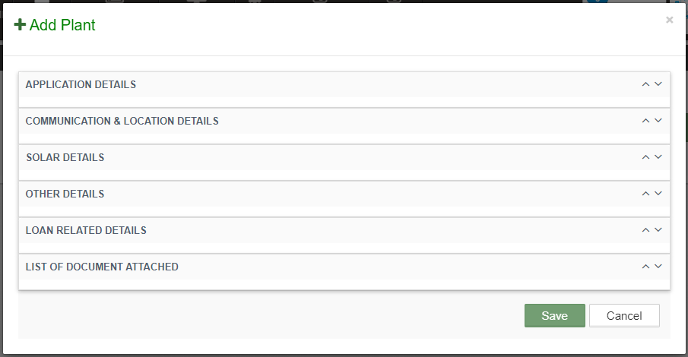
Figure 82 Add farmer Form

- After clicking on the “Add Plant” button, a screen will appear as shown in above Figure 82.
- Multiple sections are there for filling out the application details.
- User has to click on the section name (highlighted in red in above Figure 82) to open the section of the form.

- Application Details

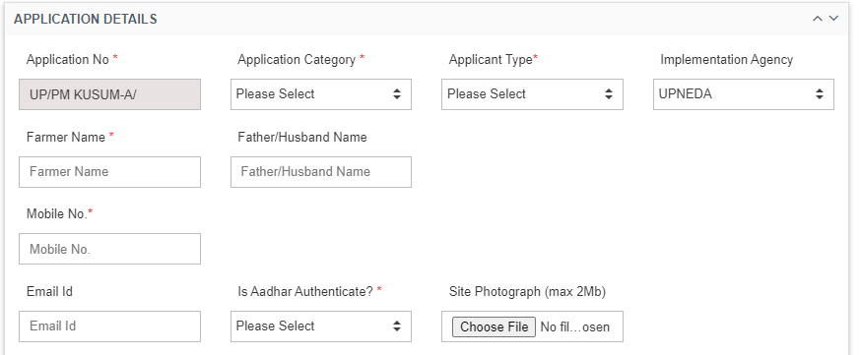

Figure 83 Application Details

Table 34 APPLICATION AND CONSUMER DETAILS
Field | Input | Drop Down Options | Mandatory Field | Sample Values | Description
Application No. | Auto-Generated | - |  | PM KUSUM-B/453 | Application no. will be unique and will be system generated
Application Category | Drop Down | - Individual Farmer  - Gaushala  - Water User Association and Community  - Farmer Production Organization  - Group of Farmer  - Co operatives |  | Others | This drop down conveys the category of the application
Applicant Type | Drop Down | - Owner  - On Lease |  | Owner | The selection describes wheather the applicant is owner of land or have taken on lease.
Implementation Agency | Drop Down | - Dropdown values |  | DISCOM Name | Specific Implementing Agency for the state
Individual Farmer Name | Text | - | - | Name | Name of the beneficiary/developer
Co Operatives Registration Number | Text | - | Yes | 09935747 or Name | Father name if individual developer or Registration no if group or agency
Gender | Drop Down | - Male  - Female  - Transgender |  | Male | Selection of relevant gender of the applicant
Email ID | Email | - | - | nithyanantham@gmail.com | -
Mobile No. (Unique) | Numerical | - |  | 9842239309 | -
Is Aadhar Authenticate? | Drop Down | - |  | Yes | Verify the authenticity of the applicant/Developer
Site Photograph | Button | - |  | Choose file | Upload picture of site

- Grid Details

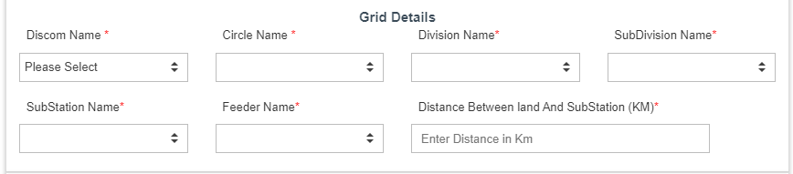

Table 5 Grid Details

Field | Input | Drop Down Options | Mandatory Field | Sample Values | Description
Discom Name | Drop Down | - DISCOM Name |  | DISCOM Name | -Select DISCOM under which site resides
Circle Name | Drop Down | - Circle Name |  | Circle Name | -Select Circle under the selected DISCOM
Division Name | Drop Down | - Division Name |  | Division Name | Select Division under the selected Circle
SubDivision Name | Drop Down | - SubDivision Name |  | SubDivision Name | Select Sub-Division under the selected Division
SubStation Name | Drop Down | - SubStation Name |  | SubStation Name | Select Sub-Station under the selected SubDivision
Feeder Name | Drop Down | - Feeder N  - ame |  | Feeder Name | Select Feeder under the selected Substation
Distance Between land And SubStation (KM) | Text |  |  | 5KM | Enter the Distance Between land And SubStation in KM
Communication (Residential) Details
State | Default | - |  | UTTAR PRADESH | -
District | Drop Down | - AGRA  - ALIGARH  - AMBEDAKAR NAGAR  - AMETHI  - AMAROHA  - AURAIYA  - AYODHYA  - AZAMGARH  - BAGHPAT  - BAHRAICH  - BALLIA  - BALARAMPUR  - BANDA  - BARABANKI  - BAREILLI  - BASTI  - BHADOHI  - BIJNOR |  | ALIGARH | This District selection is for the farmer’s residence district
Revenue Division | Drop Down | - |  | - | This revenue division selection is for the farmer’s residence revenue division
Taluka | Drop Down | - UTTAR PRADESH TEHSIL-1  - UTTAR PRADESH TEHSIL-2  - UTTAR PRADESH TEHSIL-3 | - | UTTAR PRADESH TEHSIL-2 | This taluka selection is for the farmer’s residence taluka
Town | Drop Down | - Agraharasamakulam  - Akkaraisengapalli  - Ambodi  - Annur  - Edayapalayam  - Kunnathur  - Kuppanur | - | Edayapalayam | This town selection is for the farmer’s residence town
Post Office | Numerical | - | - | - | -
Pin code | Numerical | - | - | 641407 | -
Location Details
Location State | Default | - |  | UTTAR PRADESH | -
Location District | Default | - |  | AMRITSAR | -

- Communication & Location Details

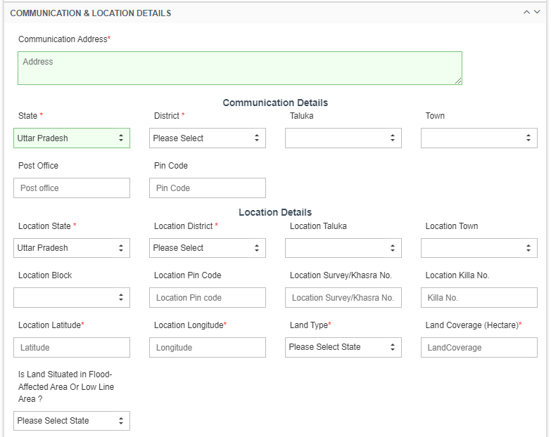
Figure 84 Communication & Location Details

Table 35 COMMUNICATION AND LOCATION DETAILS

Field | Input | Drop Down Options | Mandatory Field | Sample Values | Description
Communication Address | Text Area | - |  | 2/59. School thottam. Chellapampalayam. Kaniyur. Amritsar 641407. | -
Communication (Residential) Details
State | Default | - |  | UTTAR PRADESH | -
District | Drop Down | - AGRA  - ALIGARH  - AMBEDAKAR NAGAR  - AMETHI  - AMAROHA  - AURAIYA  - AYODHYA  - AZAMGARH  - BAGHPAT  - BAHRAICH  - BALLIA  - BALARAMPUR  - BANDA  - BARABANKI  - BAREILLI  - BASTI  - BHADOHI  - BIJNOR |  | BASTI | This District selection is for the farmer’s residence district
Taluka | Drop Down | - UP TEHSIL-1  - UP TEHSIL-2  - UP TEHSIL-3 | - | -UP TEHSIL-3 | This taluka selection is for the farmer’s residence taluka
Town | Drop Down | - Agraharasamakulam  - Akkaraisengapalli  - Ambodi  - Annur  - Edayapalayam  - Kunnathur  - Kuppanur | - | Edayapalayam | This town selection is for the farmer’s residence town
Post Office | Numerical | - | - | AMETHI | -
Pin code | Numerical | - | - | 641407 | -
Location Details
Location State | Default | - |  | UTTAR PRADESH | -
Location District | Default | - |  | AGRA | -
Location Taluka | Drop Down | - UP TEHSIL-1  - UP TEHSIL-2  - UP TEHSIL-3 | - | UP TEHSIL-3 | This taluka selection is of pump site location
Location Town | Drop Down | - Agraharasamakulam  - Akkaraisengapalli  - Ambodi  - Annur  - Kammalapatti  - Kunnathur  - Kuppanur | - | Kammalapatti | This town selection is of pump site location
Location Block | Drop Down
Location Pin code | Numerical | - | - | 642205 | Pin code of installation location.
Location Survey No | Numerical | - | - | 844 | Survey No of installation location.
Location Killa No | Numerical | - | - | 7789 | Survey No of installation location.
Location Latitude (Provisional) | Numerical | - |  | 11.0168 | Location Latitude of installation place.
Location Longitude (Provisional) | Numerical | - |  | 76.9558 | Location Longitude of installation place.
Land Type | Drop Down | - Agriculture  - Non agriculture  - Barren | - | Non Agriculture | Select Land type of Installation Site
Land Coverage (Hectare) | Numerical | - - | Yes | 2 | Enter area of installation site in terms of Hectare
Is Land Situated in Flood-Affected Area Or Low Line Area? | Drop Down | - Yes  - No | No | No | Select weather land is situated in Flood-Affected Area Or Low Line Area?

  - Communication Details : Consumer/Farmer’s Residential Details
  - Location Details : Farm site location where pump will be installed
  - Both details may vary.

- Solar Details

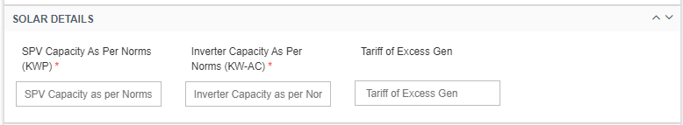
Figure 87 Solar Details

Table 38 SOLAR DETAILS
Field | Input | Mandatory Field | Sample Values
SPV Capacity as per Norms (KWp) | Numerical | Yes | 4.8
Inverter Capacity As Per Norms (KW-AC) | Numerical | Yes
Tariff of Excess Gen | Numerical | -

- Other Details

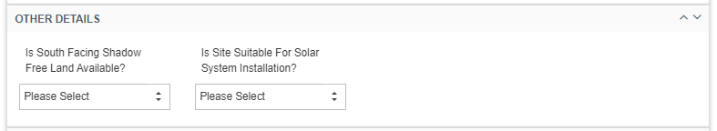

Figure 90 Other Details

Table 41 OTHER DETAILS
Field | Input | Drop Down Options | Mandatory Field | Sample Values | Description
Is Facing Shadow Free Land Available? | Drop Down | - Yes  - No | - | Yes | This drop down conveys that whether the Site has facing shadow free land available or not
Is Site Suitable for Solar System Installation? | Drop Down | - Yes  - No | - | Yes | This drop down conveys that whether the Site is suitable for the installation of Solar Pump or not

- Loan Details

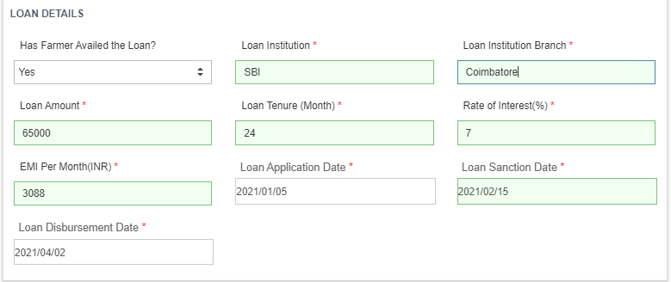

Figure 91 Loan Details

Table 42 LOAN DETAILS
Field | Input | Drop Down Options | Mandatory Field | Sample Values | Description
Has Farmer Availed the Loan? | Drop Down | - Yes  - No |  | Yes | This drop down conveys that whether the farmer had loan available or not
Loan Institution | Text | - |  | SBI Bank | Name of the Institution from where loan has been availed
Loan Institution Branch | Text | - |  | Bathinda | Branch name of the Institution
Loan Amount | Numerical | - |  | 40,000 | Loan Amount availed
Loan Tenure | Text | - |  | 20 months | Loan Duration in Months
Rate of Interest (%) | Numerical | - |  | 9 | Rate of interest at which loan is availed
EMI per month (INR) | Numerical | - |  | 5000 | Equated Monthly Instalments to be paid for loan closure
Loan Application Date | Date | - |  | 2021/09/13 | Date on which loan application has been made (YYYY/MM/DD)
Loan Sanction Date | Date | - |  | 2021/09/17 | Date on which loan application has been sanctioned (YYYY/MM/DD)
Loan Disbursement Date | Date | - |  | 2021/09/27 | Date on which loan has been disbursed (YYYY/MM/DD)

- List of Document Attached

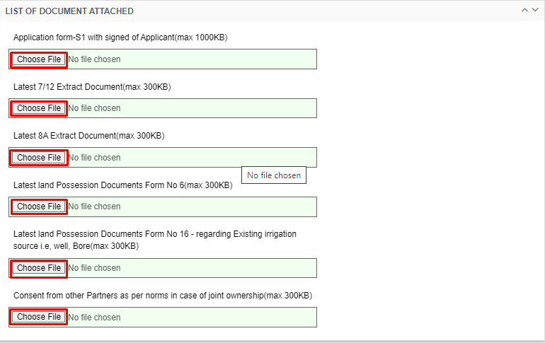

Figure 93 List of Document Attached
- By clicking on the red coloured icons in above Figure 93, user can upload these two forms from farmer registration form.

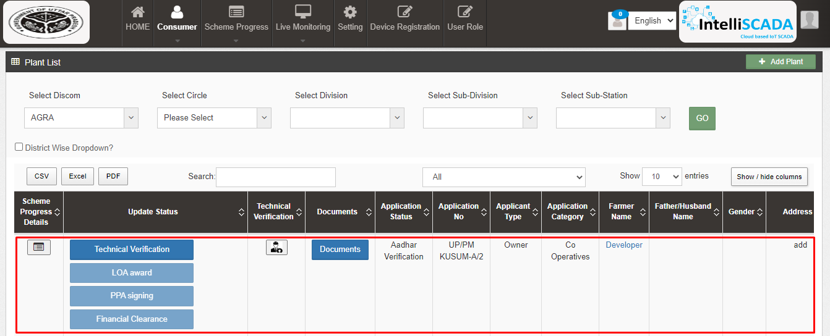
Figure 94 Detail Dashboard

- After application registration, new application will be entered in the consumer/farmer details dashboard as fresh entry (as highlighted in red above Figure 94) whose application scheme progress is yet to commence.
- Details dashboard consists following data columns :

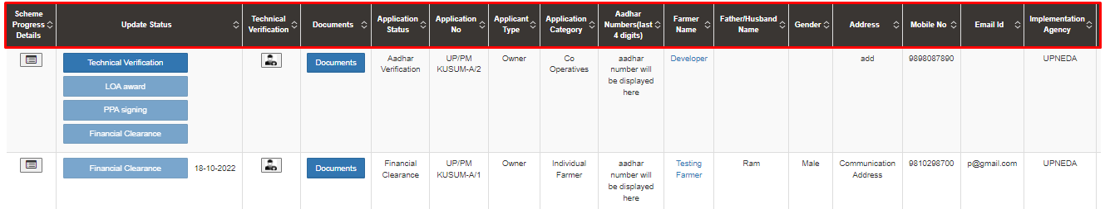
Figure 95 Consumer Detail Data Columns (i)

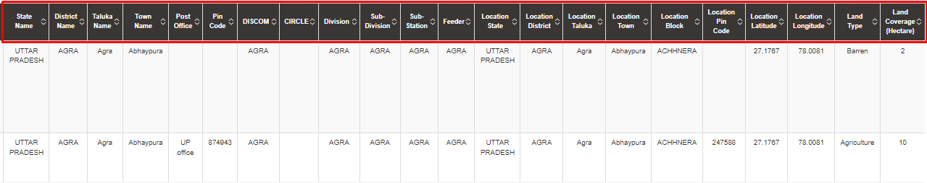
Figure 96 Consumer Detail Data Columns (iI)

Table 44 DATA COLUMN DESCRIPTION
Column Name | Data | Description
Scheme Progress Details | - | Scheme Progress Report
Update Status | - | Status Buttons
Technical Verification | - | Technical survey Details Report
Documents | - | View documents/photographs related to site and beneficiary
Application Status | Authentication | Current Application Status
Application No | (SIA name)/PMKUSUM-A/001 | Plant unique application id
Applicant Type | Owner | Describes type of applicant owner/on-lease
Applicant category | Co Operatives | Describes category as Individual/Group/association, etc
Farmer Name | Rajesh | Name of the Consumer/Beneficiary
Aadhaar number (last four digits) | 9988 | Developers last four digit of Aadhaar card
Father/Husband Name | Rangasamy | Name of Consumer/farmer’s husband or father
Gender | Male | Gender of Consumer/Beneficiary
Address | - | Consumer’s residential address
Mobile No. | 9842239309 | Consumer/Beneficiary mobile number
Email Id | user@gmail.com | Consumer/Beneficiary email id
Implementing Agency | SIA/DISCOM Name | Name of the implementing agency
State Name | State Name | State of Consumer/Beneficiary/Developer
District Name | District | District of Consumer/Beneficiary/Developer
Taluka Name | Taluka | Taluka of the Consumer/Beneficiary/Developer
Town Name | Town | Town of the Consumer/Beneficiary/Developer
Post Office | PO | Post Office of the Consumer/Beneficiary/Developer
Pin Code | 987898 | Pin code of the Consumer/Beneficiary/Developer
DISCOM | DISCOM | DISCOM of the installation site
CIRCLE | CIRCLE | CIRCLE of the installation site
Division | Division | Division of the installation site
Sub-Division | Sub-Division | Sub-Division of the installation site
Sub-Station | Sub-Station | Sub-station of the installation site
Feeder | Feeder | Feeder of the installation site
Location State Name | State Name | Location State of installation site
Location District Name | District | Location District of installation site
Location Taluka Name | Taluka | Location Taluka of the installation site
Location Town Name | Town | Location Town of the installation site
Location Block | Block | Location block of the installation site
Location Pin Code | 987898 | Pin code of the installation site
Location Latitude | 25.987679 | Latitude of the site
Location Longitude | 85.234444 | Longitude of the site
Land Type | Barren | Type of the Land
Land Coverage (Sq. Meter) | 10 | Coverage of land in terms of Hector

- Consumer Details Dashboard Explanation

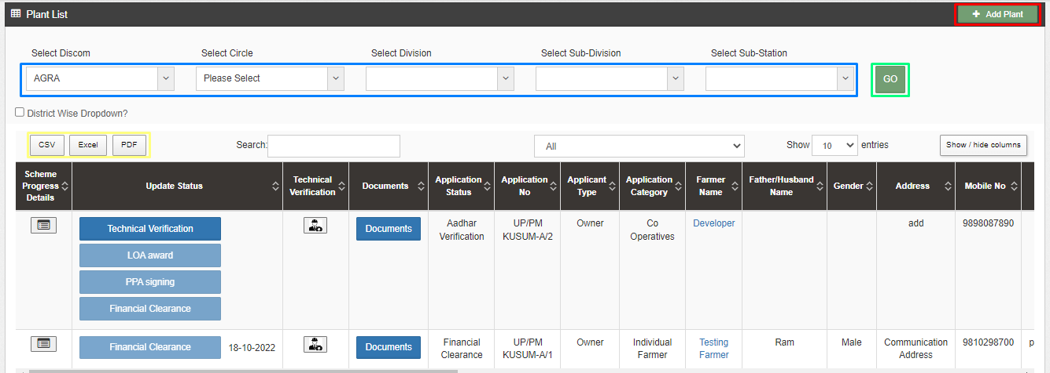

Figure 97 Consumer/Farmer Detail Dashboard

- The “Add Plant” button highlighted in red box can be used to register a new plant application.
- Use filters highlighted in blue box to get the list of a particular application as per the requirement.
- After selecting options in the filter clink on “GO” button highlighted in green box to apply the filters.
- To track or see the progress/record of any particular application click on icon under “Scheme progress Details” highlighted in pink box in first column.
- To fill or view the technical details of the site click on icon under “Technical Verification” highlighted in pink box in third column.
- To view or download the documents click on blue button “Documents” highlighted in pink box under Documents column in fourth column.
- To view the complete details of the applicant click on the “Farmer name” highlighted in pink box under Farmer Name in ninth column.

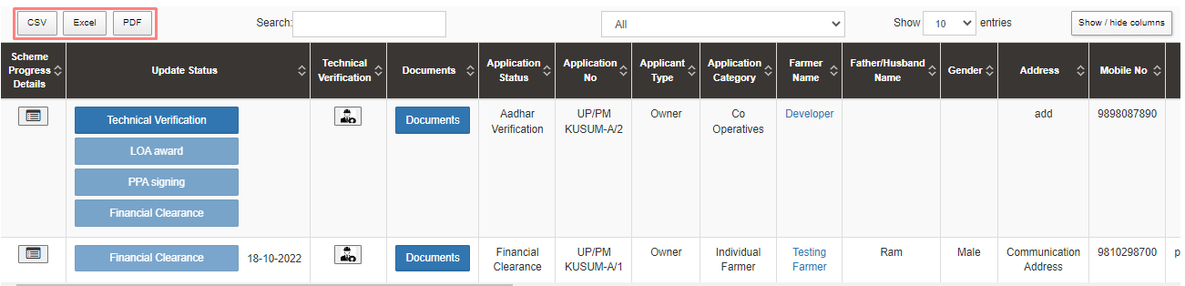
- The user can download the displayed data in three formats “CSV, Excel and PDF” highlighted in red box.
Figure 106 Details dashboard Excel file (ii)

- Excel file output - as shown in Figure 107.

Figure 107 Details dashboard Excel file (iii)

- PDF file output - as shown in Figure 108.
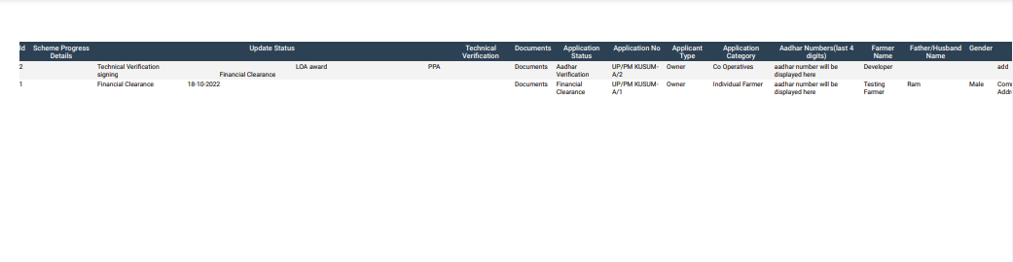
Figure 108 Details dashboard PDF

- CSV file output - as shown in Figure 108.1.

Figure 108.1 Details dashboard CSV

- The users can choose to see only the relevant information as required by them by selecting the necessary columns under the ‘Show/Hide’ columns. (highlighted in sky blue in Figure 109)

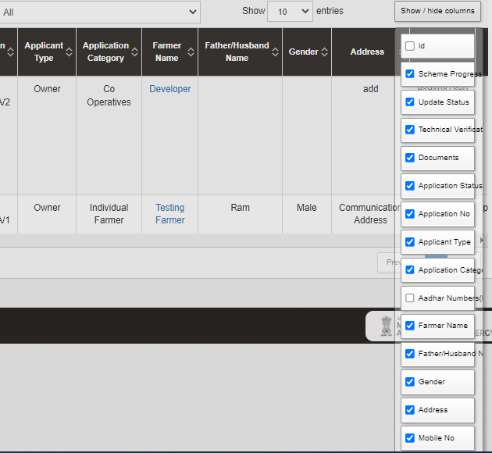
Figure 109 Show / Hide columns filter

- In Figure 97, by clicking onto the pink highlighted icon first column of Consumer Details dashboard, the user can view the chronological data for scheme progress details of any individual farmer. (as shown in below Figure 110)
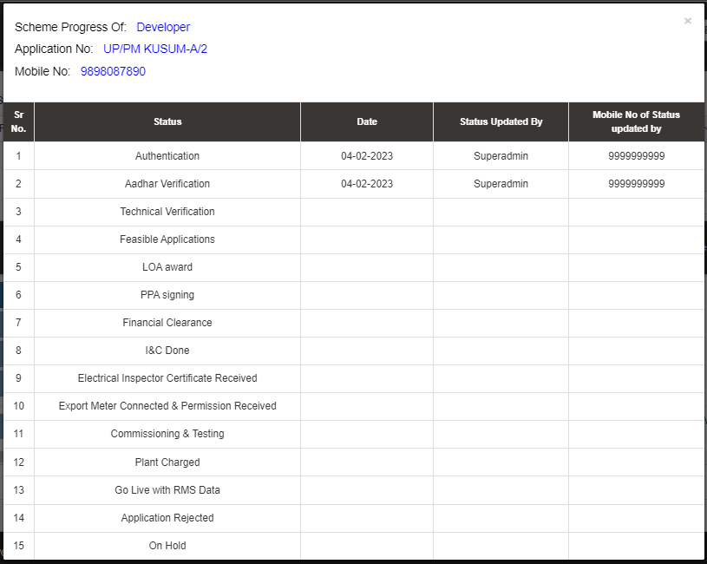
Figure 110 Scheme Progress report for Consumer/Farmer

- Similarly, by clicking on the icon (highlighted in pink in Figure 97) in the second column, the user can view the site survey details of the consumer/farmer as well as take action against individual farmer’s application and also can upload Site Photographs and Farmer Consent Form.

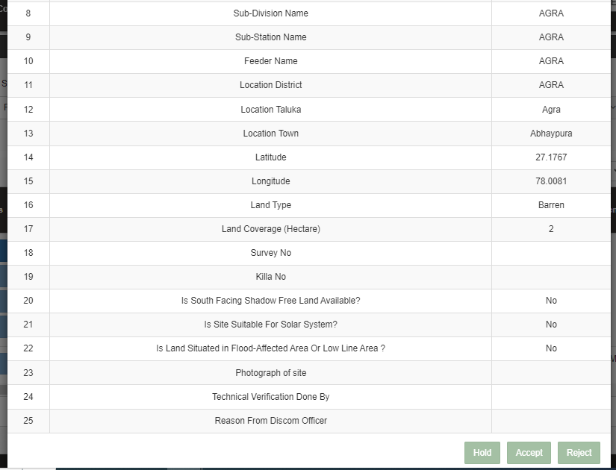
Figure 111 Site Survey Detail of Consumer/Farmer

  - At the end of the report form, user can see 3 button options (in above Figure 111) – Hold, Accept, and Reject. These buttons are solely under the authorisation of Head Office or District Officer or District Office.

Authentication
- Below are the authorized users to Authenticate the application :
- State Implementing Agency (SIA)
  - Sub Division Officer (SDN)
  - Head Officer (HO)
- Navigation Steps to change application status Authentication :-
- Sign in on the State SEDM Portal
- Click on the “Details” on Consumer Module as shown in below figure

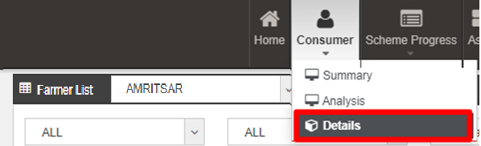

- Click on “Aadhar Verification” under update status column
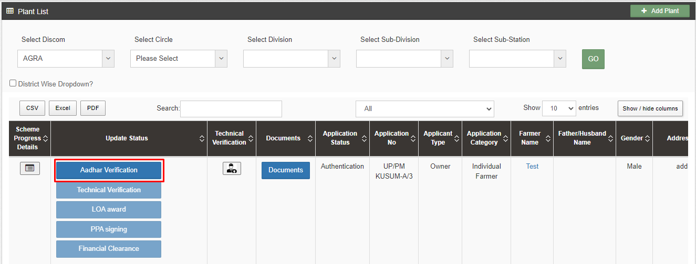

Technical Verification
- Below are the authorized users to update the status Technical Verification:
- State Implementing Agency (SIA)
  - Sub Division Officer (SDN)
  - Head Officer (HO)
- Navigation Steps to change application status Authentication :-
- Sign in on the State SEDM Portal
- Click on the “Details” on Consumer Module as shown in below fig.

- Click on the “Technical Verification” on Consumer Module as shown in below figure

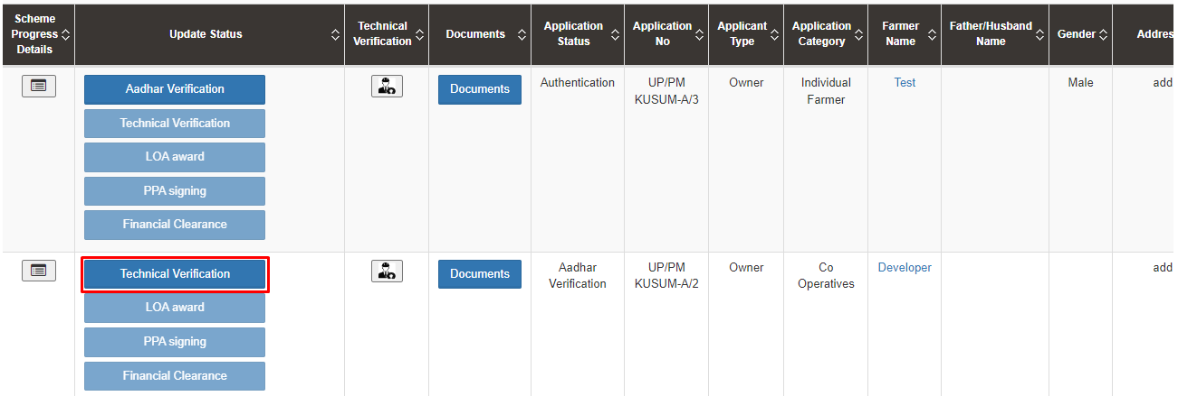

16. FEASIBLE APPLICATION

- Below are the authorized users for Feasible Application:
- State Implementing Agency (SIA)
- Sub Division Officer (SDN)
- Head Officer (HO)

- Navigation Steps to change application status “Feasible Application” :-
- Sign in on the State SEDM Portal
- Click on the “Details” on Consumer Module as shown in below Figure 112
- Click on icon shown in below figure to check the Technical details of the site:

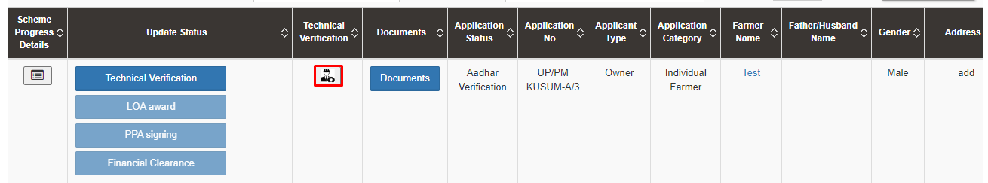

- Click on “Accept” to update the Feasible Application status:

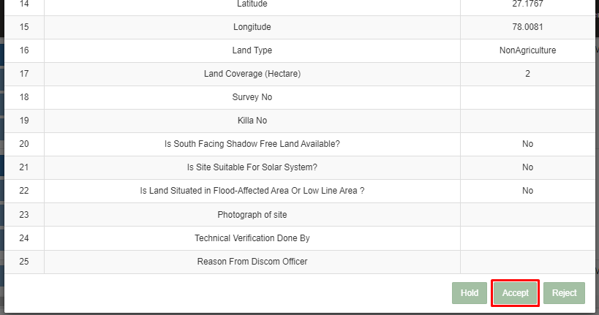

Note:
- The authorized user will Site Resurvey / Accept / Reject / Hold the application according to the site survey details.
- To change the application status to “Feasible Application”, user has to click on the “Accept” button. (pointed in the below Figure 115)
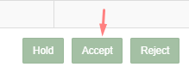

Figure 115 Application Accept button

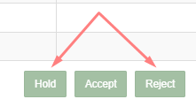
Figure 116 Application Hold-Reject Button
- To put application on hold or to reject the application, user has to click on the “Hold” or “Reject” button (pointed in red in above Figure 116) and have to give the reason for the same.
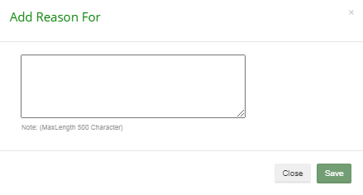
Figure 117 Reason for Application Hold/Reject

Figure 119 Details

After the application is accepted/feasible, SIA users has to change the status “LOA Award”.

LOA Award

- Below are the authorized users for Farmer Share Received :
- State Implementing Agency (SIA)
  - Sub Division Officer (SDN)
  - Head Officer (HO)
- Navigation Steps to change application status LOA Award :-
- Sign in on the State SEDM Portal
- Click on the “Details” on Consumer Module as shown in below figure
- Click on “LOA Award“ in the update status

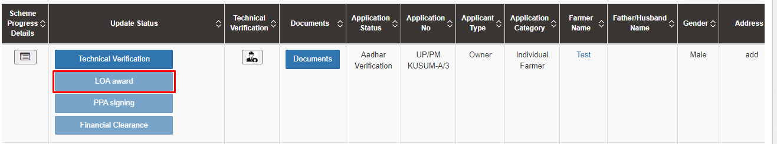

- In Details dashboard as shown in below figure, Consumer/Farmer details are displayed along with the blue buttons of Status in third column. (highlighted in red in below Figure 120)
- 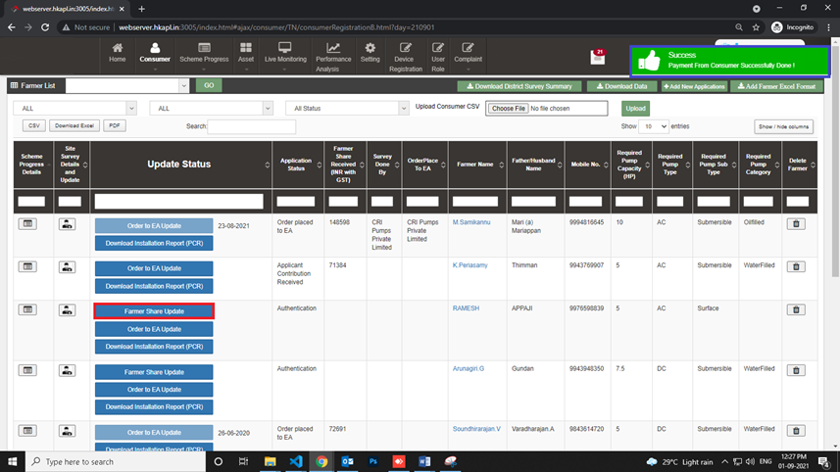

Figure 120 Updated Farmer Share Received

- User has to click on “Farmer Share Update” button (highlighted in red in Figure 120) to change the Consumer/Farmer application status to “Farmer Share Received”.
- When the button “Farmer Share Update” is clicked, a success message will arrive i.e. “Payment from Consumer Successfully Done!” (highlighted in blue in Figure 120)

NOTE: To update status “Farmer Share Received” in bulk i.e. of multiple consumers/farmers at once, click here to know more.

PPA Signing
- Below are the authorized users for Order Placed to EA :
- State Implementing Agency (SIA)
  - Sub Division Officer (SDN)
  - Head Officer (HO)
- Navigation Steps to change application status PPA Signing:-
- Sign in on the State SEDM Portal
- Click on the “Details” on Consumer Module as shown in below Figure 121 Details
Figure 121 Details
- After LOA Award, authorized users has to change the status “PPA Signing”.
- In Details dashboard as shown in below figure, Consumer/Farmer details are displayed along with the blue buttons of Status in second column.
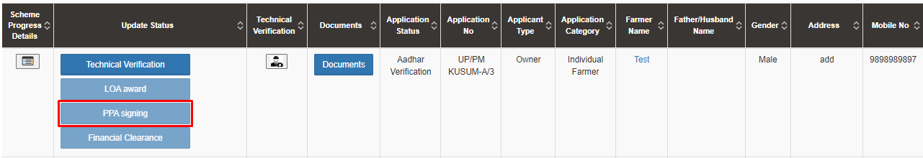
Figure 122 Details Dashboard

19. Financial Clearance
- Below are the authorized users for Financial Clearance :
- State Implementing Agency (SIA)
  - Sub Division Officer (SDN)
  - Head Officer (HO)
- Navigation Steps to change application status PPA Signing:-
- Sign in on the State SEDM Portal
- Click on the “Details” on Consumer Module as shown in below Figure 121 Details

- After PPA Signing, authorized users has to change the status “Financial Clearance”.

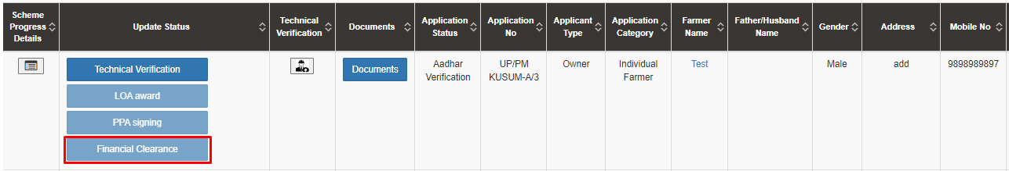

INSTALLATION AND COMMISSION (I&C) DONE

- Navigation Steps:
- Go to “Live Monitoring”
- Click on “Plant Monitoring” as shown in below Figure,

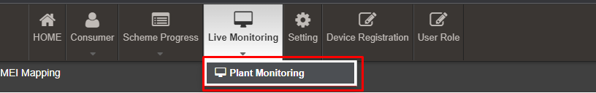

- SNA/Developer/DISCOM are the authorized user for updating status “Installation & Commission (I&C)”.
- After updating the PPA Signing, SNA/Developer/DISCOM user has to change the status “Installation & Commission” of individual Consumers/Farmers whose current status is “Dispatch”
- Updating status “Installation & Commission done” signifies Installation & Commission data. In here, the date on which the foundation was laid on the site, structure was installed, required tools and components were set up and the final commission along with working of installed components was done is updated for the SIA to review.

- To change the status of Consumers/Farmers to “Installation & Commission”, EA user has to complete the following 3 stages:
- Asset Serial No. Mapping : Serial nos of assets deployed in field are mapped against farmer
- IMEI No. Mapping
- Update the stages of “Foundation”, “Structure”, “PV System & Controller/Inverter” and “Installation & Commission Done (RMS Connected)”. While updating these stages site photograph is also captured.
- The above stages are explained in upcoming sections.

- To search consumer/farmer for individual asset serial no or IMEI no mapping, user can search consumer/farmer by two ways i.e. either entering IMEI number (if mapped) or Application number (highlighted in yellow in below Figure 150), the corresponding details of the consumer/farmer gets displayed on the Asset Mapping by EA Dashboard or the another way is, by applying four filters i.e. District selection, Empanelled Agency selection, Capacity selection and Application Status selection (highlighted in pink in below Figure 150) to get the particular consumer/farmer details.

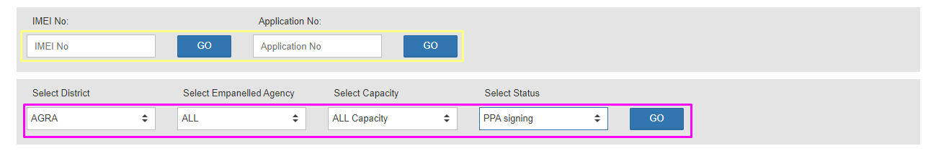
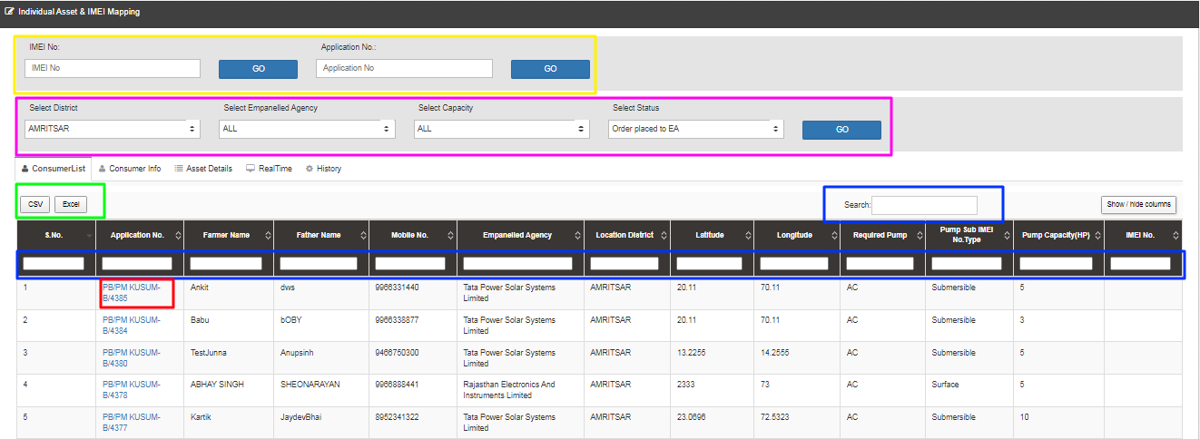
Figure 150 Asset Mapping by EA Dashboard
______________________________________________________________________________________________________________________________

- User can download CSV or Excel file (highlighted in green in Figure 150) of the filtered farmer details for analysis.
- User also can search the particular farmer details by entering input in the search boxes. (highlighted in blue in Figure 150)
- By clicking on to the farmer’s Application no. (Highlighted in red in above Figure 150) user will be redirected to the Consumer Info tab as highlighted in red in below Figure 151.

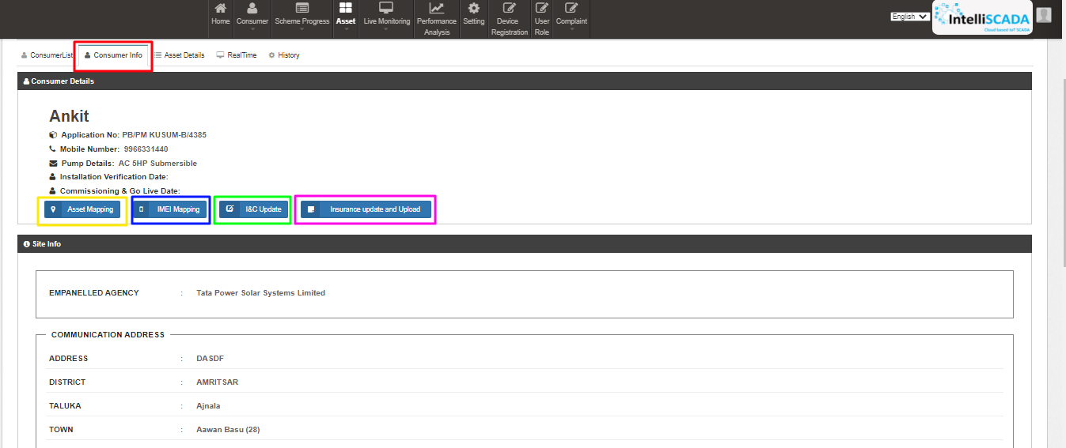
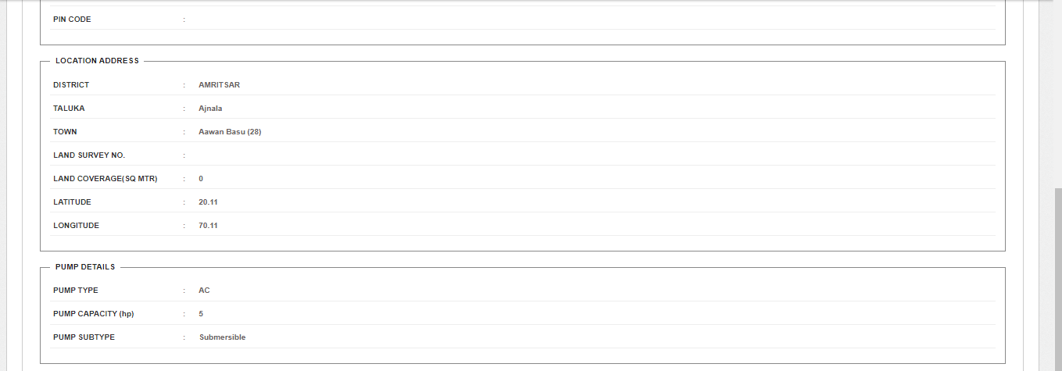
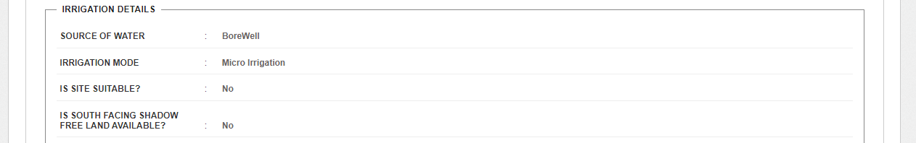
Figure 151 Consumer Info Tab
- In above Figure 151, the four sub features will function for the Asset Mapping, IMEI mapping, uploading I&C photos and uploading Insurance policy details.

Figure 152 Individual Asset Mapping
- The second sub feature is “IMEI Number Mapping”. By clicking “IMEI Mapping” button (highlighted in blue in Figure 151), user can map new IMEI no. (as shown in below Figure 153), IMEI nos of own empanelled agency shall be available for mapping.
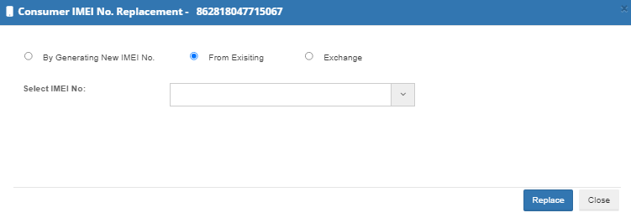
Figure 153 IMEI Replacement

NOTE: To register IMEI nos., click here to know about it.

20.1 INSTALLATION & COMMISSION DONE (I&C)

- The third sub-feature is ‘I&C done.
- By clicking “I&C Update” button (highlighted in green in Figure 151), a screen will appear (as shown in Figure 154) in which user has to upload below mentioned four photographs:
  - Foundation
  - Structure
  - PV System & Controller/Inverter
  - Installation & Commission Done (RMS Connected)
- I&C Photo’s specifications :
  - Supported Photo extension : “jpeg”, “png” & “pdf”
  - Photo Size restriction : Less than 5 MB
- It is preferred that all the uploaded I&C photos are imprinted with Latitude-Longitude.
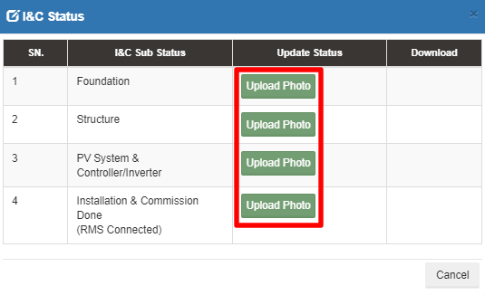
Figure 154 I & C Photos

- User has to click on the “Upload Photo” (green button highlighted in red in above Figure 154) to upload the photos.
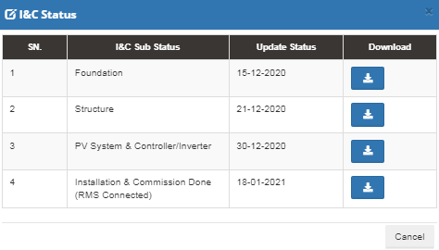
Figure 155 I&C Status box
- When the photo gets uploaded, the current date will appear just beside the I&C Sub Status name (as shown in third column in above Figure 155) and user can also download the uploaded photo by clicking on the blue coloured download icon. (as shown in fourth column in above Figure 155)

UPLAODING INSURANCE POLICY DETAILS

- The fourth sub-feature is related to the ‘Insurance Policy’ of the farmer.
- By clicking the “Insurance Update & Upload” button (highlighted in pink in Figure 151), a screen will appear (as shown in below Figure 156) to the user to enter Insurance Number and upload Insurance Policy Document of the consumer/farmer.
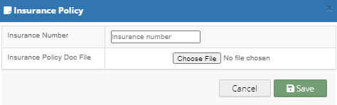
Figure 156 Insurance Policy

- The third panel tab of the Consumer Monitoring Dashboard gives us a Real Time view of the functioning of different components and their output, like the data that is shown on the consumer mobile application.
- This data is received from the RMS module, which is installed along with the Pump Controller.
- The Real Time dashboard lists down the site location, IMEI number, Device ID, Geographic coordinates, RSSI, energy generated per day and the live performance of the Pump

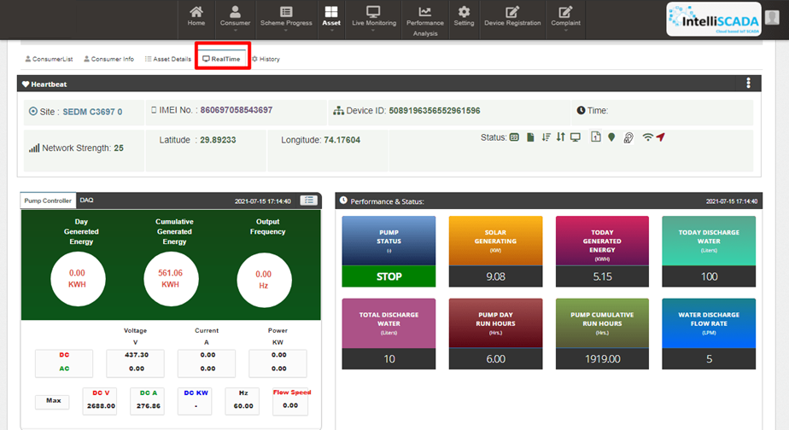
Figure 158 Real-time Dashboard

- The fourth option tab of Asset Mapping by EA Dashboard gives the users a mode to retrieve and view the History of data and activities of a farmer by entering the time period for which they want to search the results. (highlighted in red in below Figure 159)

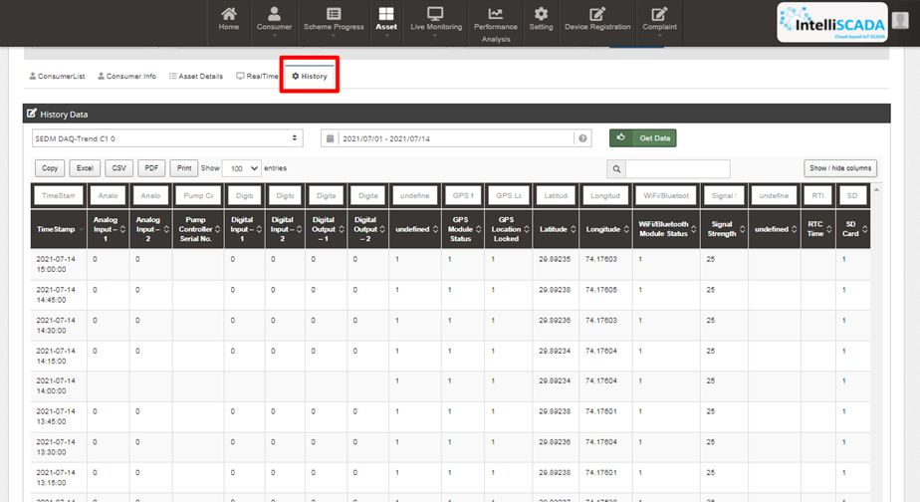
Figure 159 View History

Figure 165 Project Completion Report

LIVE MONITORING

- The Live Monitoring Module on SEDM Platform gives the users a dynamic functionality to monitor and assess the scheme statistics as well as the functioning of the solar plant/pump efficiently, all of this from a single window.

- Navigation Steps: -
- Sign in on the State SEDM Portal
- Click on the ‘Live Monitoring’ option on the Title Bar of the SEDM Portal Dashboard
- Navigate “Dashboard” (as shown in Figure 166)

- Sign In >> Live Monitoring >> Dashboard

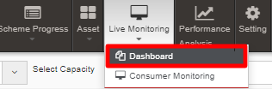
Figure 166 Live Monitoring Dashboard Option

- Live Monitoring Dashboard Screen

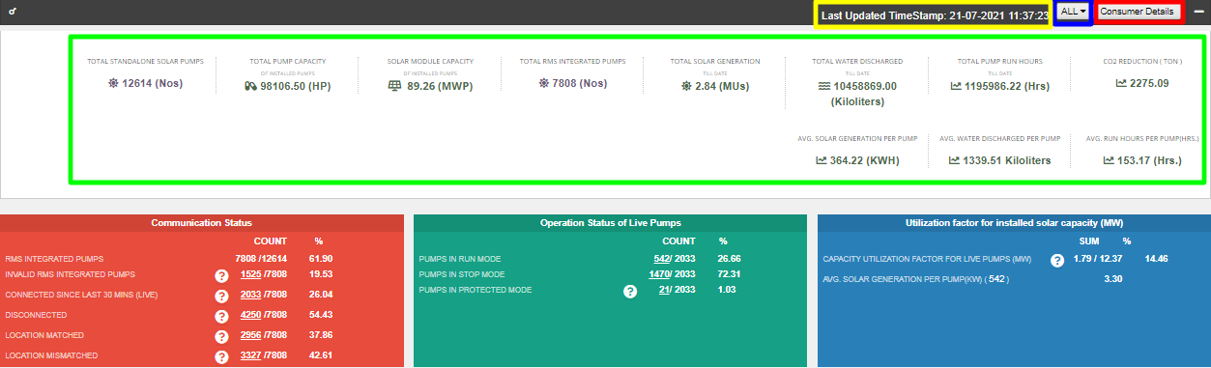
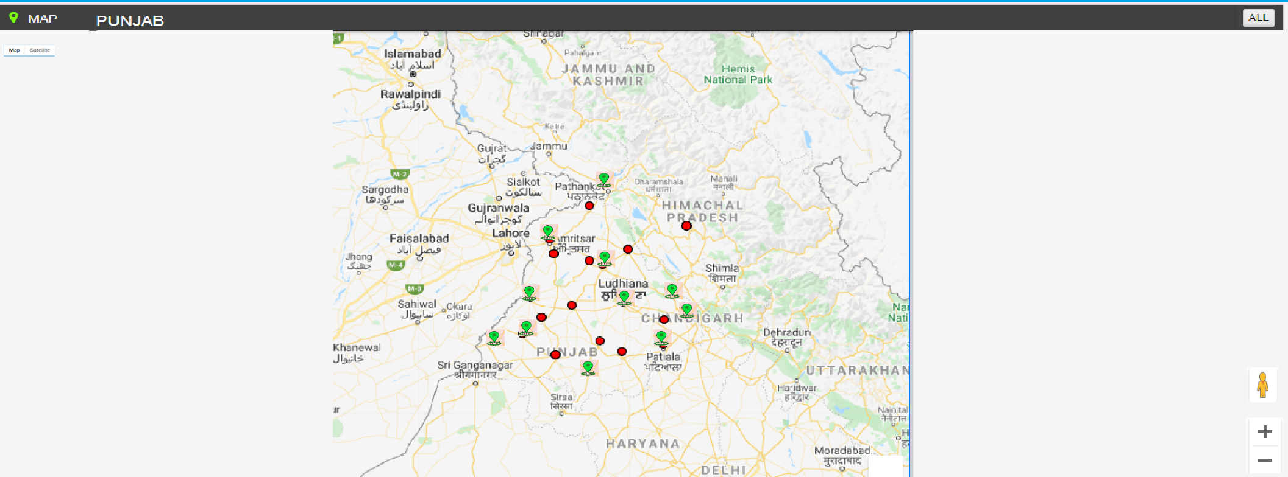
Figure 167 Live Monitoring Dashboard
- Last Updated Time Stamp (highlighted in yellow in above Figure 167)
It is the start date when the system became operational.
- This time stamp updates every 15 minutes in Live Monitoring Dashboard on State SEDM Platform and consequently, data of live monitoring dashboard gets updated every 15 minutes.
- Empanelled Agency Filter (highlighted in blue in above Figure 167)
    - User can view live monitoring dashboard data of all empanelled agencies or else, can view data empanelled agency wise also by filtering out empanelled agency.
- Consumer Details (highlighted in red in above Figure 167)
    - By clicking on the “Consumer Details” button, user can view a screen where the consumer details as well as their corresponding RMS details (last updated) will be displayed and can also edit consumer’s RMS latitude-longitude in this screen only just for once.

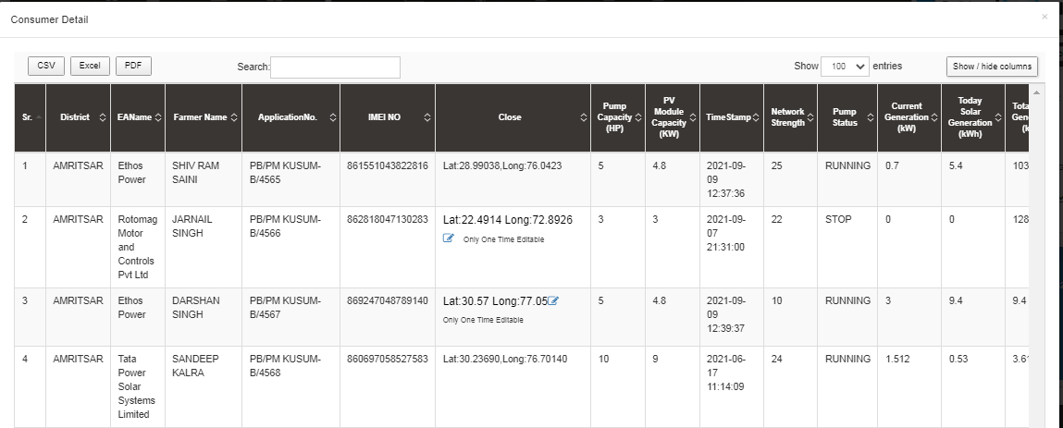
Figure 168 Consumer Details (i)
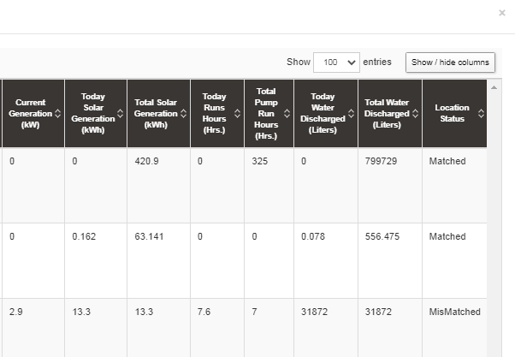
Figure 169 Consumer Details (ii)
- User can change RMS latitude and longitude by clicking on edit icon (highlighted in red in above Figure 168) and in below Figure 170 is shown how to change the RMS latitude and longitude.

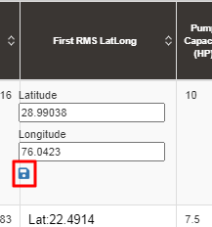
Figure 170 Update RMS Latitude - Longitude

- After entering new RMS latitude and longitude, user has to click on the save icon (highlighted in red in Figure 167) to update the RMS latitude-longitude.

NOTE: RMS Latitude-Longitude can be updated only once and not more than that.

- Below are the parameters covered in Live monitoring dashboard (highlighted in green in above Figure 167) :

  - Total Standalone Pumps
    - It reflects the total numbers of applications whose application status is updated to “Installation & Verification done”.
  - Total Pump Capacity
    - It reflects the total sum of capacity (HP) of total standalone pumps.
  - Total Module Capacity
    - It reflects the total sum of SPV capacity of total standalone pumps. (SPV Capacity as per EA rate card, click here to know more)
  - Total RMS Integrated Pumps
    - It reflects the total number of pumps who had sent RMS data on the portal for the first time.
  - Total Solar Generation
    - It reflects the total cumulative Solar Generation of RMS Integrated pumps till today. (in terms of MUs i.e. Million Units)
  - Total Water Discharge
    - It reflects the total cumulative kilolitres of Water discharged from RMS Integrated pumps till today.
  - Total Pump Run Hours
    - It reflects the total cumulative hours that RMS Integrated pumps ran till today.
  - CO2 Reduction (TON)
    - CO2
  - Avg. Solar Generation per Pump
    - Formula : Total Solar Generation / Total RMS Integrated pumps
  - Avg. Water Discharge per Pump
    - Formula : Total Water Discharge / Total RMS Integrated pumps
  - Avg. Run Hours
    - Formula : Total Pump Run Hours / Total RMS Integrated pumps

- Live Monitoring has three different coloured boxes (Red, Green and Blue as shown in Figure 167) are explained in below Table 49.

Table 49 Live Monitoring – Explanation of three boxes
Box Name (Colour) | Sub Status | Description | Refer Figure 167 for below figures as an example
Communication Status (Red Box) | RMS Integrated Pumps | Displays Total RMS Integrated Pumps out of Total Pumps whose current status is Installation & Commission Done | 7808 (Total RMS Integrated pumps) / 12614 (Total Pumps having current status Installation & Commission )
 | Invalid RMS Integrated Pumps | This sub status considers standard time of Total Pump running hours as 12 hours. If any pump from total RMS Integrated pumps runs for more than standard hours than it falls in Invalid category | 1525 (Pumps ran more than standard hours) / 7808 (Total RMS Integrated pumps)
 | Connected Since Last 30 Mins (LIVE) | Displays Total no. of Pumps that are connected from last 30 mins out of Total RMS Integrated pumps | 2033 (Total Pumps connected since last 30 minutes) / 7808 (Total RMS Integrated pumps)
 | Disconnected | Displays Total no. of Pumps that are disconnected out of Total RMS Integrated pumps | 4250 (Total disconnected Pumps) / 7808 (Total RMS Integrated pumps)
 | Location Matched | Displays Total no. of pumps whose latitude-longitude (captured while Site Survey) matched with the latitude-longitude that RMS had sent along with the data for the first time on the portal out of Total RMS Integrated pumps | 2956 (matched Latitude-Longitude) / 7808 (Total RMS Integrated pumps)
 | Location Mismatched | Displays Total no. of pumps whose latitude-longitude (captured while Site Survey) mismatched with the latitude-longitude that RMS had sent along with the data for the first time on the portal out of Total RMS Integrated pumps | 3327 (mismatched Latitude-Longitude) / 7808 (Total RMS Integrated pumps)
Operation Status of Live Pumps (Green Box) | Pumps in Run Mode | Displays Total no. of pumps that are currently running out of total no. of pumps that are connected since 30 minutes (sub status given in red box) | 542 (Pumps currently running) / 2033 (Pumps connected since last 30 minutes)
 | Pumps in Stop Mode | Displays Total no. of pumps that are currently not running i.e. stopped out of total no. of pumps that are connected since 30 minutes (sub status given in red box) | 1470 (Pumps currently stopped) / 2033 (Pumps connected since last 30 minutes)
 | Pumps in Protected Mode | Displays total no. of pumps that falls in below shown four categories (highlighted in red in below Figure 171) out of total no. of pumps that are connected since 30 minutes (sub status given in red box) | 21 (Invalid Pumps) / 2033 (Pumps connected since last 30 minutes)
Utilization Factor for installed solar capacity (MV) (Blue Box) | Capacity Utilization Factor For Live Pumps (MV) | Displays total SPV capacity (MW) produced of total no. of pumps (currently in run mode - sub status given in green box) out of total SPV capacity as mentioned in the EA rate card (click here to know about SPV capacity as per EA rate card) | 1.79 (total SPV capacity (MW) produced of total no. of running pumps) / 12.37 (total SPV capacity as mentioned in the EA rate card)  1.79 / 12.37 * 100 = 14.46 % (percentage shown in blue box of live monitoring dashboard in Figure 167)
 | Avg. Solar Generation per Pump (KW) 542 (Pumps currently in run mode) | 1.79 (total SPV capacity (MW) produced of total no. of running pumps) / 542 (Pumps currently in run mode) * 1000 (to convert value from MW into KW) = 3.30 KW

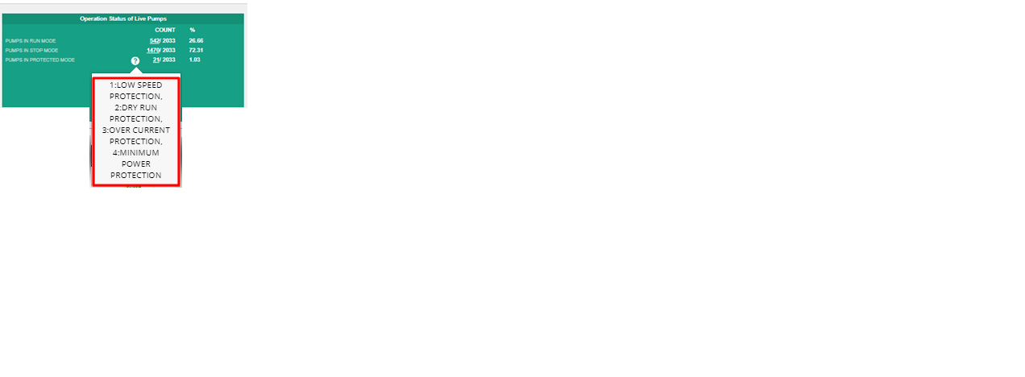
Figure 171 Invalid Parameters of Green Box of Live Monitoring Dashboard

- Below are the brief points covered under map of Live Monitoring dashboard:
- Monitoring of Live Parameters on Dashboard with Map View
- Navigation:
- It is possible to navigate from state to district to individual Consumer/Farmer on a single page in the map view.
- At state and district level, summary of parameters are displayed in a pop-up window.
- By clicking upon the green location icon on map (shown in Figure 167), a screen (refer ) will open that covers the following list of Important Parameters of particular district:
- Standalone Solar Pumps
  - Total no. of Standalone Solar Pumps
  - Total Pump Capacity (HP)
  - Total Solar Module Capacity (Actual) (KW)
- RMS Integrated Pumps
  - Total no. of RMS Integrated Pumps
  - Pumps in Run Mode
  - Pumps in Stop Mode
  - Pumps in Protection Mode
  - Current Solar Capacity Utilization of Pump in Run Mode (KW)
- Indicators
  - Pump Run Hours
  - Solar Generation (kWh)
  - Water Discharged (Kiloliter)

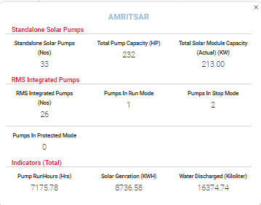
Figure 172 Amritsar District Solar Pump Statistics

- By clicking upon district name, user will get a broad view of selected district in which consumers/farmers of that district (in terms of green and red location icons, as shown in below Figure 173) will be displayed.
  - Green Icon (Live) - Consumer/Farmer’s Solar Pump that is connected since 30 minutes.
  - Red Icon (Not Live) - Consumer/Farmer’s Solar Pump that is disconnected.
- User can filter out the view by selecting any of the three status of Solar Pump. (highlighted in yellow in below Figure 173)
- Also user can navigate back to the state view by clicking on state name. (highlighted in red in below Figure 173)

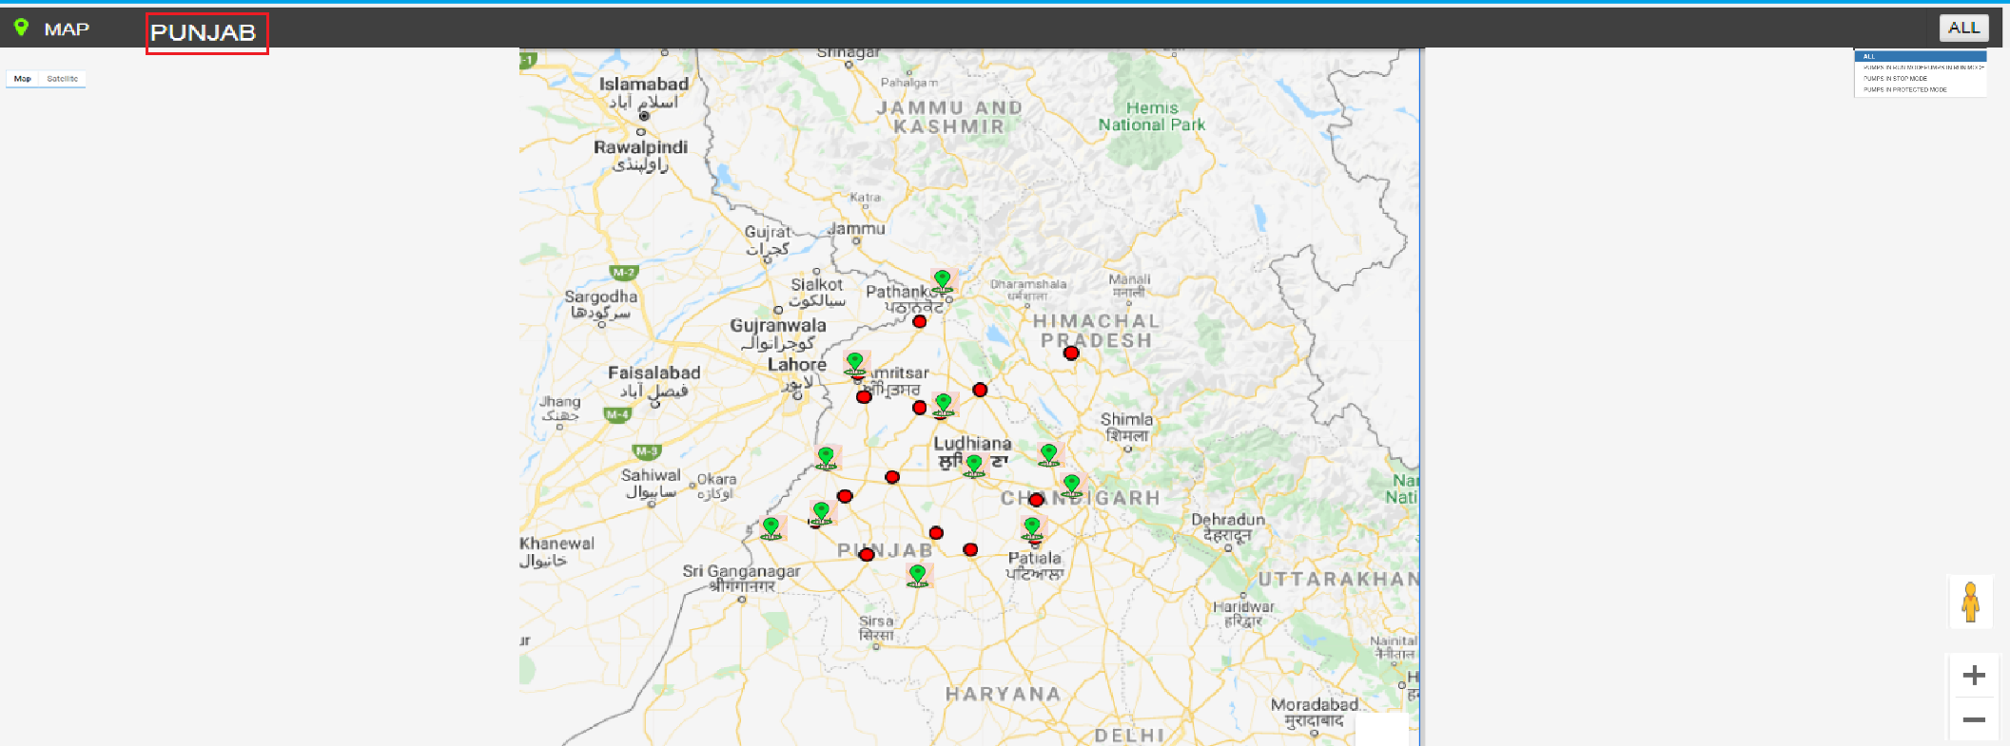
Figure 173 Broad View of Consumer/Farmer of Selected District

- By clicking on any of two coloured icon, user can view particular consumer/farmer’s Solar Pump statistics as shown below in Figure 174.

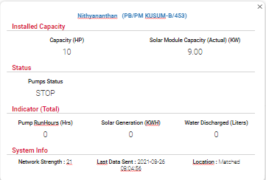
Figure 174 Consumer/Farmer Solar Pump Statistics

- By clicking on consumer/farmer’s name and application no. (Blue text in above Figure 174), user will be redirected to the Real Time tab under Asset Mapping by EA under Asset module.

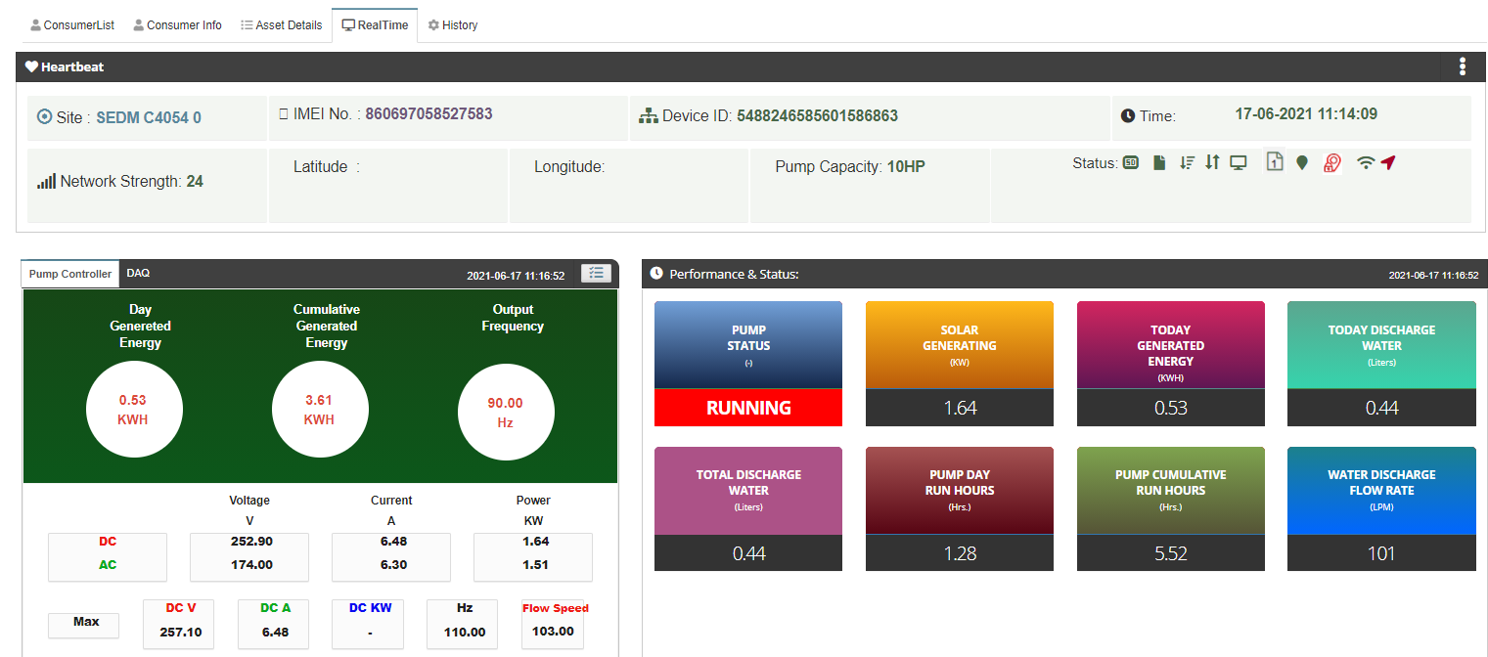

Figure 175 Real Time View of the Consumer/Farmer

PERFORMANCE ANALYSIS

- The Performance Analysis Module of the SEDM Portal gives a detailed analytical report comprising System Performance Numbers and Energy Transaction Statistics, for both state-level and district-level analysis, based on the date range or district selection provided by the user.

- Navigation Steps: -
1. Sign in on the State SEDM Portal
2. Click on the ‘Performance Analysis’ option on the Title Bar of the SEDM Portal Dashboard
- Sign In >> Performance Analysis

- Below are the brief points covered under this module:
- Duration Selection Filter
- Last Week
- Last Month
- Current Week
- Current Month
- Between User Configurable Dates

- System Performance Analysis
- Solar Performance Analysis – Generation, %CUF, %PR
- RMS Performance Analysis - % Data Availability, % Device Connectivity

- On the State Level Performance Analysis Dashboard, in the centre, a map of State is displayed with locations marked where the Solar Pump Project is set up.
- The columns on either side of the dashboard show various Diagnostic Statistics and Asset Performance and Parameters.
- Users can view the performance report for any desired date range, Empanelled Agency and District by selecting the relevant option from the filters. (highlighted in red in below Figure 176)

NOTE: Date Custom range is allowed upto 60 days only.

- State Level Performance Analysis

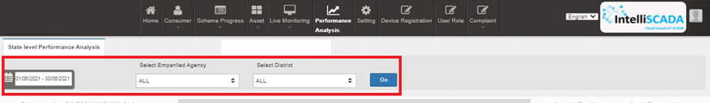
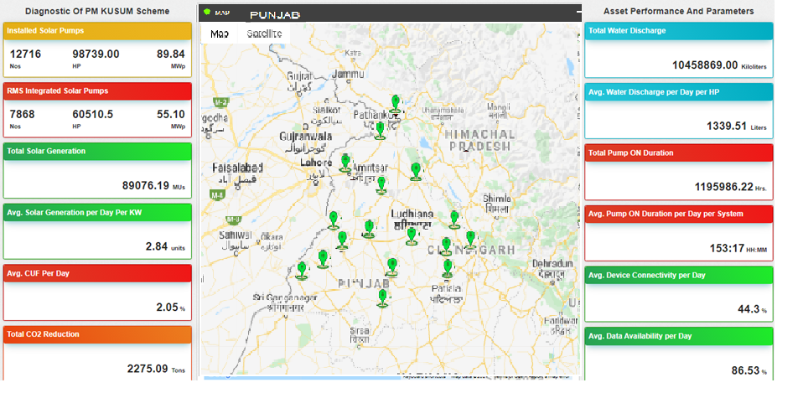

Figure 176 State level performance analysis

Table 50 Performance Analysis Statics Calculations and Description

Performance Analysis Statistics | Calculation | Description
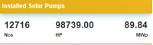 | - Nos. :- Total no. of I&C Pumps  - HP :- Sum of Capacity (HP) of Total no. of I&C Pumps  - MWp :- Sum of KWp / 1000 (to convert in MWp) = (value in MWp) | Displays the details of total no. of Solar Pumps of the consumer/farmer application whose current status is “Installation & Commission Done”
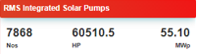 | - Nos. :- Total no. of RMS Integrated Pumps  - HP :- Sum of Capacity (HP) of Total no. of RMS Integrated Pumps  - MWp :- Sum of KWp / 1000 (to convert in MWp) = (value in MWp) | Displays the details of total no. of RMS integrated pumps. (the pumps that had sent data on the State SEDM Platform since the first time)
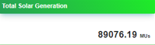 | - Cumulative Sum of total solar generation (KWh) according the selected days in date range / 1000000 (to convert in MUs) | It is calculated as per :  1MWp = 1000 KWp  1KWp = 1000 watts  (1kwh/1000000)=MUs
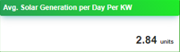 | - Total Solar Generation / ( selected no. of days in date range * Total capacity of RMS Integrated Pumps (HP) ) | It is calculated considering Total Solar generation, Sum of total Capacity of RMS Integrated Pumps and Date range (no. of days)
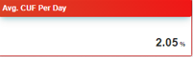 | - Total Solar Generation / (Total capacity of RMS Integrated Pumps (HP) * selected no. of days in date range) * 100 = (value in %) | It is calculated consider the no. of units generated per day, solar generation (kWp) and 24 hours (to calculate avg per day)
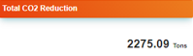 | - Total Solar Generation / 1000000 (MUs) * 800 = (value in Tons) | This calculation consider Total Solar Generation and convert it into Tons by dividing the value by 10,00,000
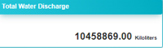 | - Cumulative Sum of total water discharged according to the capacity of total RMS Integrated Pumps | This calculations will be Cumulative considering total units generated per HP and sum of total capacity (HP)
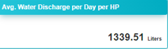 | - Total water discharge / 30 (days selected in date range) / total rms integrated pumps capacity (HP) | This calculations will be Cumulative considering total water discharge, selected days in date range and total capacity (HP) of RMS Integrated Pumps
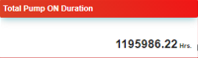 | - Sum of total running hours of RMS Integrated Pumps according to the selected no. of days in date range | This calculations will be Cumulative considering total running hours of RMS Integrated Pumps and selected days in date range
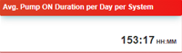 | - Total Pump ON Duration / 30 (selected no. of days in date range) / Total no of RMS Integrated Pumps = (value in HH:MM) | This calculation will be Cumulative considering Total running hours of RMS Integrated Pumps, no. of days selected in date range and total no. of RMS Integrated Pumps
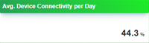 | - Total no. of hours of RMS device connectivity / Total no. of RMS Integrated Pumps / selected no. days in date range * 100 = (value in %) | This calculation considers the total no. hours that RMS device has been connected on the State SEDM Platform, total no. of RMS integrated pumps to calculate average of each device and no. of days selected in date range to calculate average device connectivity per day
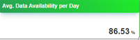 | - Total no. of samples (RMS data) received from the RMS device / Total no. of hours of RMS device connectivity / selected no. days in date range * 100 = (value in %) | This calculation considers total no. of samples (RMS data) that is received from the RMS device from the total hours of RMS device connectivity with the State SEDM Platform and no. of days selected in date range to calculate average device connectivity per day

- By clicking upon the green location icon (shown in Figure 177), user can view Performance Analysis statistics of particular district as shown in below Figure 177.

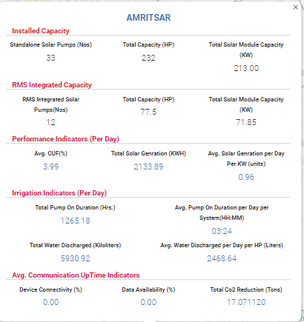
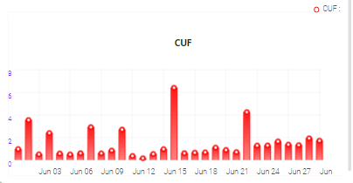
Figure 177 District Statistics

- By clicking upon district name, user will get a broad view of selected district in which consumers/farmers of that district (in terms of green and red location icons, as shown in below Figure 178) will be displayed.
  - Green Icon (Live) - Consumer/Farmer’s Solar Pump that is connected since 30 minutes.
  - Red Icon (Not Live) - Consumer/Farmer’s Solar Pump that is disconnected.

- Also user can navigate back to the state view by clicking on state name. (highlighted in red in below Figure 178)

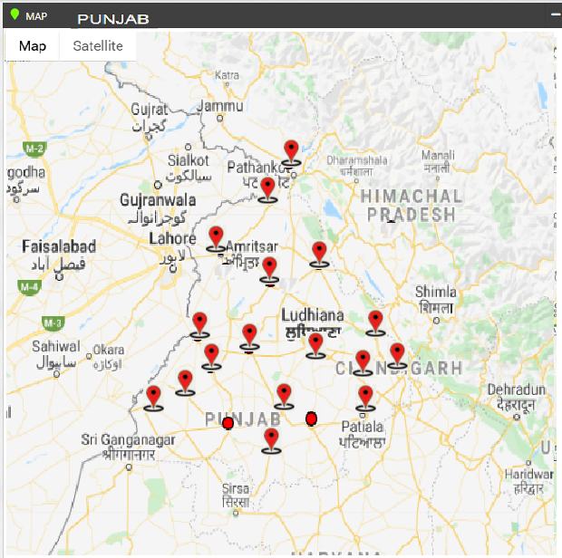
Figure 178 Broad View of Consumer/Farmer of Selected District

- By clicking on red location icon, user can view particular consumer/farmer’s Solar Pump statistics as shown below in Figure 179.

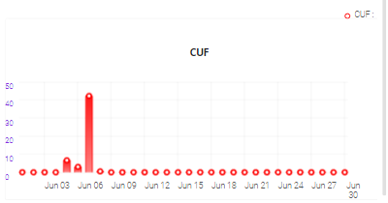
Figure 179 Consumer/Farmer Solar Pump Statistics

- By clicking on consumer/farmer’s name and application no. (Blue text in above Figure 179), user will be redirected to the Real Time tab under Asset Mapping by EA under Asset module. (as shown in below Figure 180)

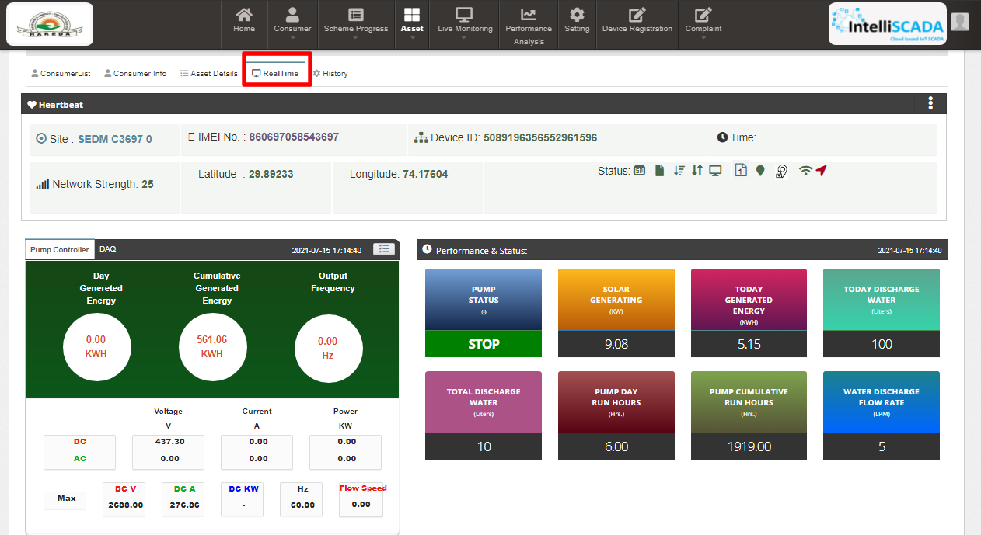
Figure 180 Real Time View of the Consumer/Farmer

SUMMARY

- Under the ‘Consumer’ tab title bar, there are two options in the drop-down menu. These options provide different views of application tracking and analysis.
- The first option is ‘Summary’ provides an overall Consumer Management Summary.
This dashboard displays an organised flowchart which helps user to understand different stages of application processing and to view details about any specific EA if needed.
- Navigation Steps: -
1. Sign in on the State SEDM Portal
2. Click on the ‘Consumer/Farmer’ option on the Title Bar of the SEDM Portal Dashboard
3. Click on the ‘Summary’ option from the drop-down menu
- Go to Consumer and click on Summary
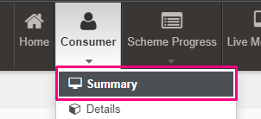
- Sign In >> Consumer >> Summary
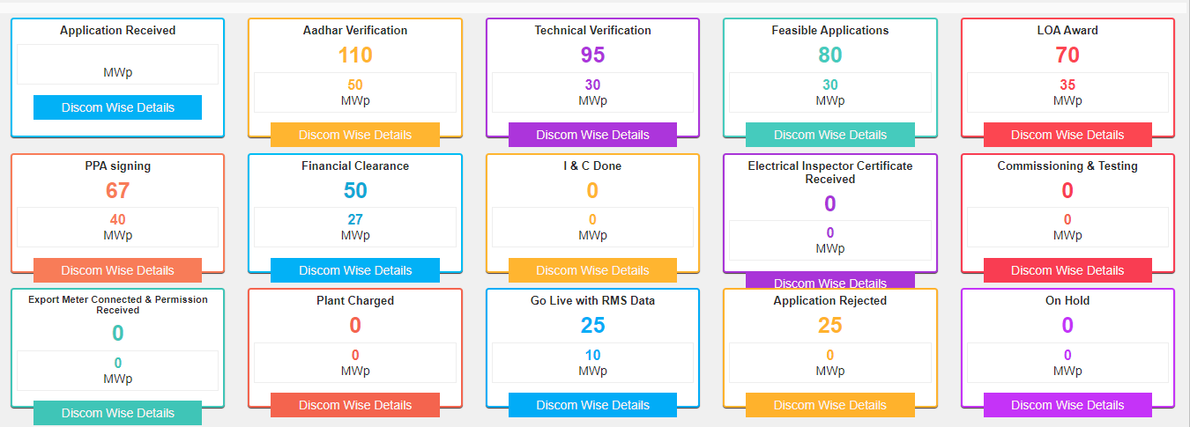

Figure 181 Consumer/Farmer Management Summary option selected on Consumer/Farmer Dashboard

- Description of each and every coloured boxes of application status as shown in the above image

- Count of all application status will be incremented according to the status gets changed of the consumers/farmers by the authorized person.

Status | Image | Description | Want to know how to change status?  (Click Ctrl + Click)
Application Received | 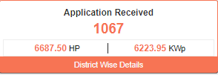 | This box indicates the total number of consumer/farmer applications received. | Click here
Aadhar Authentication | 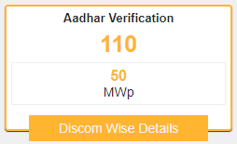 | This box indicates the total number of Aadhar authenticated consumers/farmers. | Refer Table 34
Technical Verification | 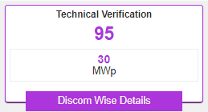 | This box indicates the total number of consumers/farmers whose status “Technical Verification” status is updated. | Click here
Feasible Application | 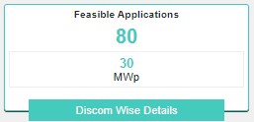 | This box indicates the total number of consumers whose application is accepted by the authorized user. | Click here
LOA Award | 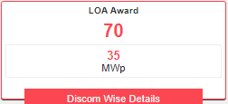 | This box indicates the total number of consumers to whom LOA award is issued. | Click here
PPA Signing | 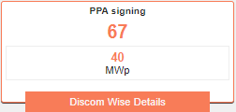 | This box indicates the total number of consumers whose PPA is signed. | Click here
Financial Clearance | 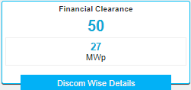 | This box indicates the total number of consumers whose status is changed to “Financial Clearance”. | Click here
I&C Done | 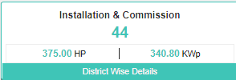 | This box indicated the total number of consumers/farmers whose status is changed to “Installation & Commission”. | Click here
Electrical Inspector Certificate Received | 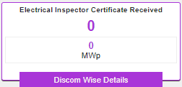 | This box indicates the total number of consumers, when authorized person changes the status to “Electrical Inspector Certificate Received” of consumers. | Click here
Commissioning & Testing | 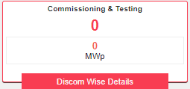 | This box indicates the total number of consumers whose plant is commissioned and tested. | Click here
Export Meter Connected & Permission Received | 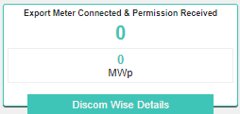 | This box indicates the total number of consumers whose “Export Meter Connected & Permission Received” status is updated. | Click here
Plant Charged | 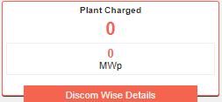 | This box indicates the total number of consumers whose “Plant charged” status is updated. | Click here
Go Live with RMS Data | 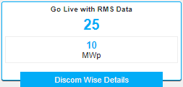 | This box indicates the total number of consumers whose “Go Live with RMS Data” status is updated. | Click here
Application on Hold | 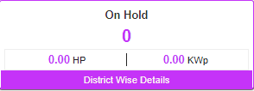 | This box indicates the total number of consumers/farmers whose application is on Hold by the authorized user. | Click here
Application Rejected | 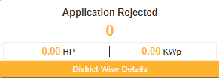 | The above box indicates the total number of consumers/farmers whose application is Rejected by the authorized user. | Click here

- There are several DISCOMs that a user can choose from (pointed out in below Figure 182), depending on their analytical requirement or data studying.

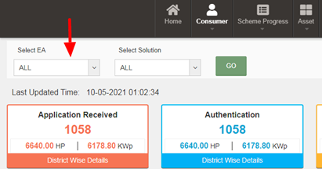
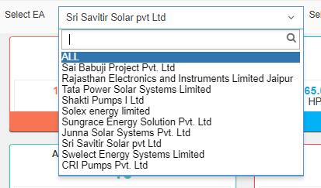
Figure 182 EA selection option in ‘Select EA’ filter

Figure 183 Capacity options in ‘Select Capacity’ filter

- Consumer/Farmer Management Dashboard Output after applying filters. (shown in below Figure 184)
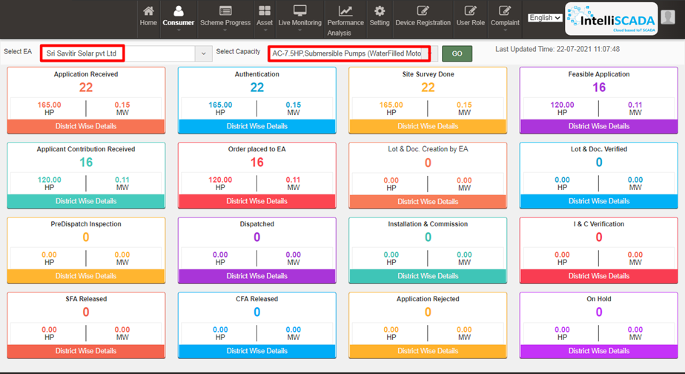
Figure 184 Applied filter: Sri Savitir Solar Pvt Ltd (EA), AC-7.5HP, Submersible Pumps (Waterfilled Motors)
- Each box label has a suitable name given to it which signifies the step at which the application of a user has reached at. It also provides the statistical numbers for this information, along with total solar installation capacity in kilowatts peak (kWp) generated in Horsepower (HP), for allocated users.
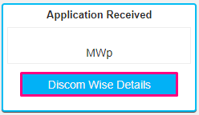
Figure 185 Individual application stage

- To get more details for every sub-division, users can click on the ‘Discom Wise Details’ button in the label box. It will display the screen shown below in Figure 186 :
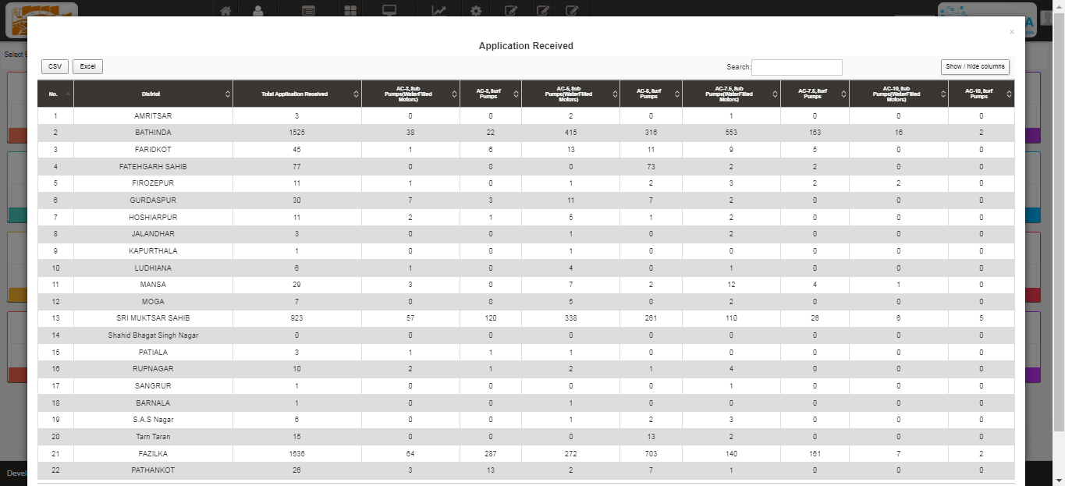
Figure 186 District-wise summary of Applications Received for various pump models report
- In this table, users can choose to show or hide columns as per their preference by selecting ‘Show / hide columns’ button on top right corner.
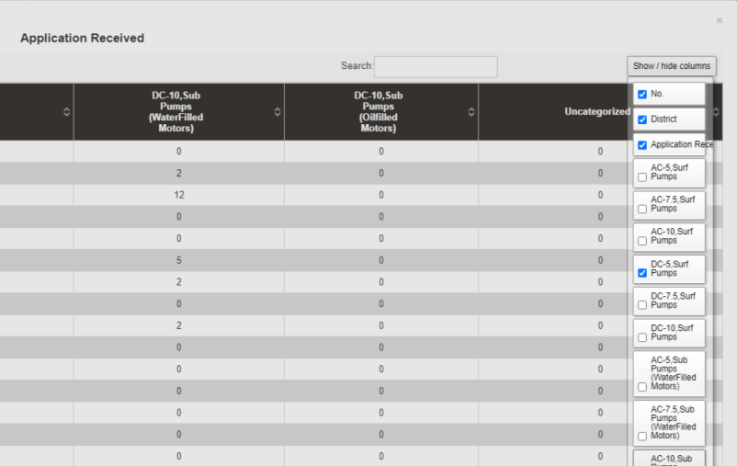

Figure 187 Show / Hide columns filter

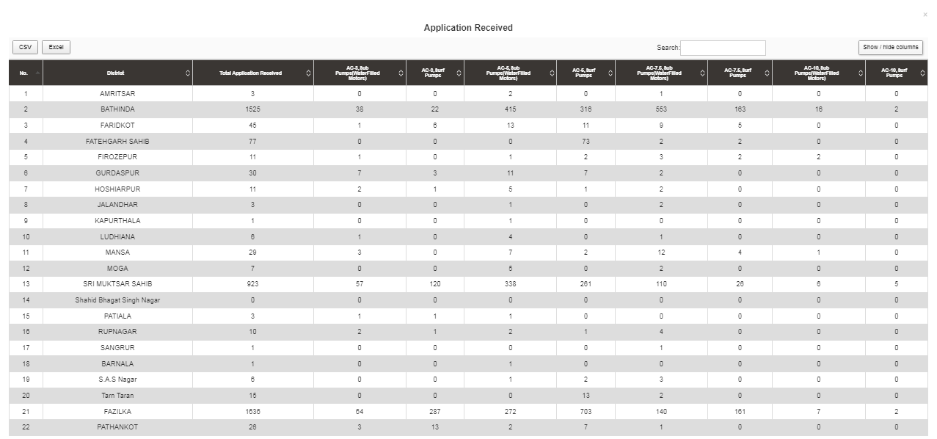
Figure 188 Using the filter “Show / hide columns” to display only selected columns

- Additionally, users can search for their specific division or sub-division by inputting the relevant search query in the ‘Search’ dialogue box. (highlighted in red in below Figure 189)
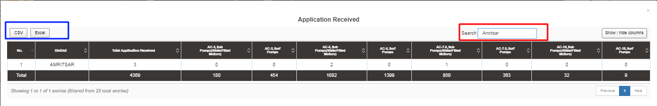
Figure 189 Using “Search” filter to list down all entries for District = Amritsar

- The users can directly download the whole data in tabular formats by clicking onto the required file source buttons, i.e. CSV or Excel, present on the top left corner. (highlighted in blue in above Figure 189)
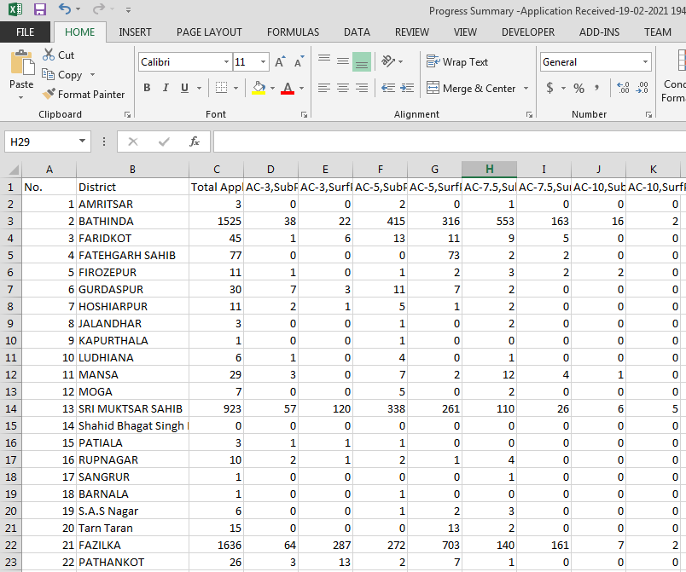
Figure 190 The view of downloaded CSV/Excel file
______________________________________________________________________________________________________________________________

SCHEME PROGRESS

- The Scheme Progress Module of SEDM portal helps the users to track the progress of application with detailed information, to understand the user role management, to search for bulk queries, and to generate reports including the progress status and application workflow.

- Navigation Steps: -
- Sign in on the State SEDM Portal
- Click on the ‘Scheme Progress’ option on the Title Bar of the SEDM Portal Dashboard

- Sign In >> Scheme Progress

- Below are the brief points covered under this module:

24.1 SCHEME PROGRESS REPORT
- Navigation Steps: -
1. Sign in on the State SEDM Portal
2. Click on the ‘Scheme Progress’ option on the Title Bar of the SEDM Portal Dashboard
3. Click on the ‘Reports’ option from the drop-down menu

- Sign In >> Scheme Progress >> MIS Reports
- With the Report feature in Scheme Progress Module on SEDM portal, the users can view and download various types of reports based on the input parameters of the filters provided.
- Different Types of Reports are:

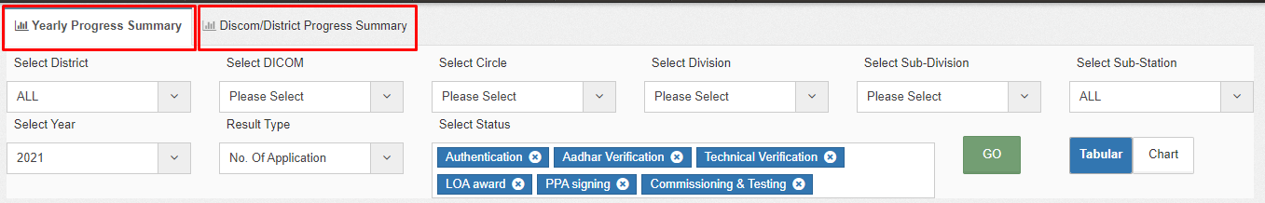
Figure 204 MIS Reports

- YEARLY PROGRESS SUMMARY

- Yearly Progress Summary to show PM-KUSUM scheme progress statistics with respect to years.
- The filter options provided to the users are :
  - Select Empanelled Agency
  - Select District
  - Select Year
  - Result Type
  - Application Status Selection
  - Report View (Tabular/Chart).

- Tabular View

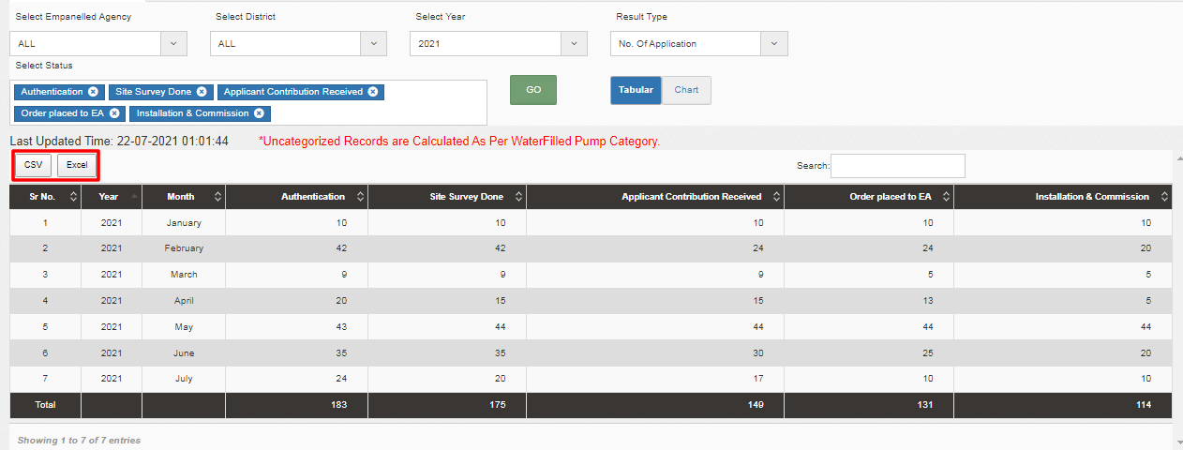
Figure 205 Yearly Progress Summary – Tabular view

- Chart View

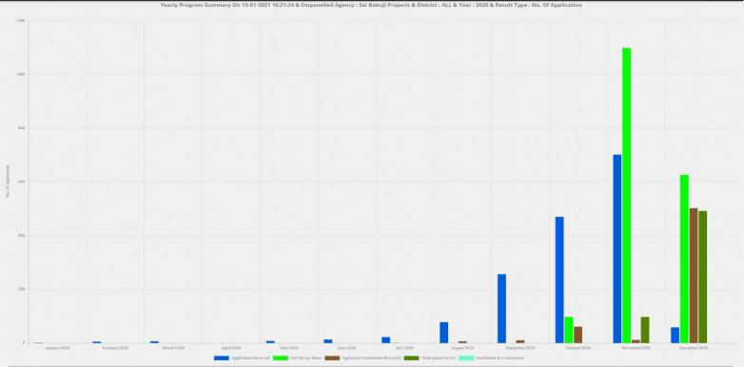

Figure 206 Yearly Progress Summary – Chart view

- District/DISCOM Progress Summary

- District / Discom Progress Summary to show PM-KUSUM scheme progress statistics with respect to different districts of State.
- The filter options provided to the users are :
  - Select DISCOM, Circle, Division, Sub-Division, Sub-Station, and Capacity
  - Result Type
  - Application Status Selection
  - Report View (Tabular/Chart)

- Tabular View

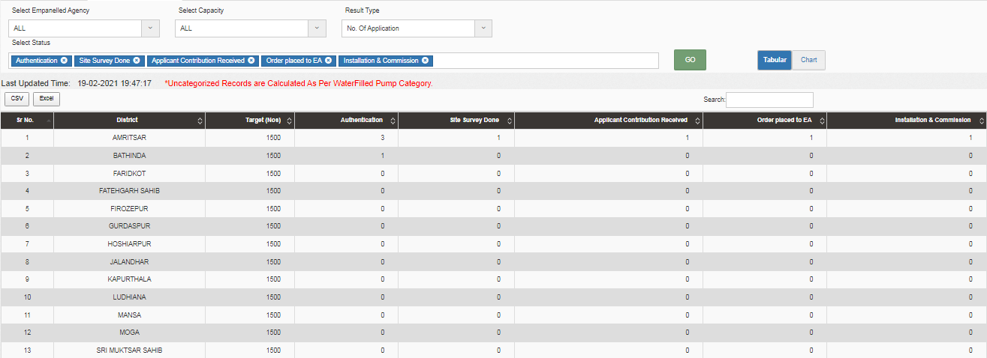
Figure 207 District Progress Summary- tabular view

- Chart View

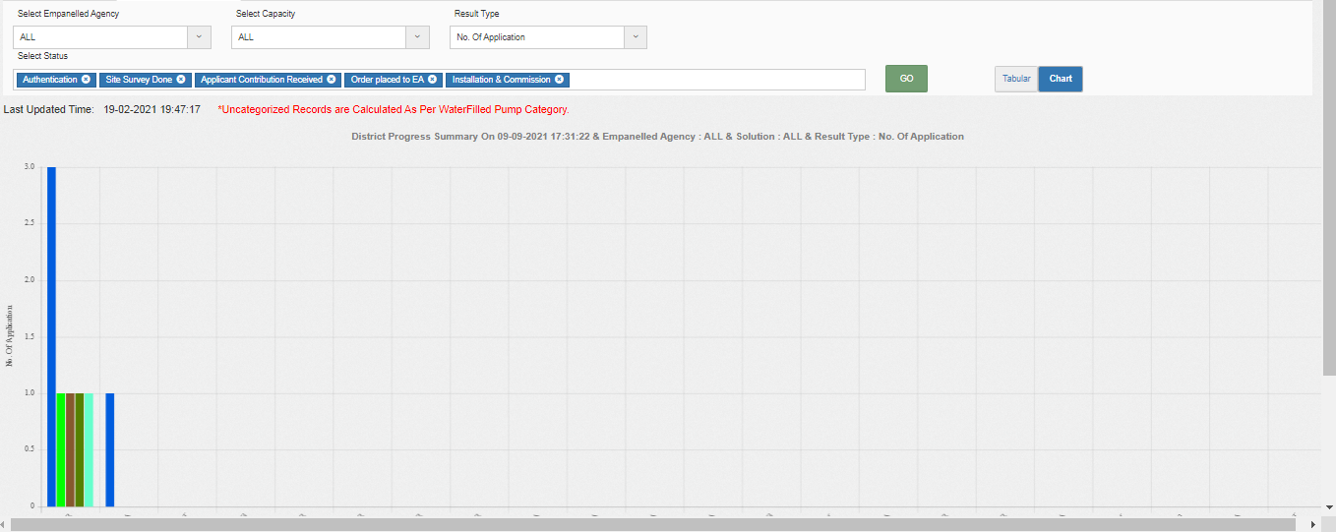

Figure 208 District Progress Summary – Chart view

SIGN OUT

- The users can log out or sign out from the State SEDM Portal by following 2 methods.
- Either by clicking onto the ‘User’ icon, present at the top right corner on the title bar of the SEDM Portal (pointed in below Figure 244) and then selecting the option of ‘Logout’ (highlighted in red in below Figure 244).

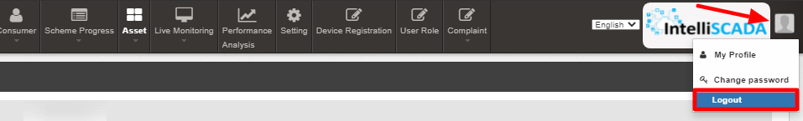

Figure 244 Logout

- The second method is to first click onto the ‘Home’ page button on the title bar of the SEDM Portal (pointed in red in below Figure 245), and then on the Home Page selecting the option of ‘Sign Out’ present in the form of a blue coloured button on the top right corner of the page (highlighted in red in Figure 246)

Figure 245 Home Selected
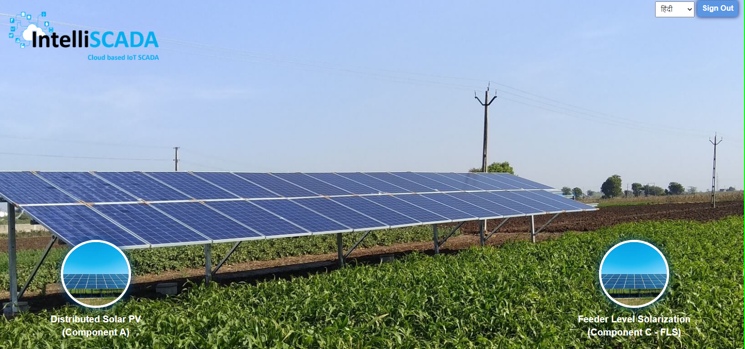

Figure 246 Sign out

SUPPORT TEAM CONTACT DETAILS

Email - HO[DOT]LUCKNOW[AT]UPBVN[DOT]ORG

ANNEXURE-I (IMEI NUMBER REGISTRATION)

IMEI NUMBER REGISTRATION
- Navigation Steps: -
1. Sign in on the State SEDM Portal
2. Click on the “Device Registration” option on the Title Bar of the SEDM Portal Dashboard

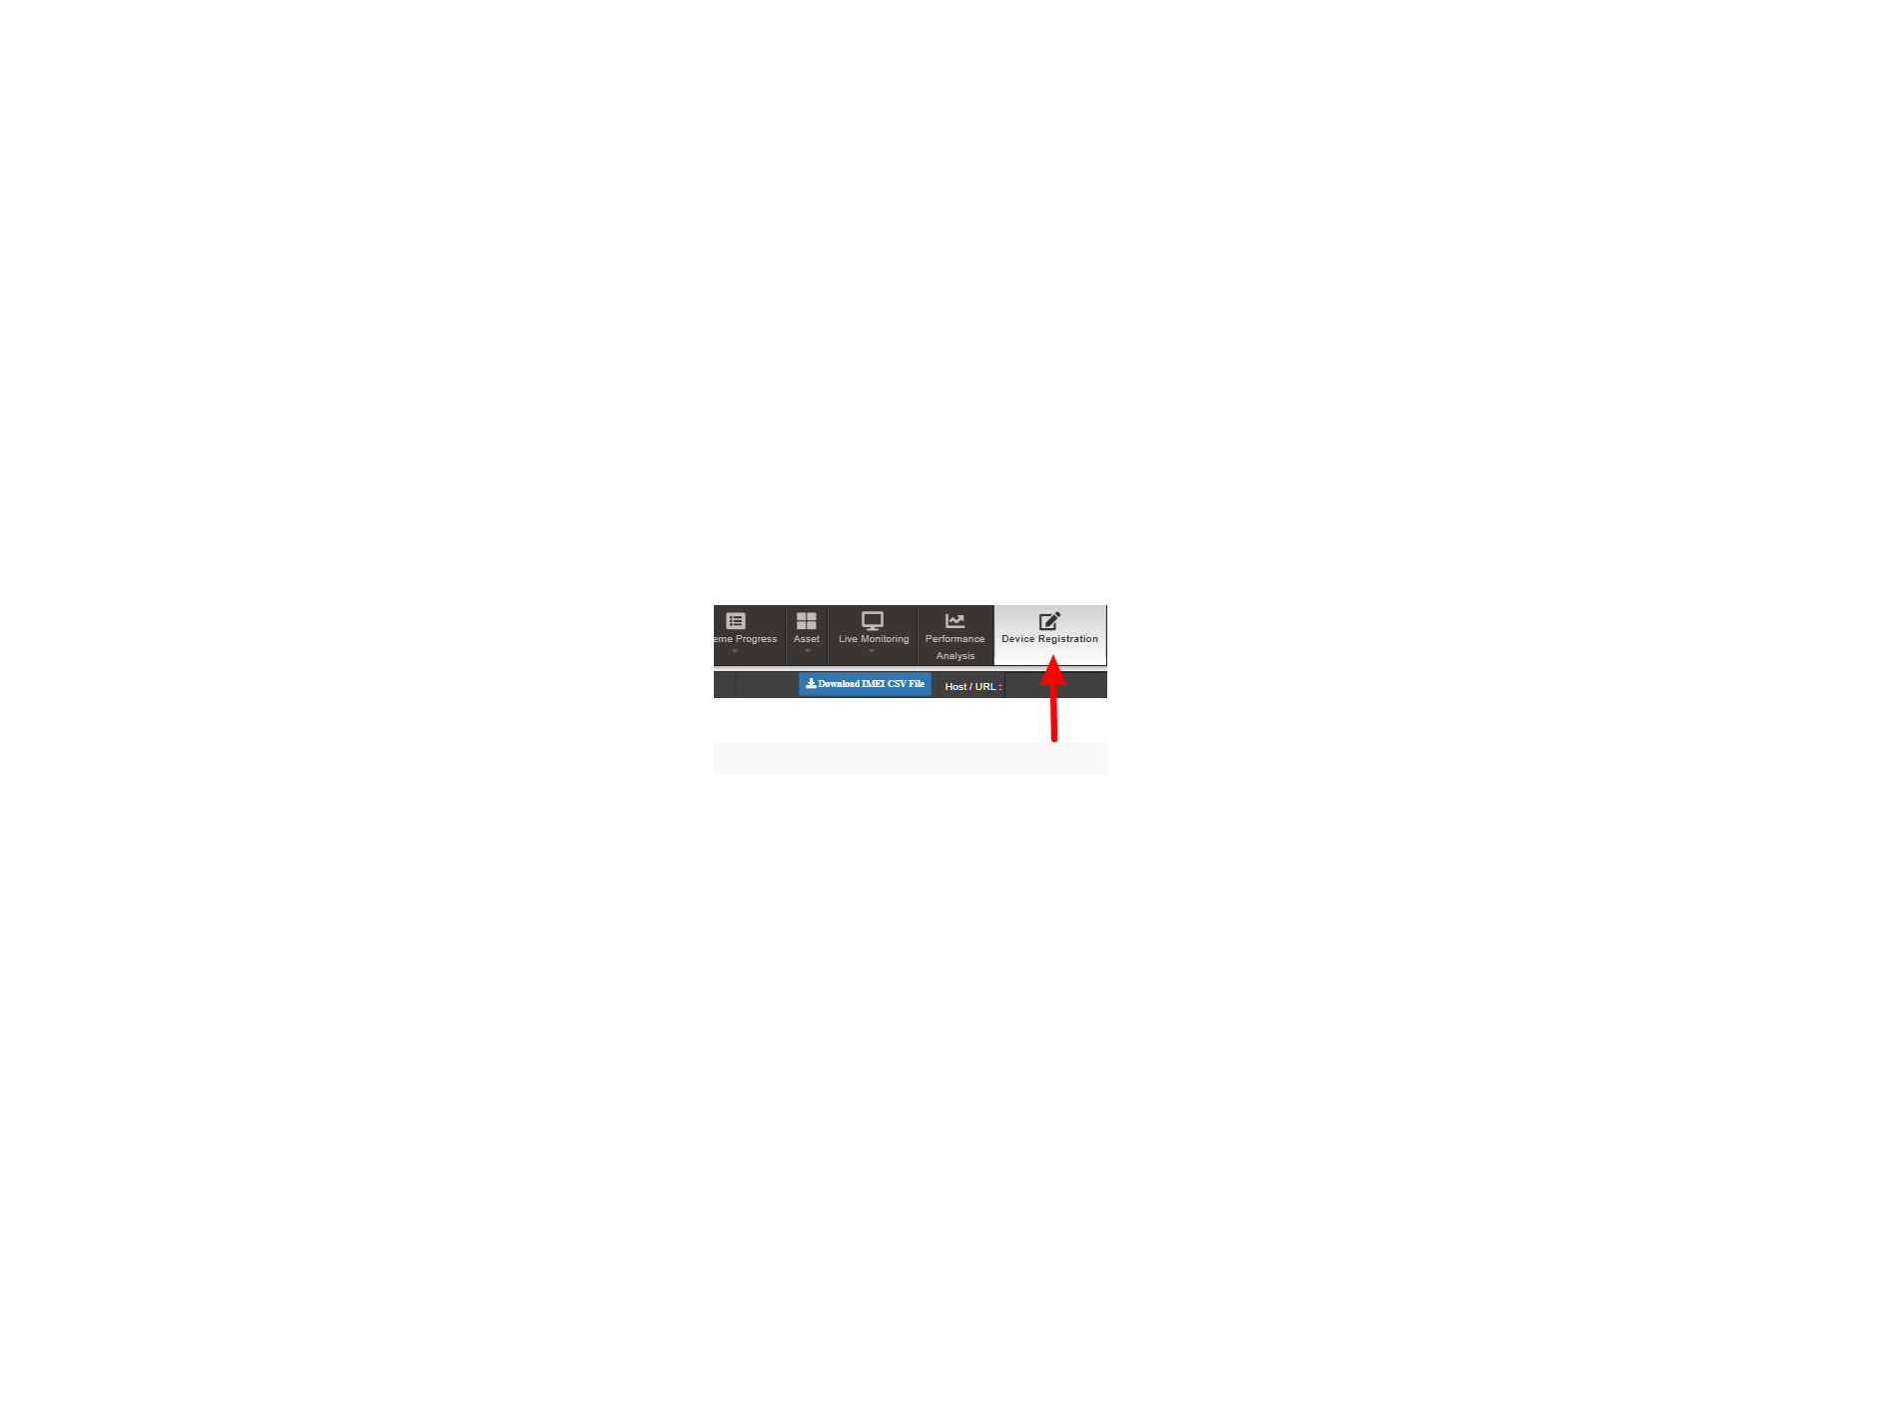

Figure 255 Device Registration

- IMEI no. can be registered in two ways :
  - Bulk Registration of IMEI nos. by uploading CSV file.
  - Registration of single IMEI no.

- Bulk Registration of IMEI nos. by Uploading CSV file :

- To upload the CSV file for bulk registration of IMEI nos., EA user can download the format of CSV file by clicking on the “Download IMEI CSV File” blue button from the Device Registration dashboard. (highlighted in red in below Figure 256)

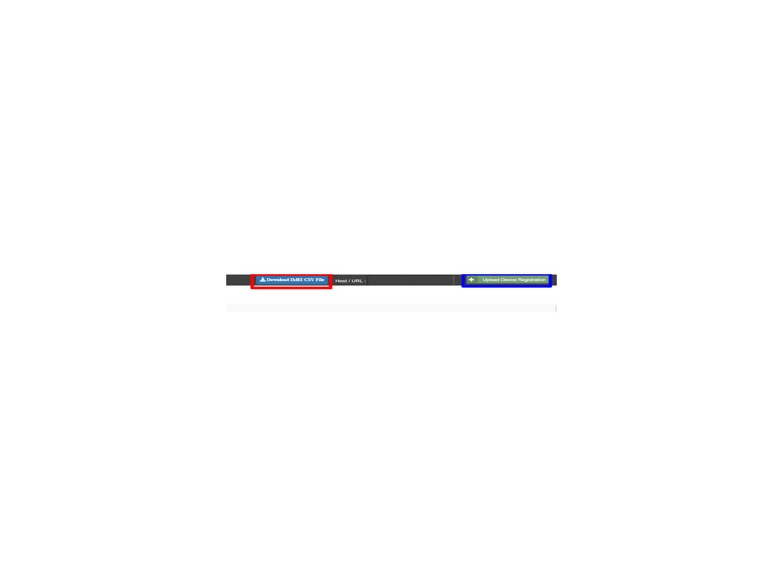
Figure 256 IMEI Bulk Upload

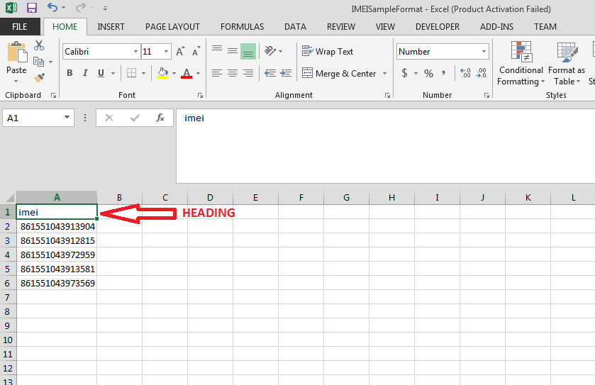

Figure 257 IMEI No. CSV Format

- The above image is the CSV file format of IMEI nos.
- EA user has to keep the heading “imei” as shown in the first row of CSV file and has to enter their own IMEI nos. starting from the 2nd row as shown in the above Figure 257.
- After creating the CSV file carrying IMEI nos., user has to click on the “Upload Device Registration” button as highlighted in blue in Figure 256: “IMEI bulk upload”.
- A window screen will appear to upload the CSV file carrying IMEI nos. as shown in below Figure 258.

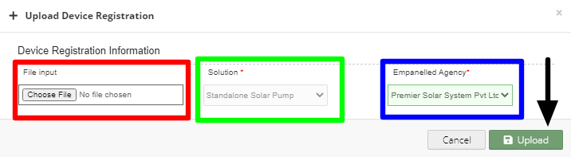

Figure 258 Upload IMEI No. CSV
- In above screen, EA user can upload IMEI csv file by clicking on the “Choose File” button. (highlighted in red in above Figure 258)
- The above screen arrives with the two filters which is by default selected i.e. “Solution” and “Empanelled Agency”
- EA user can see by default his Empanelled Agency name. (highlighted in blue in above Figure 258)

- Registration of single IMEI no.

- EA user can also register single IMEI no, manually by clicking on the “Add New Device Registration” button from the Device Registration Dashboard. (pointed in below Figure 259)
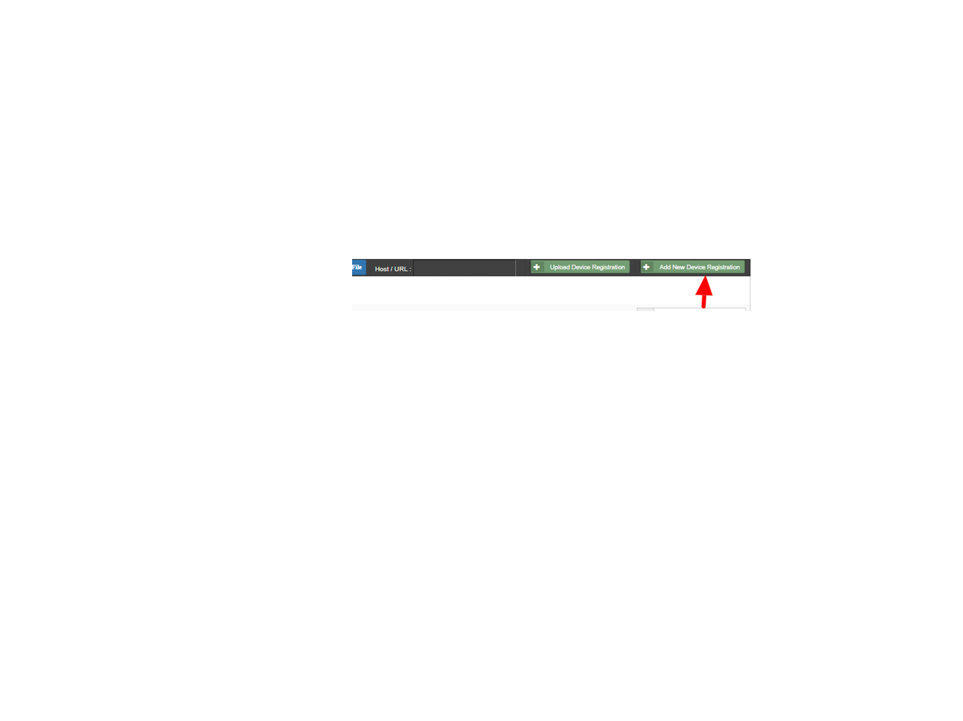
Figure 259 Add New Device Registration Button

- When EA user will click on the “Add New Device Registration” button, a window screen will appear to enter the 15 digit IMEI no. (as shown in below Figure 260)
- When the user select “Is Password” option (highlighted in red in below Figure 260), it will generate the SSL certificates in the Device Registration dashboard, if not selected then it won’t generate the certificates.
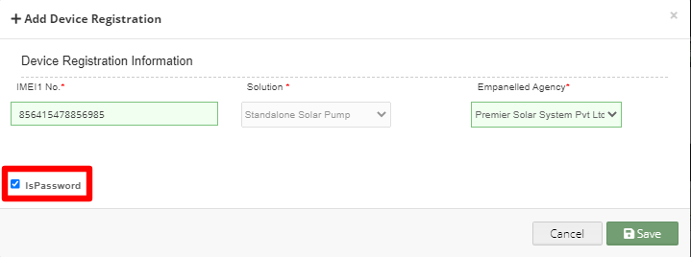

Figure 260 Add Device Registration

- After entering IMEI no., user has to click on the save button and IMEI no. will be registered on the portal and is ready to map with necessary consumer/farm18er.
Disclaimer

- Nothing in this report constitutes a valuation or legal advice.
- HKRP has not verified the reliability or accuracy of any information obtained in the course of its work, other than in the limited circumstances set out in the Services Contract.
- In connection with the report or any part thereof, HKRP does not owe duty of care (whether in contract or in tort or under statute or otherwise) to any person or party to whom the report is circulated to and HKRP shall not be liable to any party who uses or relies on this report. HKRP thus disclaims all responsibility or liability for any costs, damages, losses, liabilities, expenses incurred by such third party arising out of or in connection with the report or any part thereof.

